PRINCIPLES OF EXCELLENCE COMPLAINT SYSTEM – INTAKE QUESTIONNAIRE
1. Education Benefits & Issue:
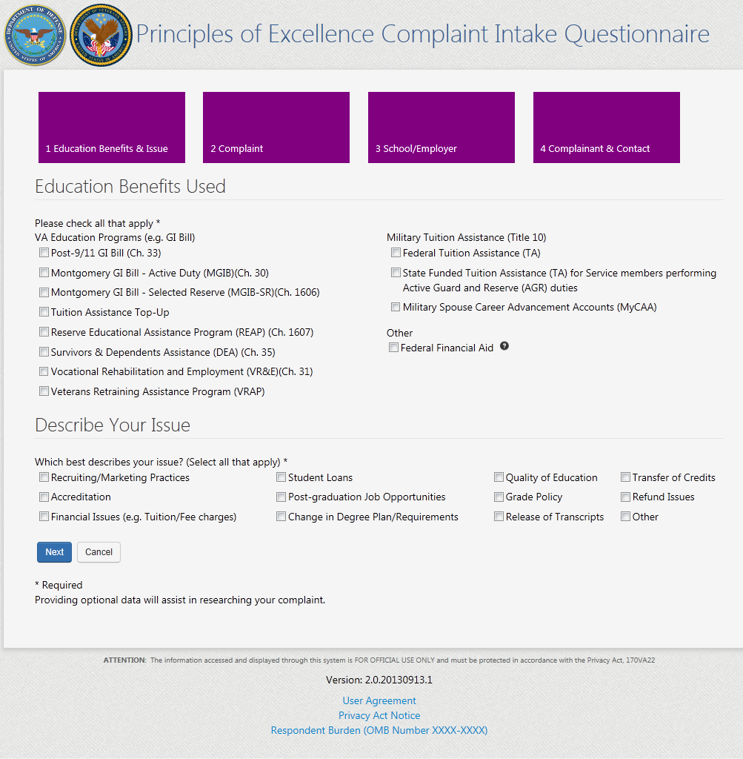
(Expires November 25, 2016)

2. Complaint Information:
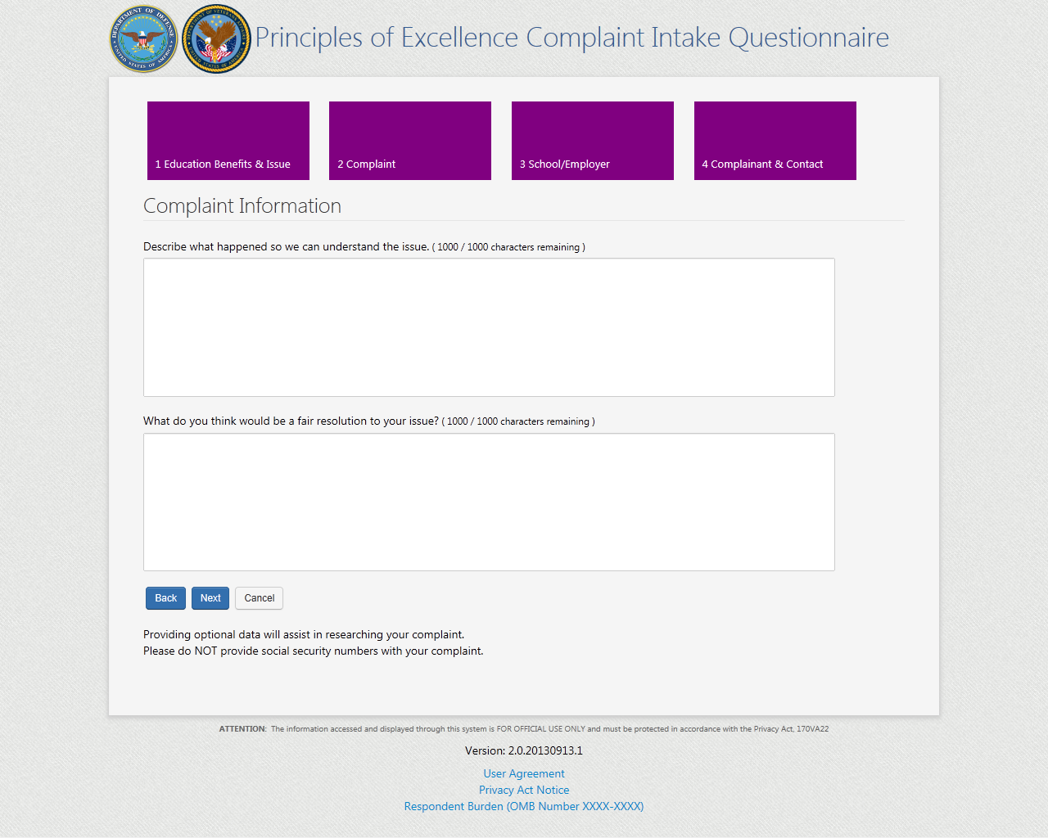
3. School/Employer Information:
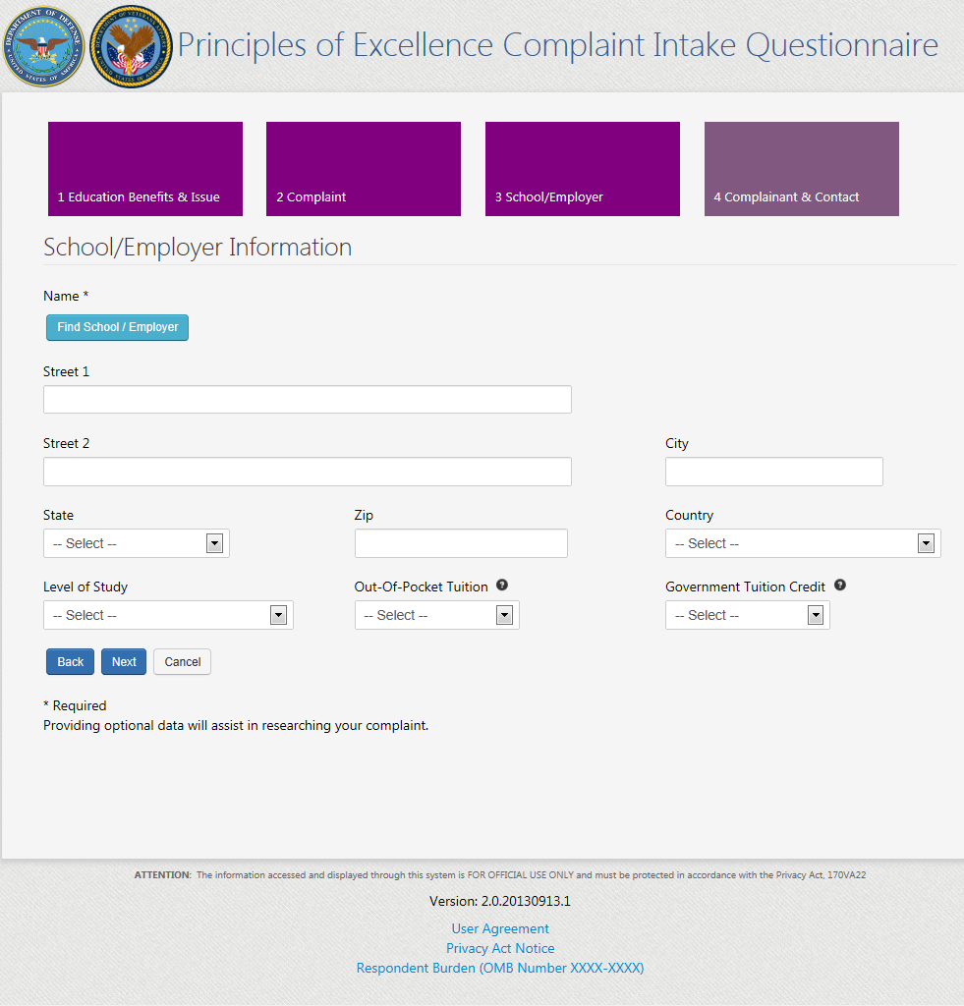

4. Complainant and Contact:
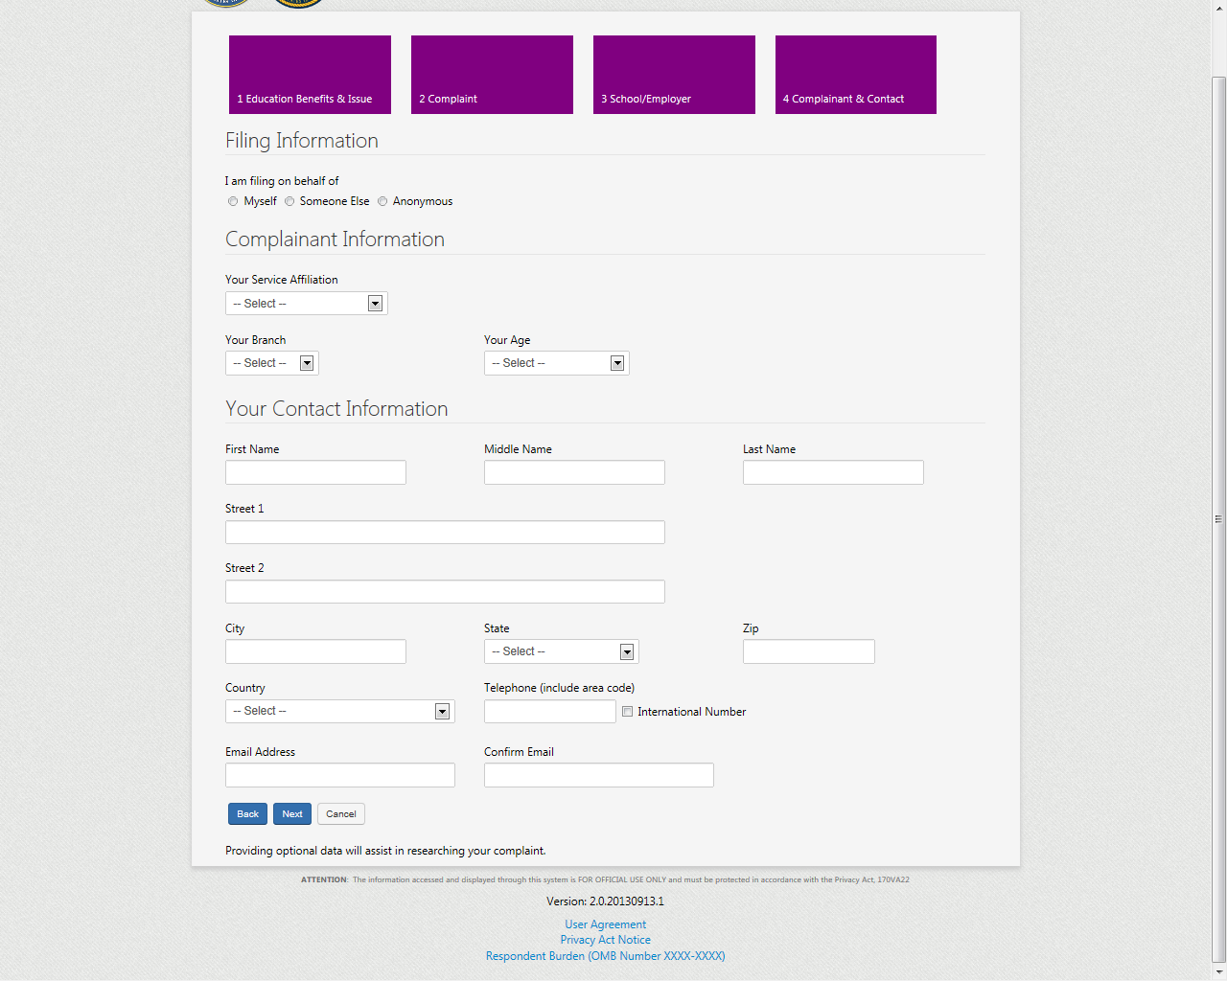
User Agreement:
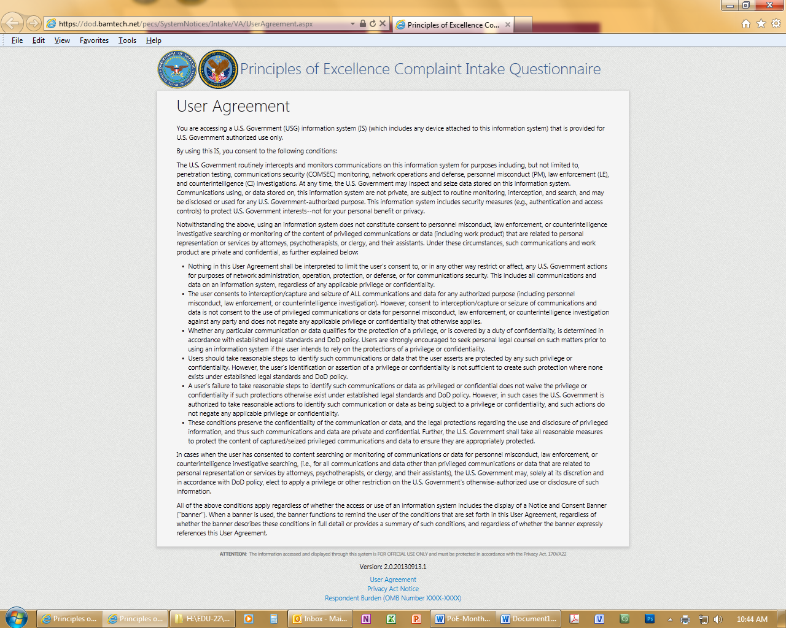
Privacy Act Notice:
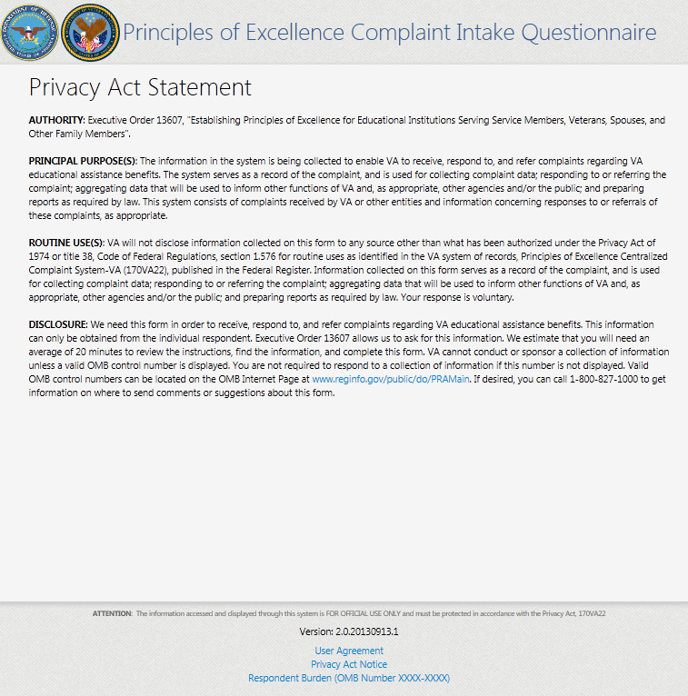

Respondent Burden (OMB Number XXXX-XXXX):
