**United States Department of Agriculture**

Farm and Foreign

Agricultural

Services

Farm Service Agency

1400 Independence Avenue, SW

Stop 0540

Washington, DC

20250-0540

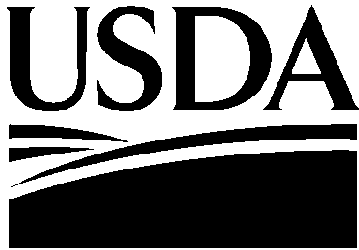

USDA is an Equal Opportunity Provider and Employer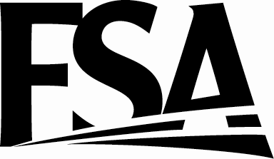

DATE: May 24, 2016

TO: Cortney Higgins

OMB Desk Officer

THROUGH: Ruth Brown

USDA Information Collection Officer

FROM: Brad Pfaff

FSA Deputy Administrator Farm Programs

SUBJECT: Request for Emergency Approval for a New Information Collection Request— Cotton Ginning Cost-Share (CGCS) Program to Cotton Producers

This request is for OMB review and emergency approval of a collection of information necessary to process one-time Cotton Ginning Cost-Share (CGCS) payments to cotton producers. The Commodity Credit Corporation (CCC) is announcing the availability of cost-share funds to cotton producers of the United States for cost-sharing of cotton ginning expenses for harvest 2015 cotton crop incurred by cotton producers in the States, the Commonwealth of Puerto Rico, and Washington, D.C. CGCS applicants receive a one-time cost-share payment on a per acre basis by certifying to the number of 2015 acres they reported as planted to cotton on a FSA-578 Crop Acreage Report, and the percentage of shares they had in the ginned cotton, not to exceed 40% of the calculated 2015 ginning costs. The funds may be used to assist cotton producers in marketing ginned cotton, as there is no commerce for un-ginned cotton. Funds for CGCS are limited to $304 million. The Notice of Fund Availability (NOFA) will be published in the Federal Register on June 7, 2016.

This information collection is needed for FSA to identify eligible producers requesting cotton ginning cost-share assistance. FSA requires each cotton producer to submit an application to FSA. Cotton producers will be required to report the number acres planted to cotton for the 2015 crop year, and their respective share in the cotton acres. CCC expects to disburse funds to eligible cotton producers before September 30, 2016. The funds available announced in this NOFA will not be subject to sequestration if the funds are obligated by CCC during fiscal year 2016.

FSA is requesting emergency approval of the new information collection package by June 7, 2016. If there are any questions or concerns, please call Deirdre Holder at 202-205-5851 or Mary Ann Ball at 202-720-4283.