Flu Vaccine Tree Test screen shots

# Old site

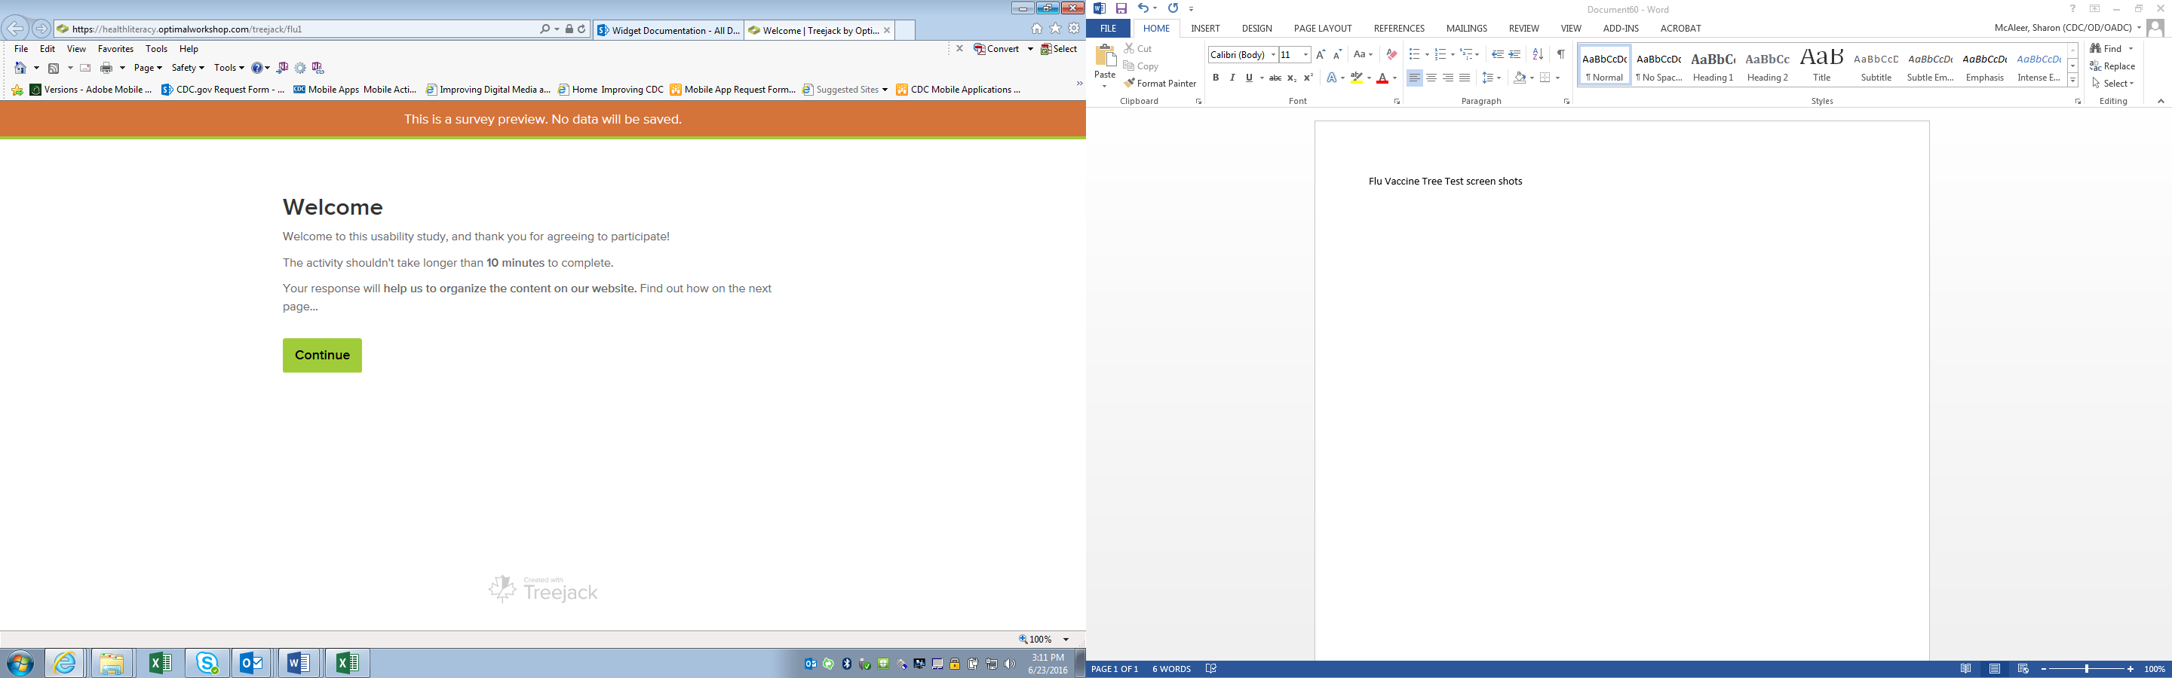

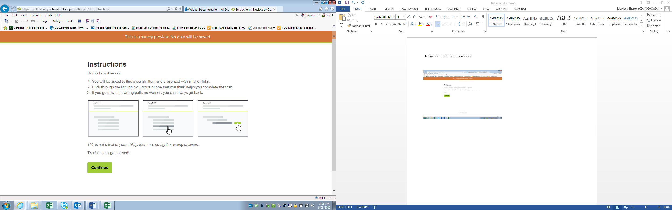

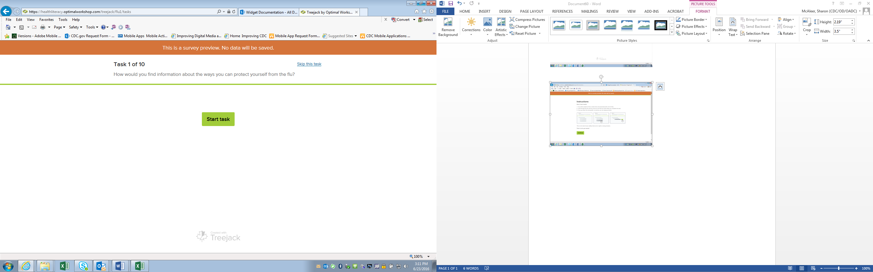

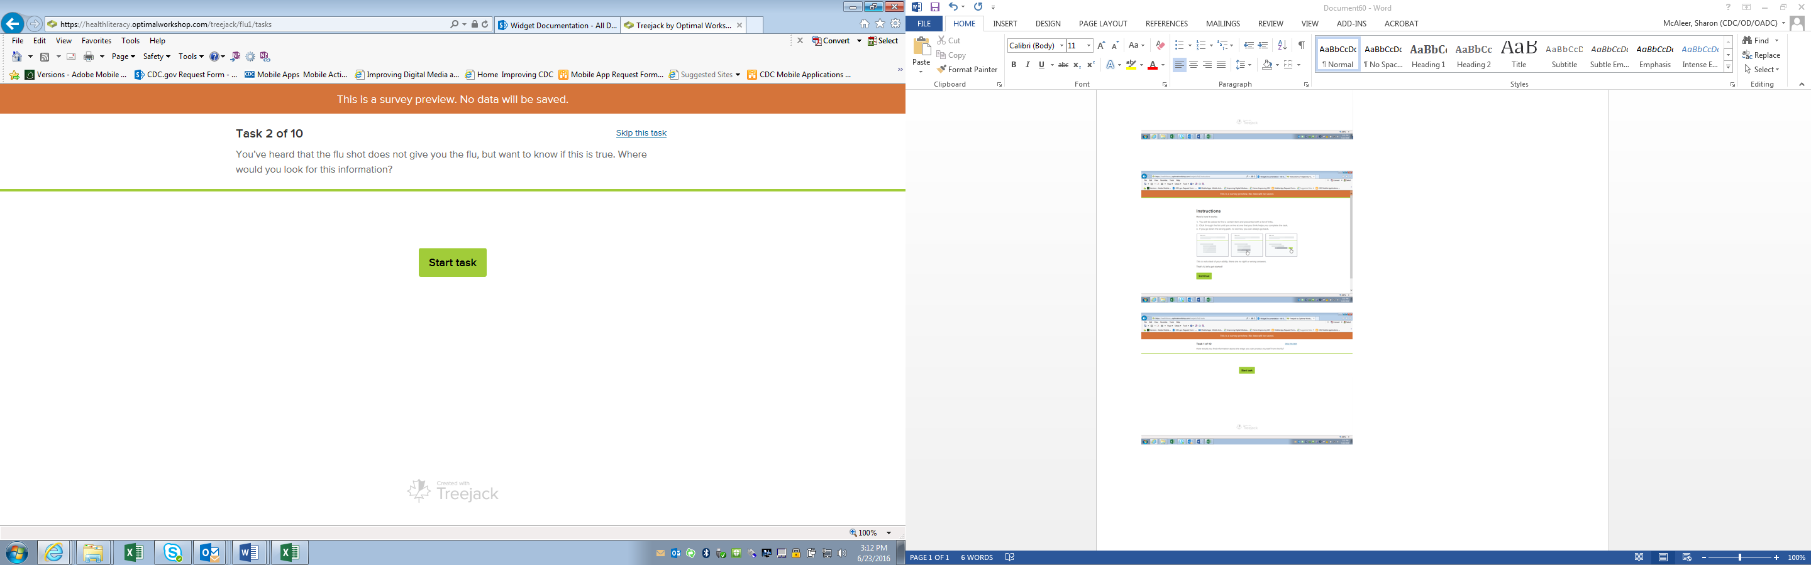

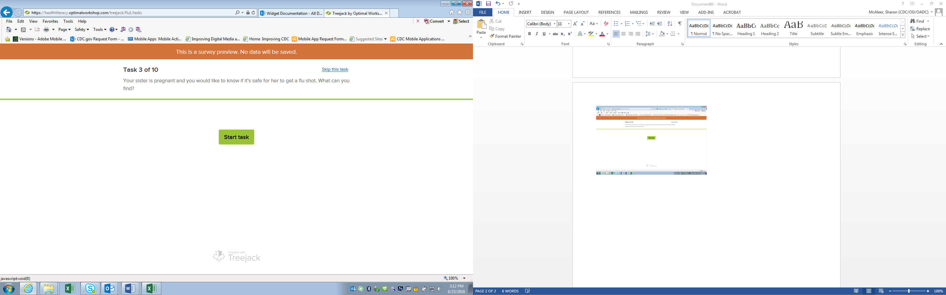

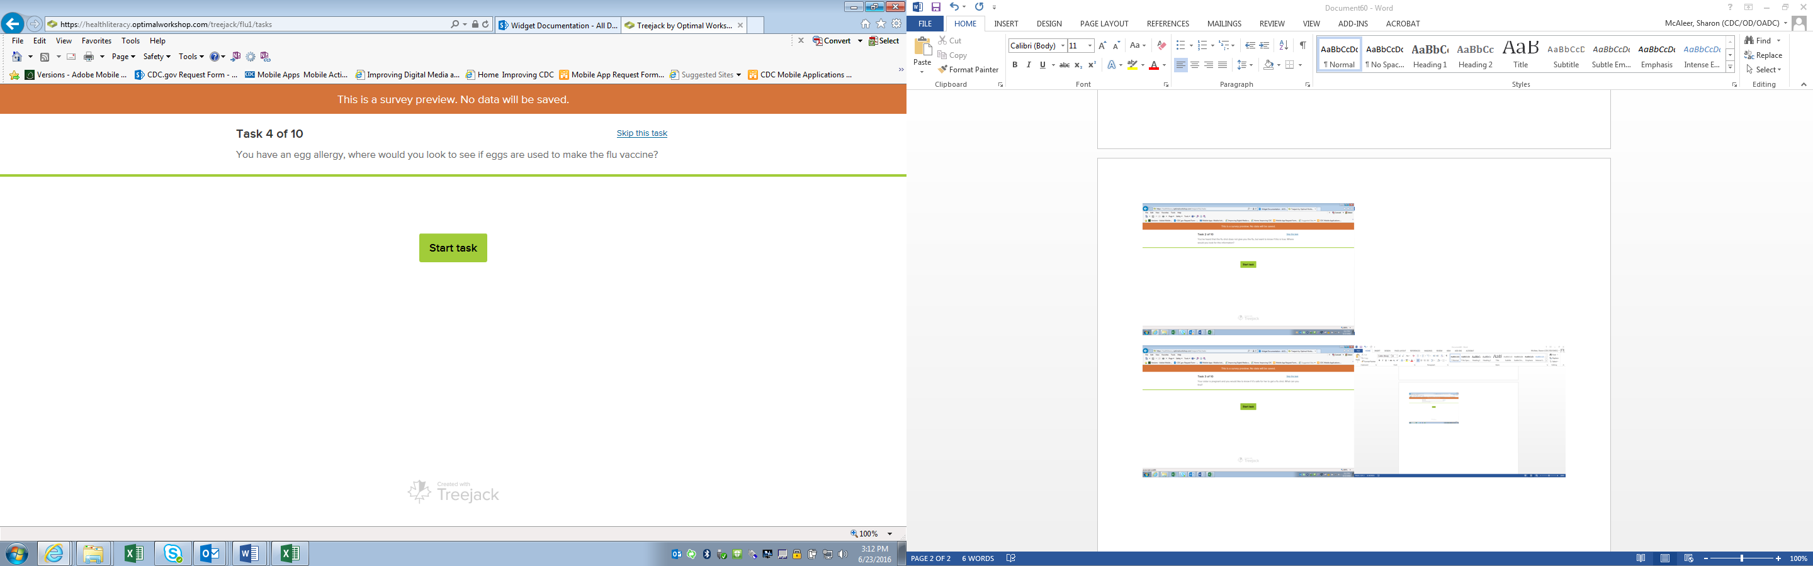

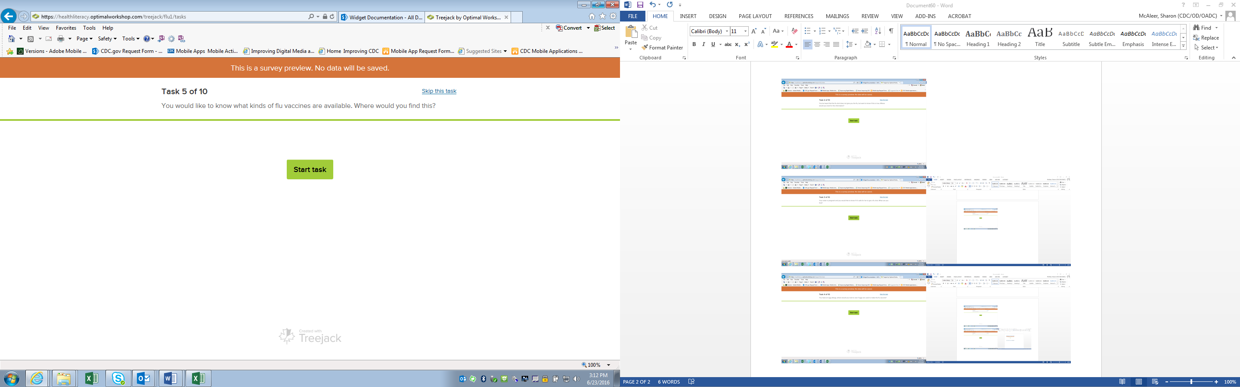

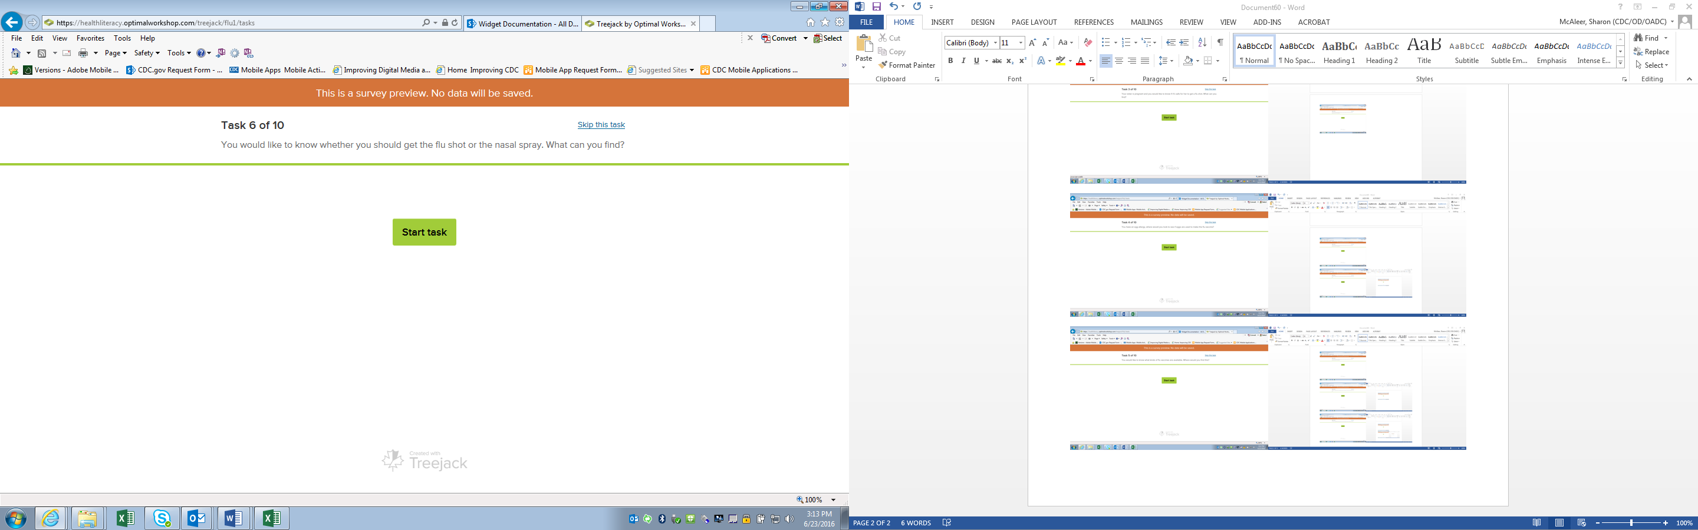

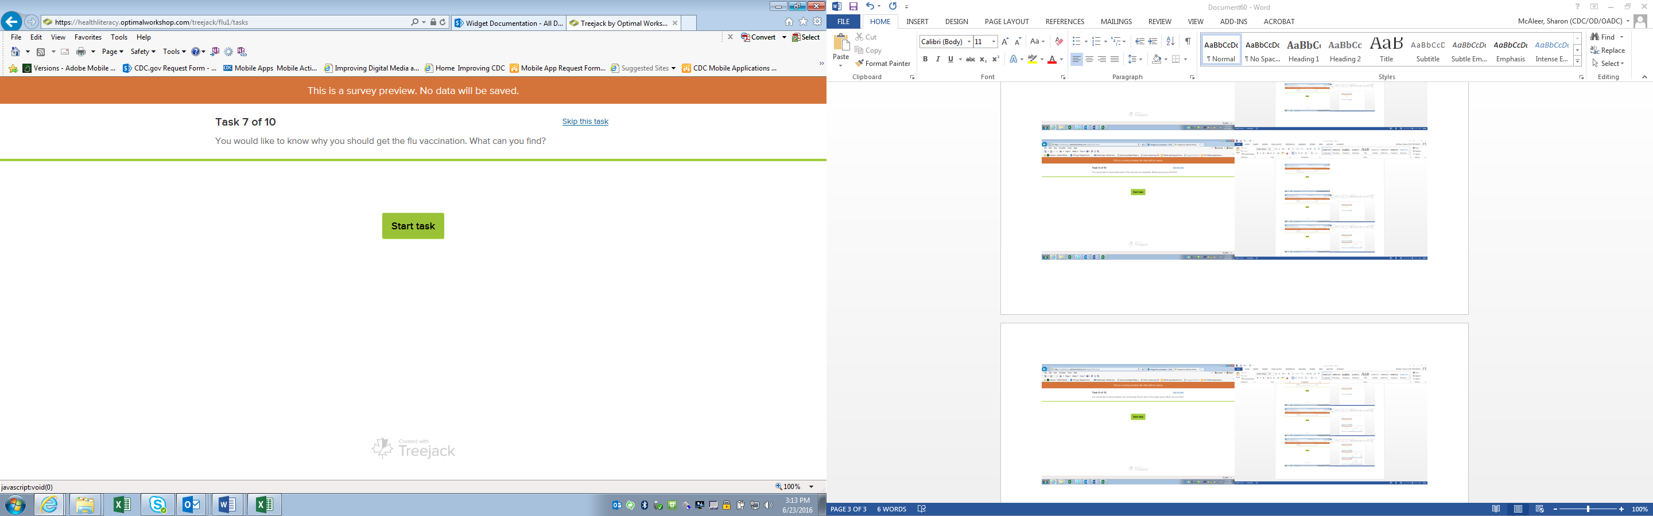

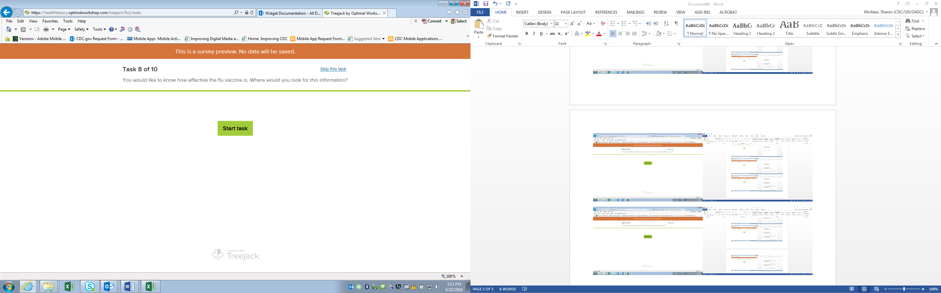

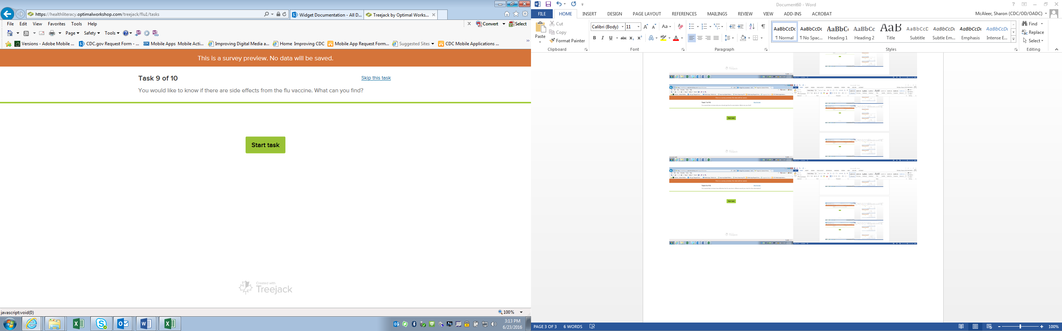

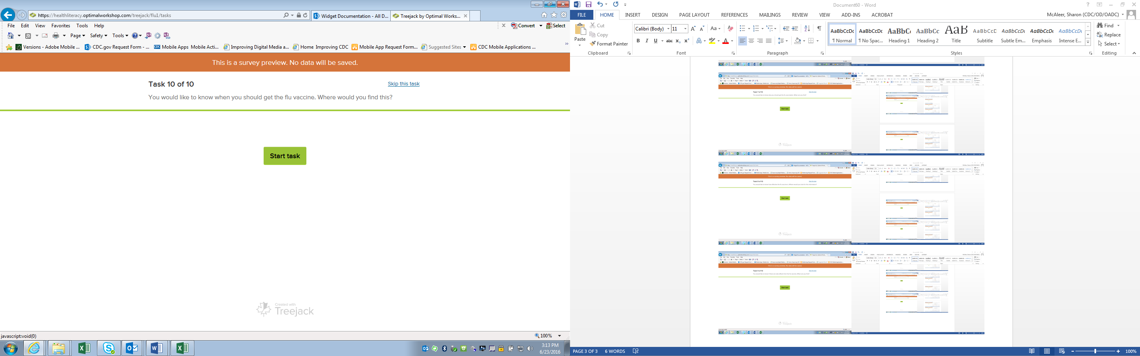

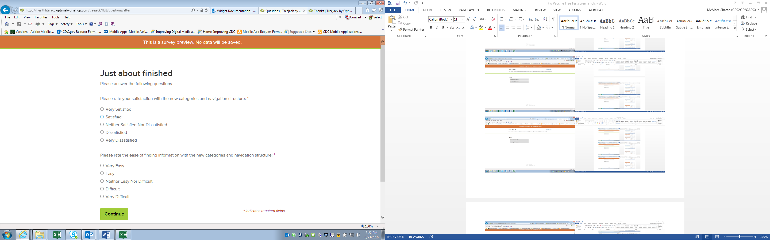

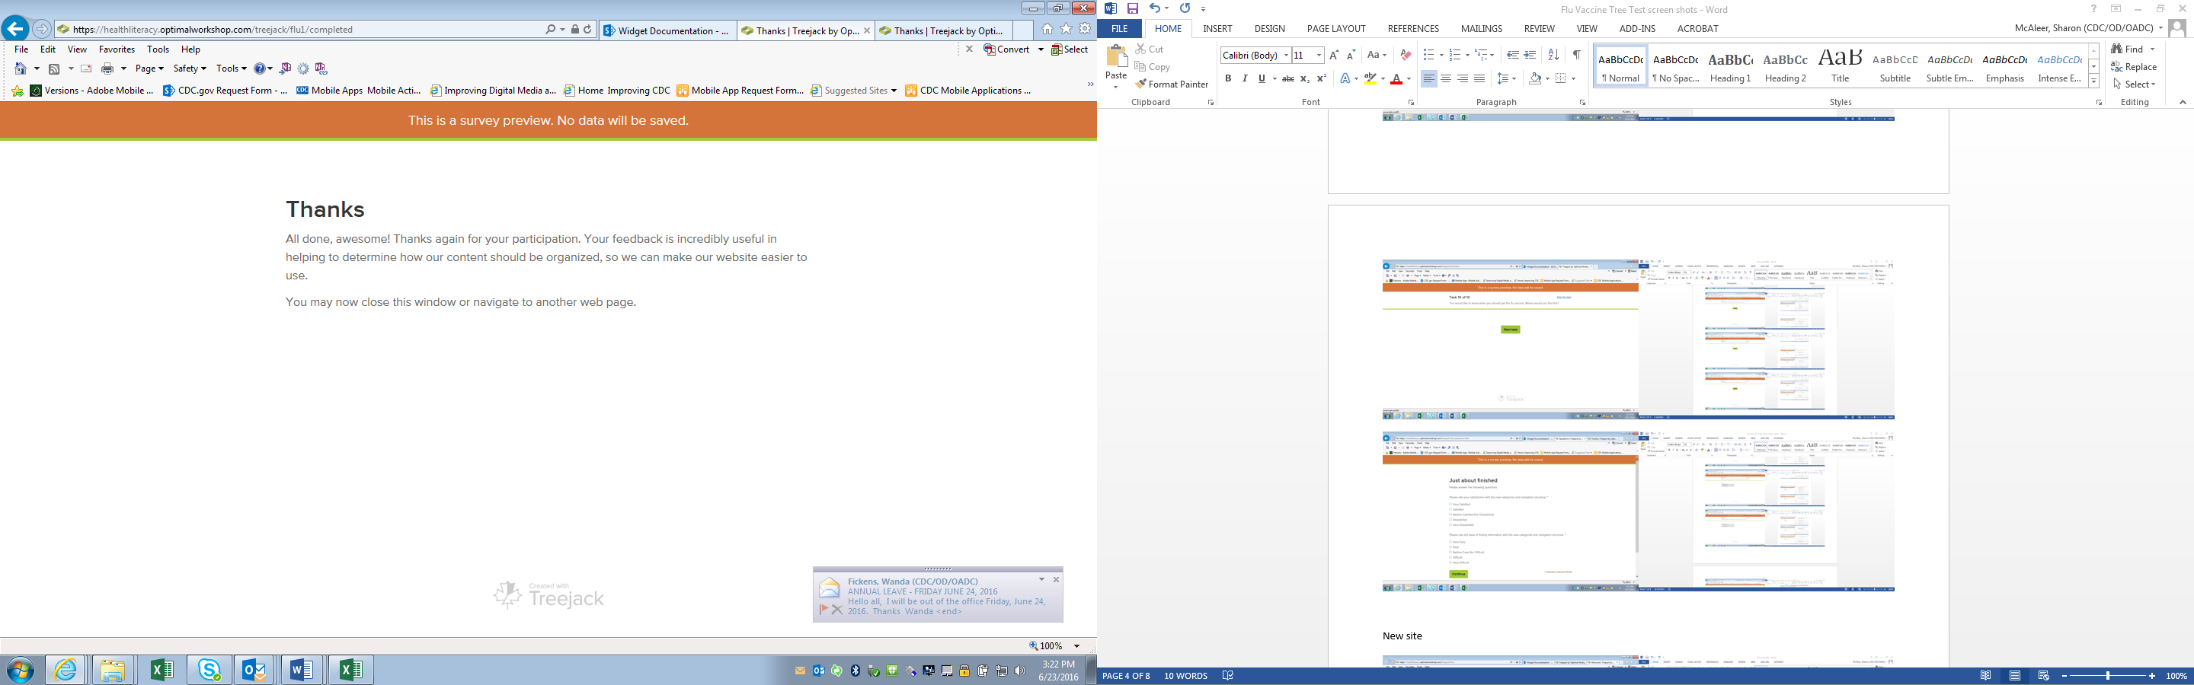

# New site

