Attachment C

Survey Plan: CDC Page Info Tab

**Customer Satisfaction Survey on CDC’s Page Info Tab**

The Page Info Tab tool, is visible on CDC web pages on the **development server** <https://wwwdev.cdc.gov> (see upper left corner of the page). It is available to anyone inside CDC’s firewall (contractors and FTEs). It is NOT available outside the firewall or the public.   
  
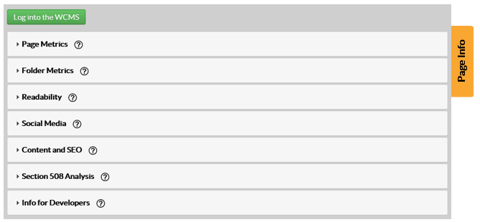

**Goals of the Survey**

* Evaluate the use and effectiveness of a new web metrics tool, the Page Info Tab.
* Use the results of the survey to inform improvements of the Page Info Tab tool, making it easier to use and understand.

**Participants**

This is a voluntary survey, conducted via a web link. A request to complete the survey will be emailed to CDC’s Web Managers and Developers List. The list has 436 total members (215 contractors, 221 FTEs). We anticipate about a 15% completion rate, or about 65 respondents. The survey will be open for two weeks.

**Instructions**

The survey contains 11 questions total. Seven questions are multiple choice and are mandatory. Four questions are open-ended, and are optional (see **Attachment D: Survey).**