Flu Vaccine Tree Test screen shots

Old site


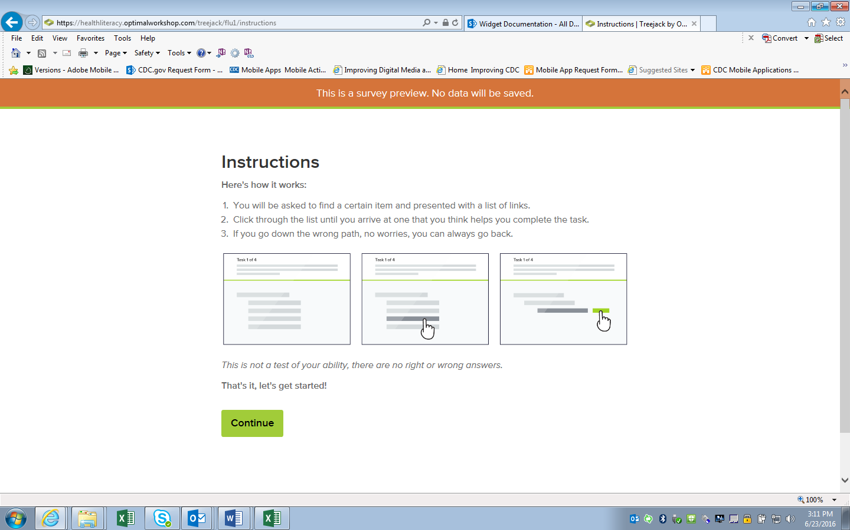
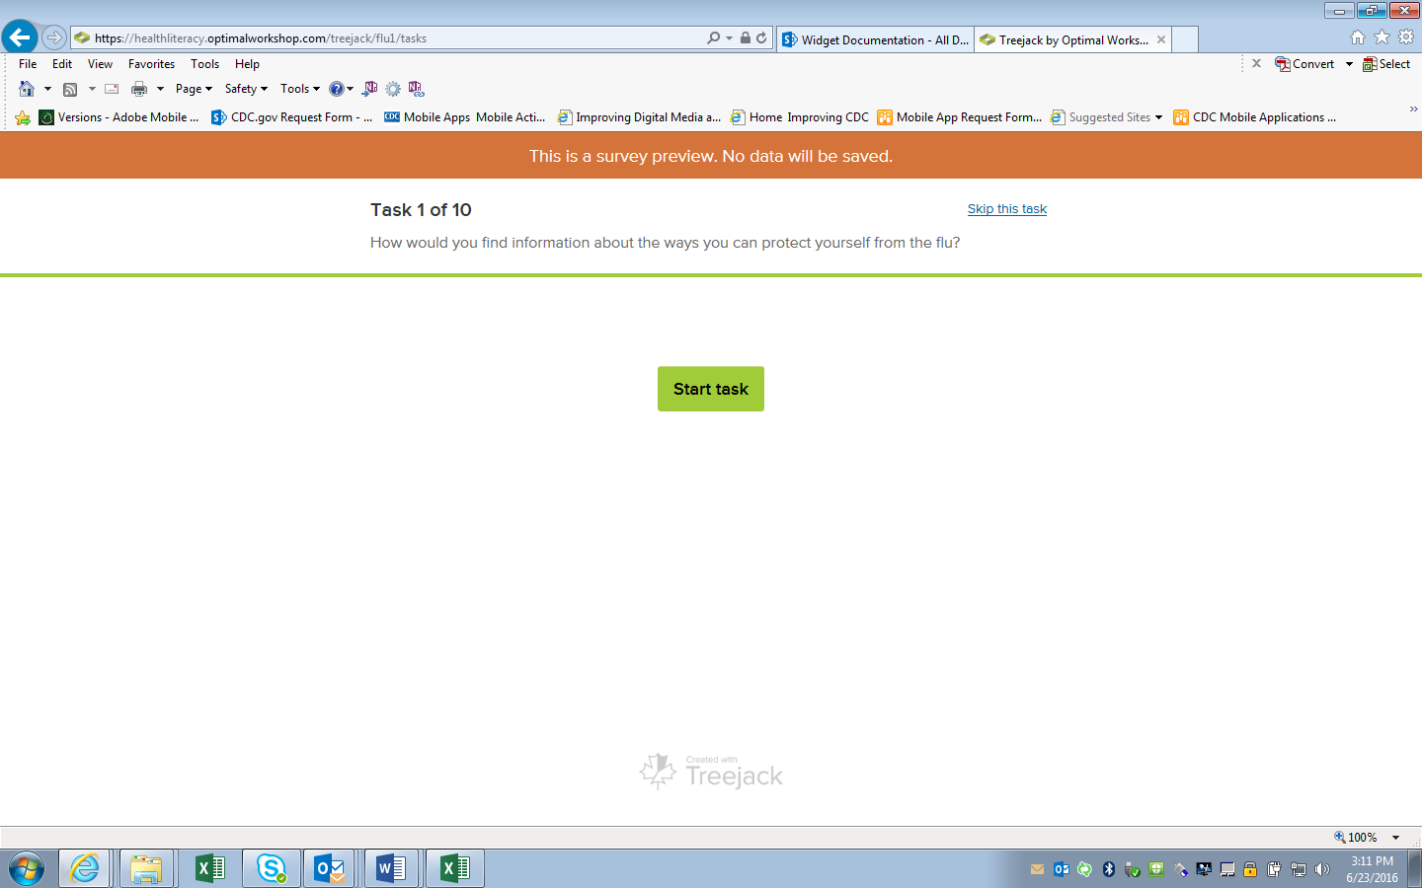
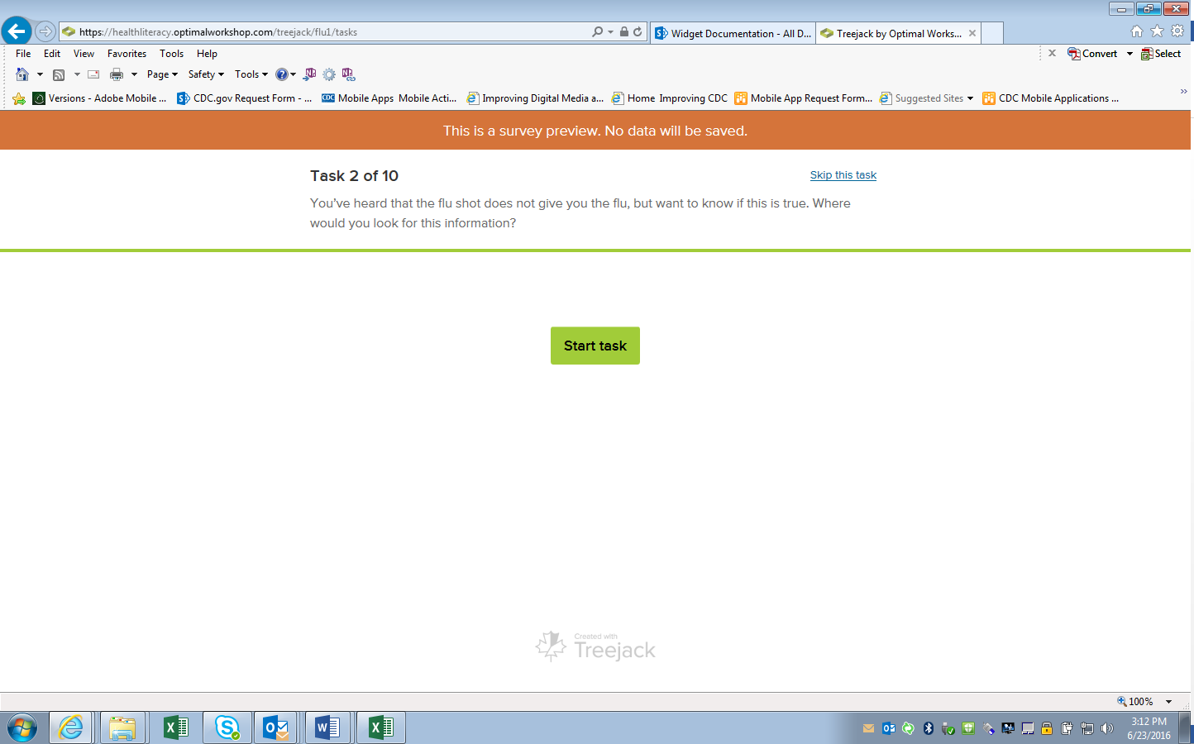
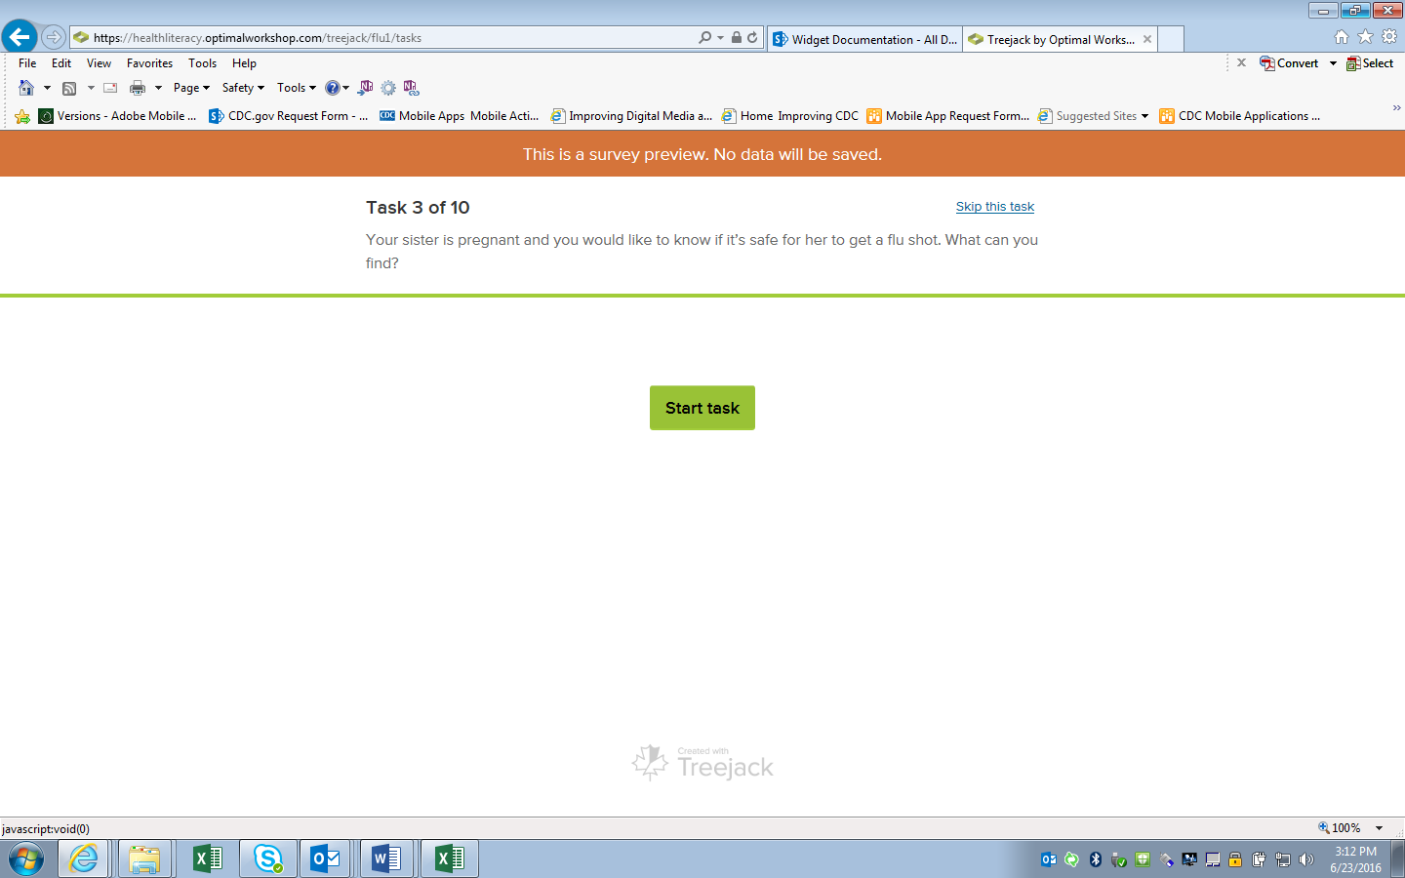
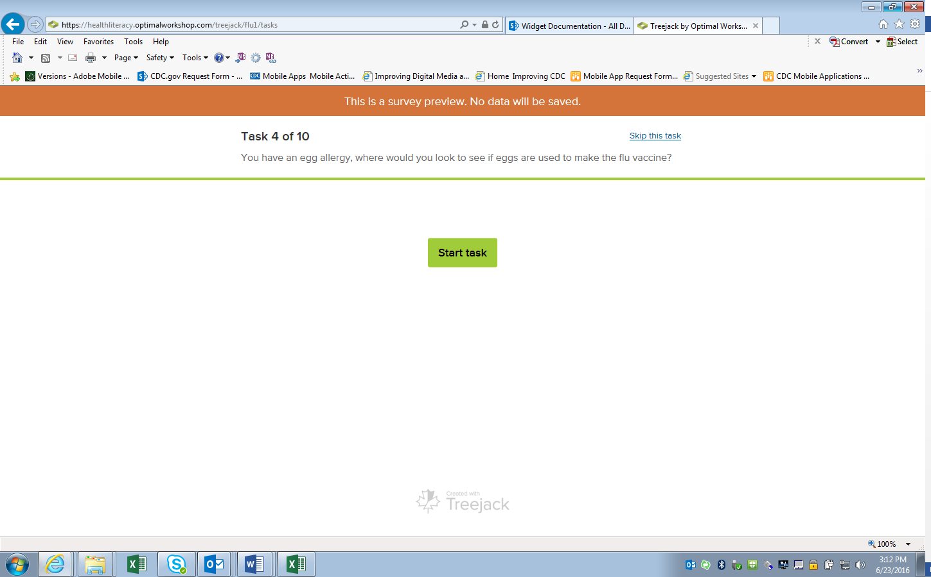
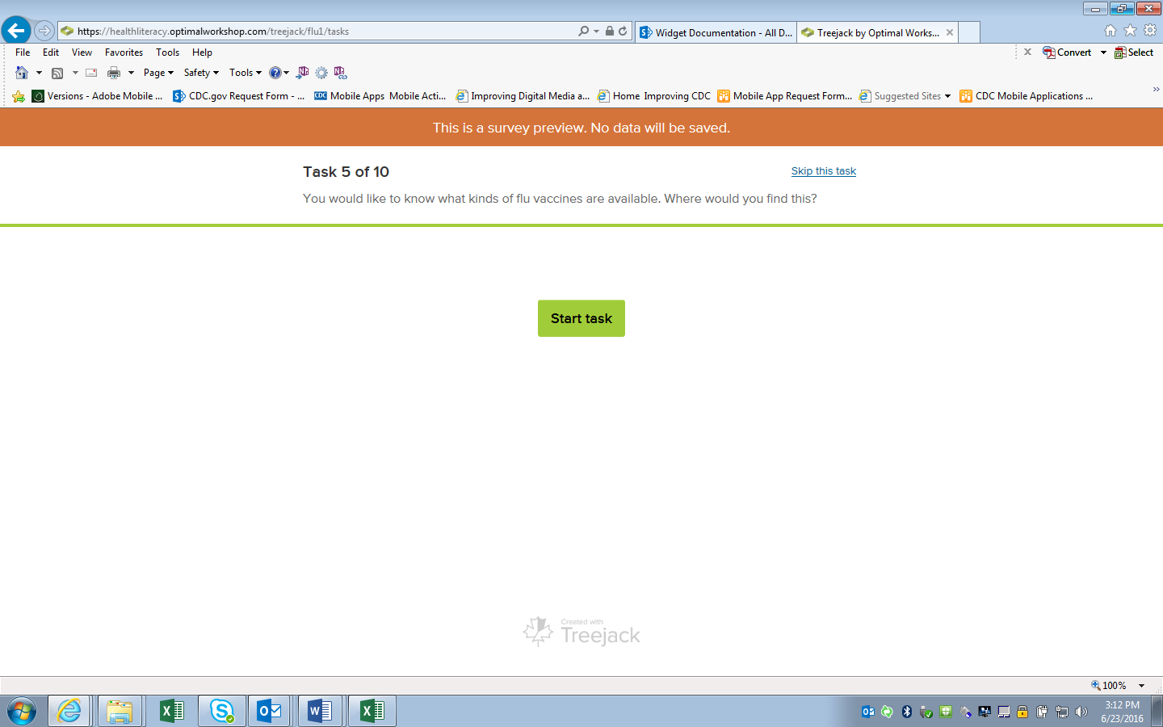
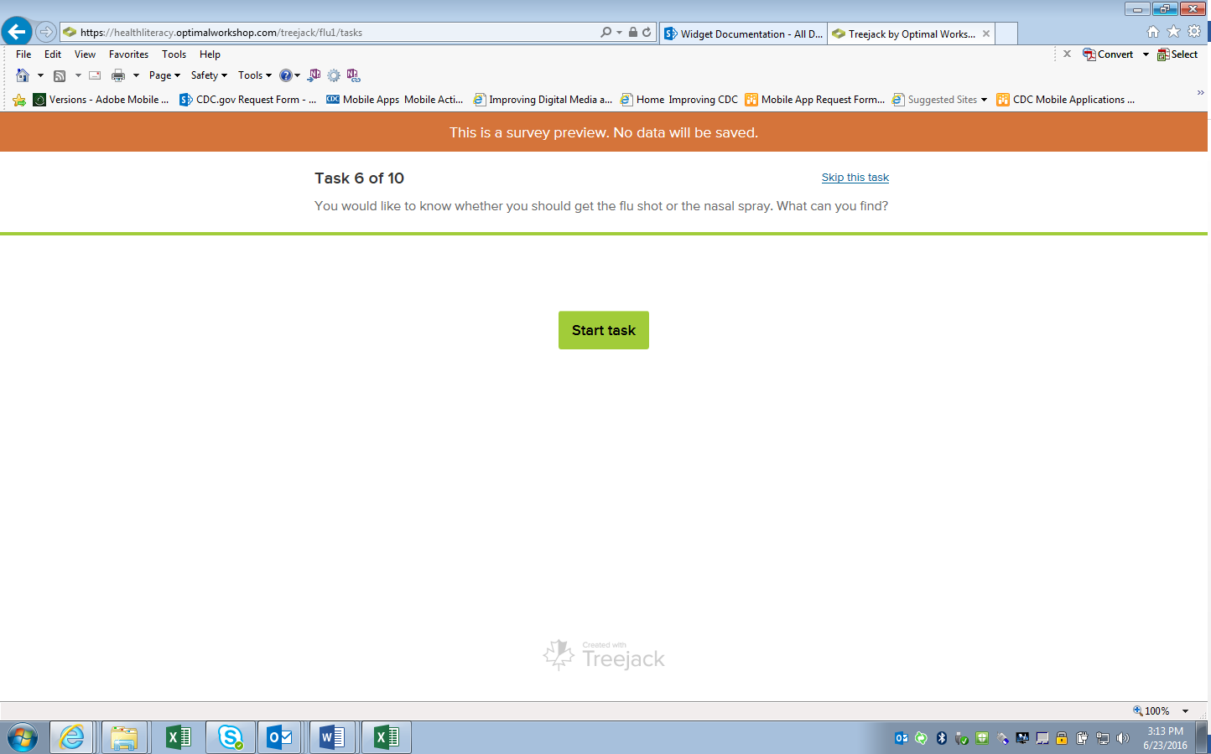
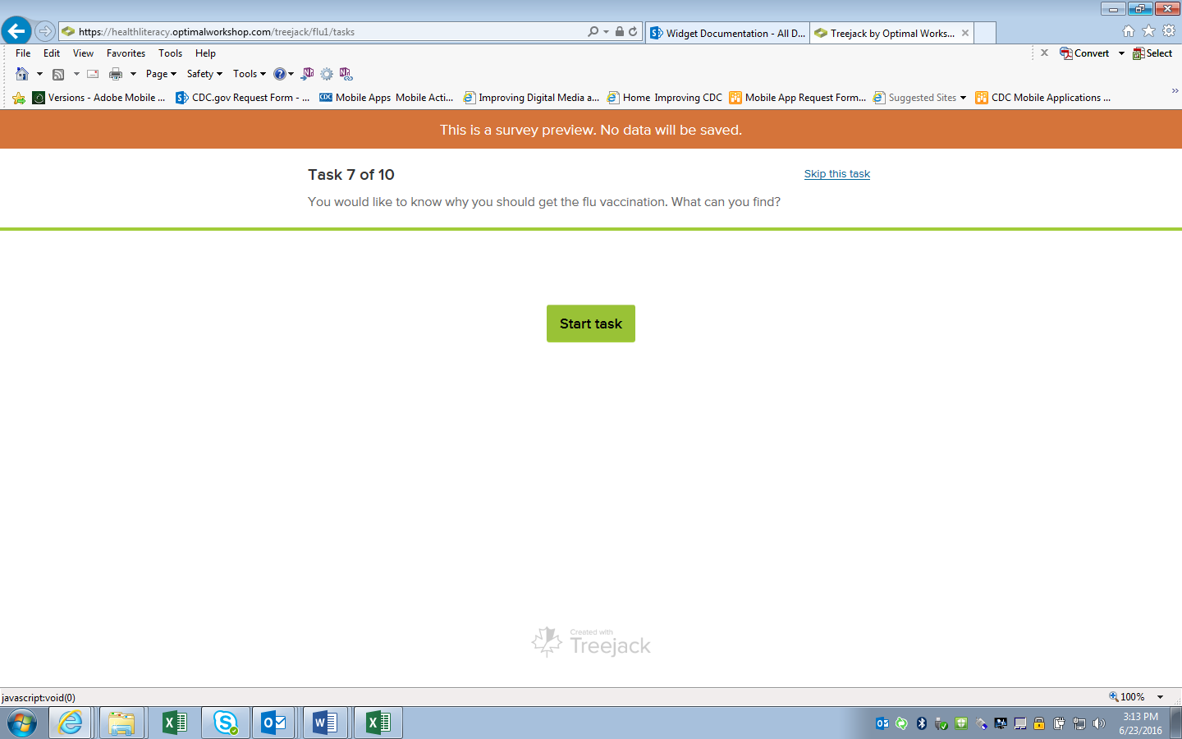
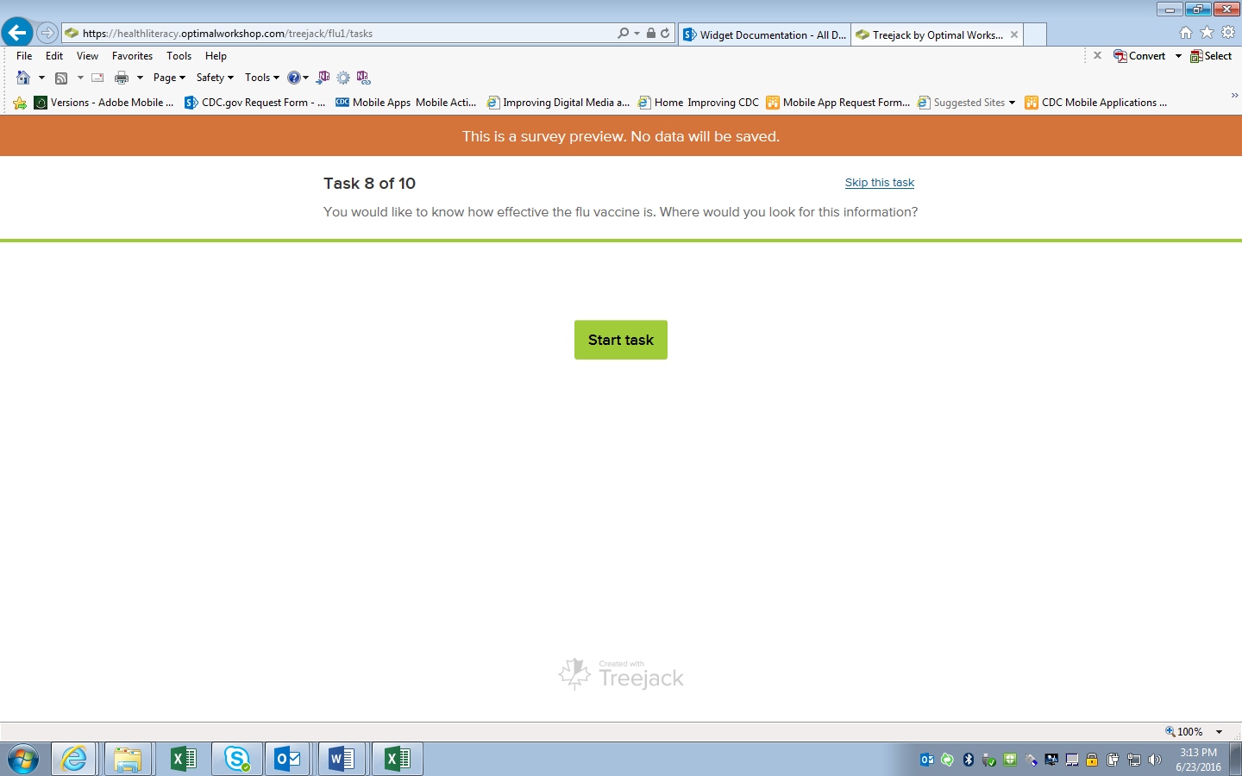
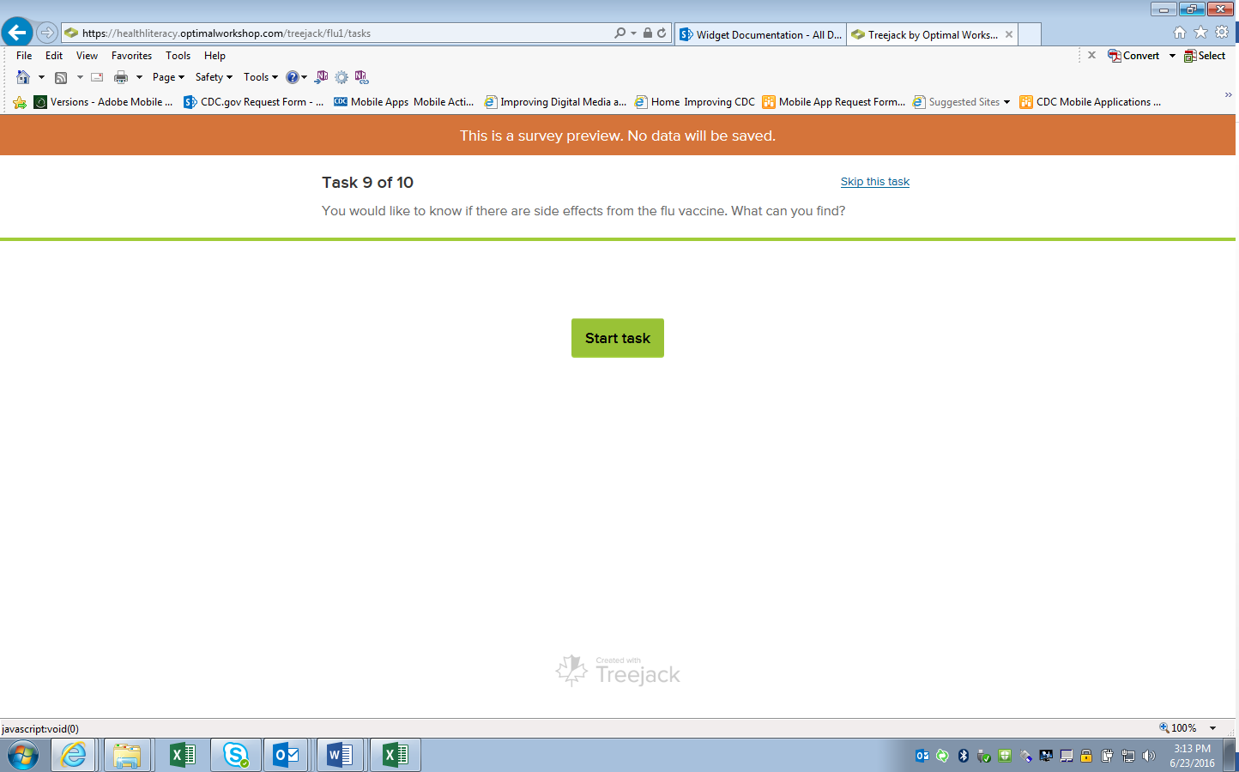
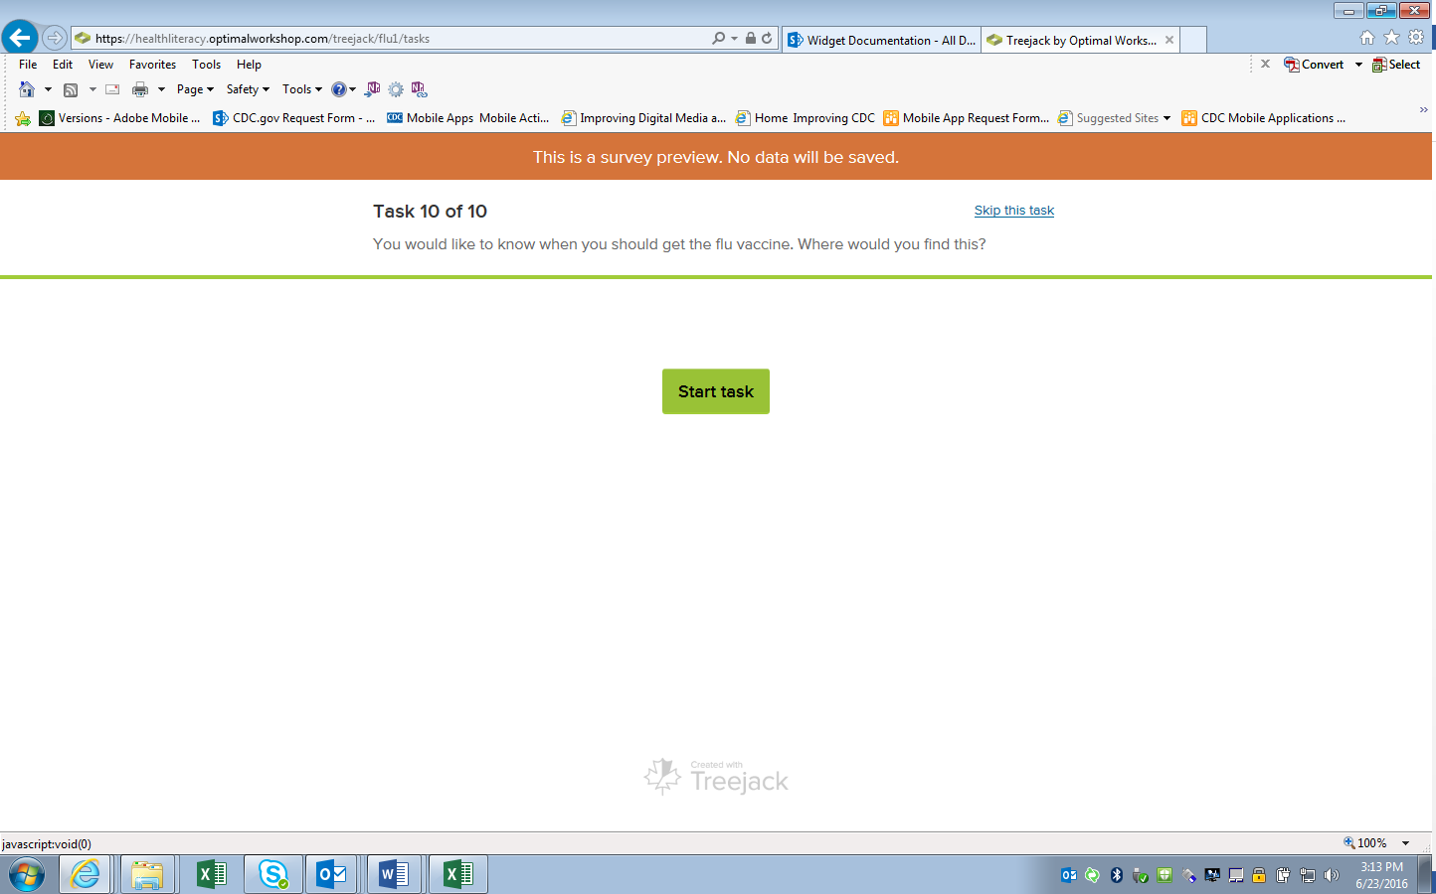
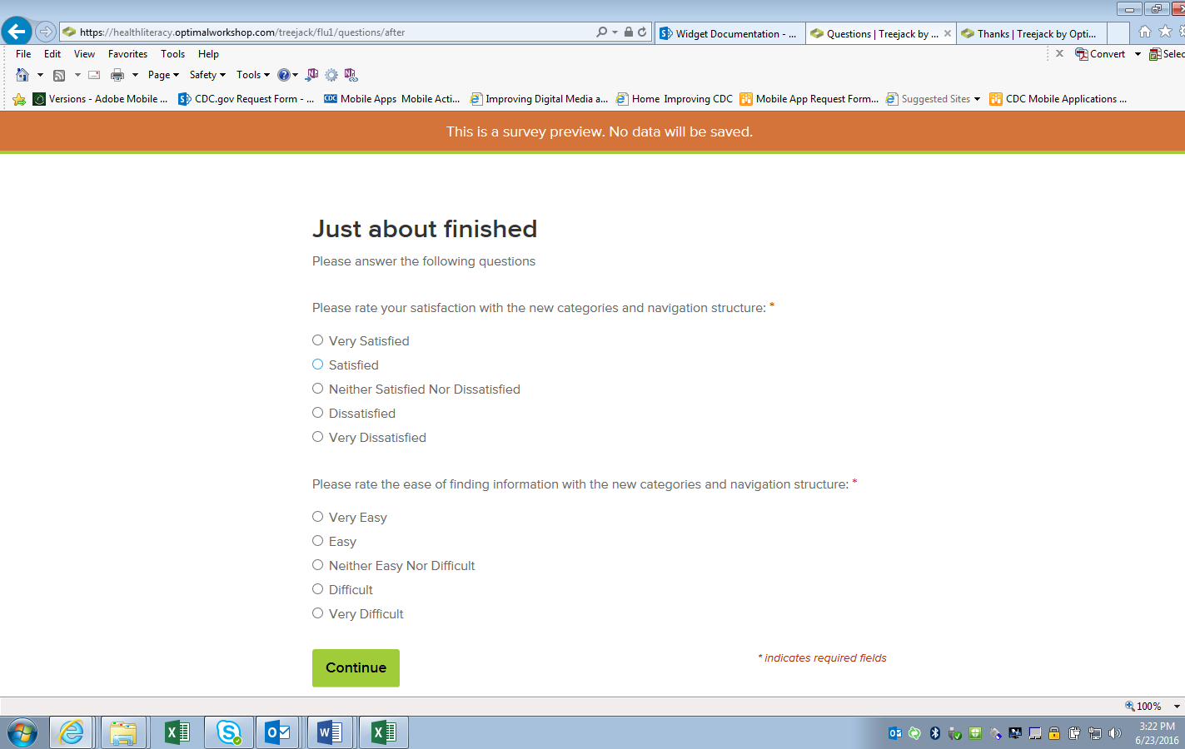
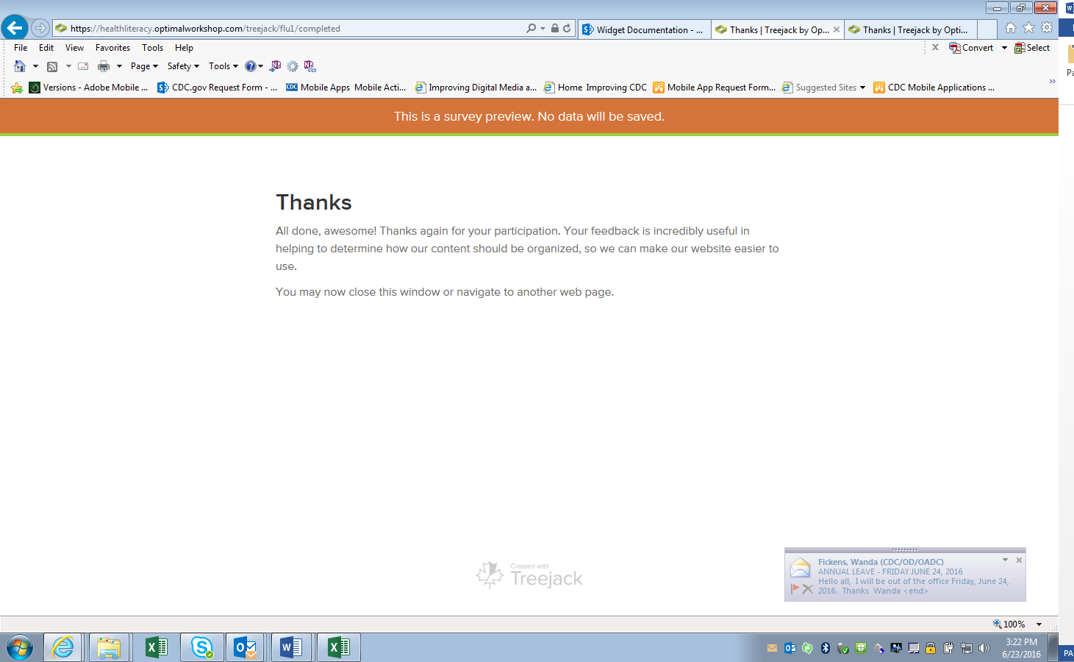

New site

