Attachment C
Survey Plan: CDC Page Info Tab
Customer Satisfaction Survey on CDC’s Page Info Tab
The Page Info Tab tool, is visible on CDC web pages on the development server https://wwwdev.cdc.gov (see upper left corner of the page). It is available to anyone inside CDC’s firewall (contractors and FTEs). It is NOT available outside the firewall or the public.
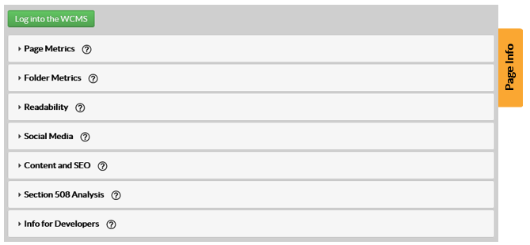
Goals of the Survey
- Evaluate the use and effectiveness of a new web metrics tool, the Page Info Tab.
- Use the results of the survey to inform improvements of the Page Info Tab tool, making it easier to use and understand.
Participants
This is a voluntary survey, conducted via a web link. A request to complete the survey will be emailed to CDC’s Web Managers and Developers List. The list has 436 total members (215 contractors, 221 FTEs). We anticipate about a 15% completion rate, or about 65 respondents. The survey will be open for two weeks.
Instructions
The survey contains 11 questions total. Seven questions are multiple choice and are mandatory. Four questions are open-ended, and are optional (see Attachment D: Survey).

