NCI CTRP Attachment 3a

NCI CTRP Registration Workflow and Screen Shots
Step 1: User accesses the NCI Clinical Trials Reporting Program website at http://trials.nci.nih.gov – see screenshot, page 2
Step 2: User enters “Username” and “Password” – see screenshot, page 2
Step 3: User reviews NCI Clinical Trials Reporting Program burden statement – see screenshot, page 3
Step 4: System displays “Search Submitted Clinical Trials” page – see screenshot, page 4
Step 5: User selects to perform “Initial Trial Registration” and completes initial registration – see screenshots, pages 5 - 7
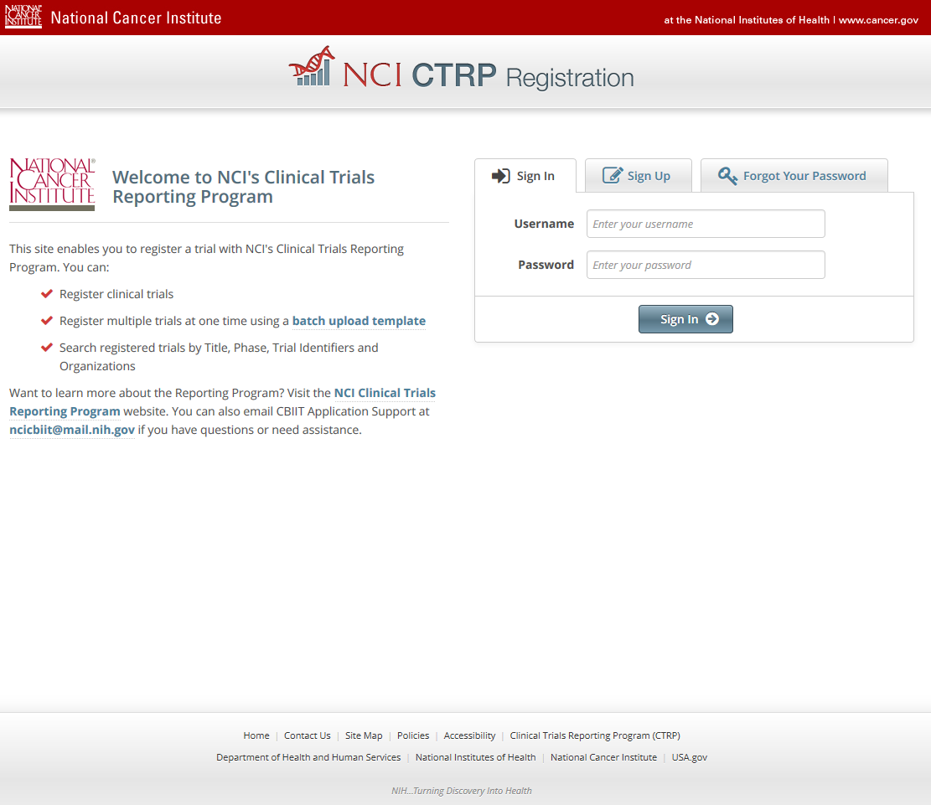
CTRP Home and Login page
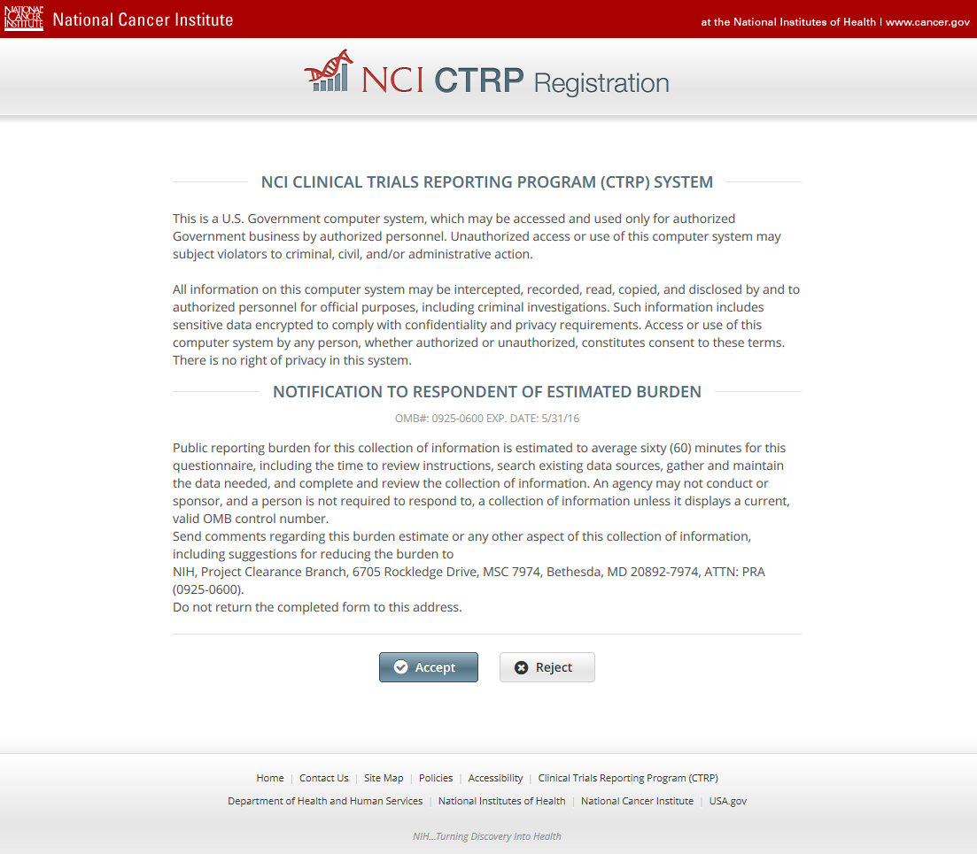
CTRP Burden Statement
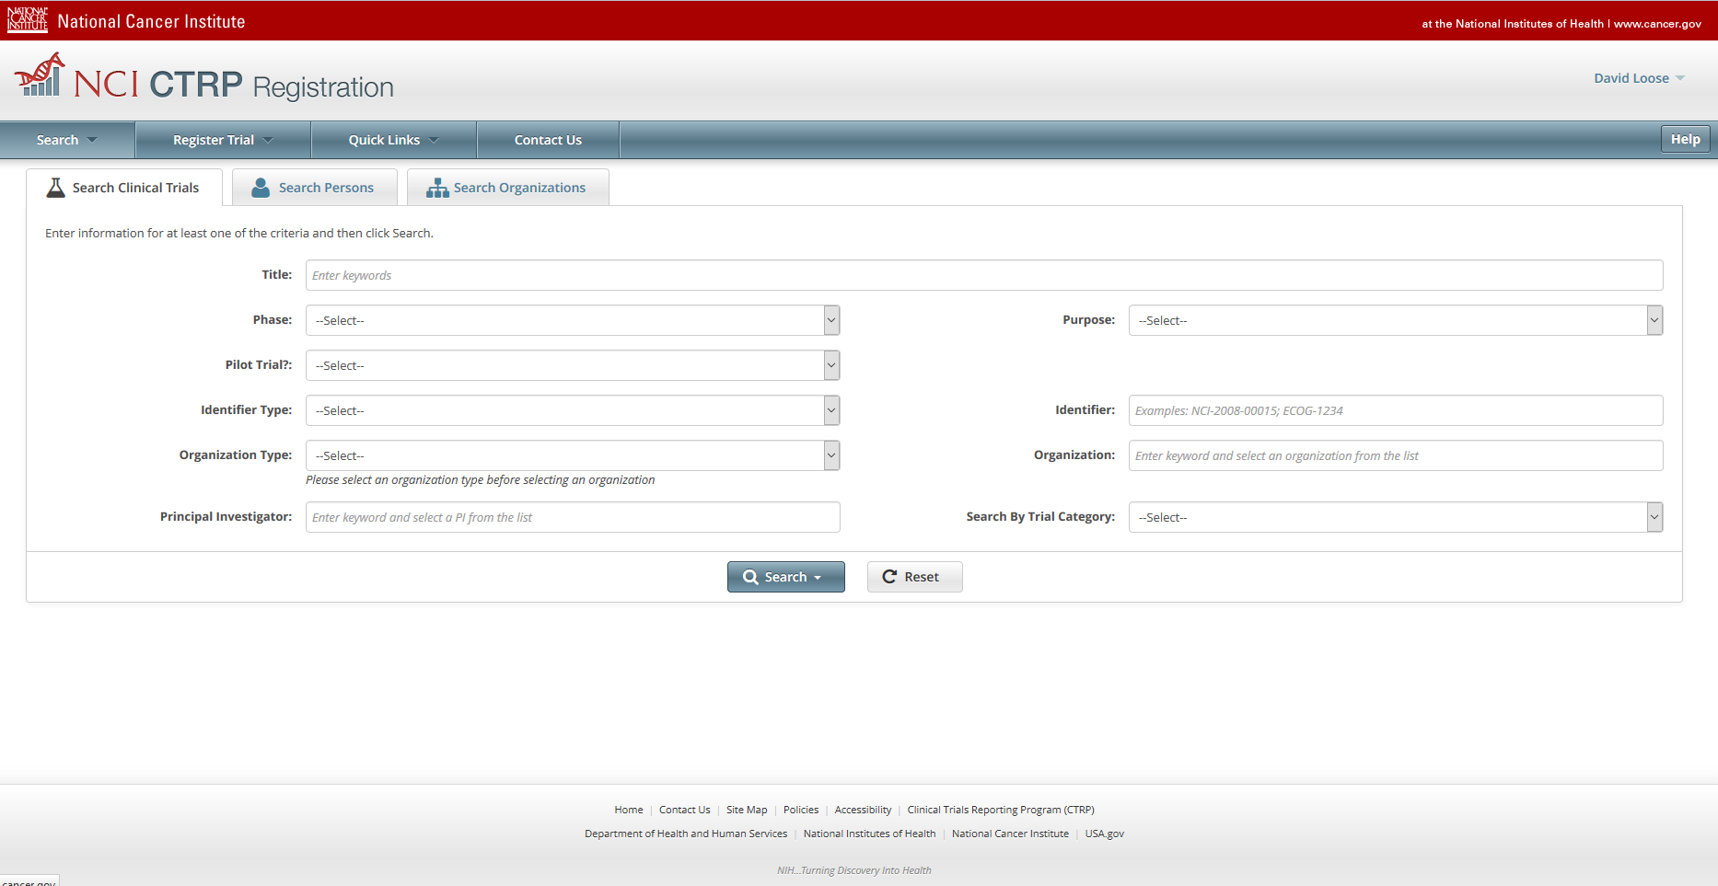
Search Submitted Clinical Trials
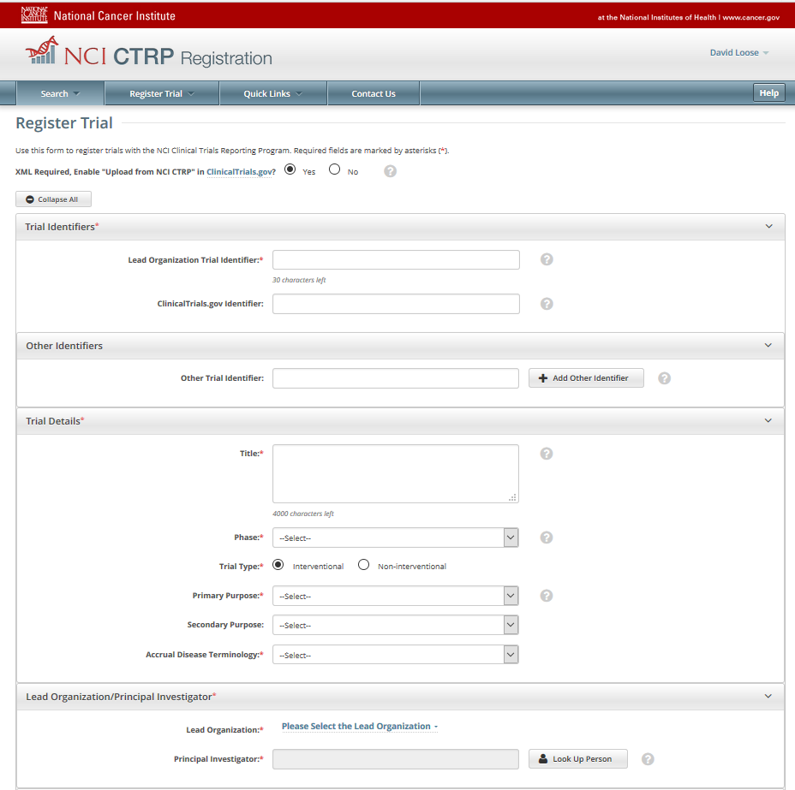
Initial Trial Registration
