NCI CTRP Attachment 3b

NCI CTRP Update Workflow and Screen Shots

Step 1: User accesses the NCI Clinical Trials Reporting Program website at http://trials.nci.nih.gov – see screenshot, page 2

Step 2: User enters “Username” and “Password” – see screenshot, page 2

Step 3: User reviews NCI Clinical Trials Reporting Program burden statement – see screenshot, page 3

Step 4: System displays “Search Submitted Clinical Trials” page – see screenshot, page 4

Step 5: User selects to “Update Trial” and updates an existing trial record – see screenshots, pages 5 - 8

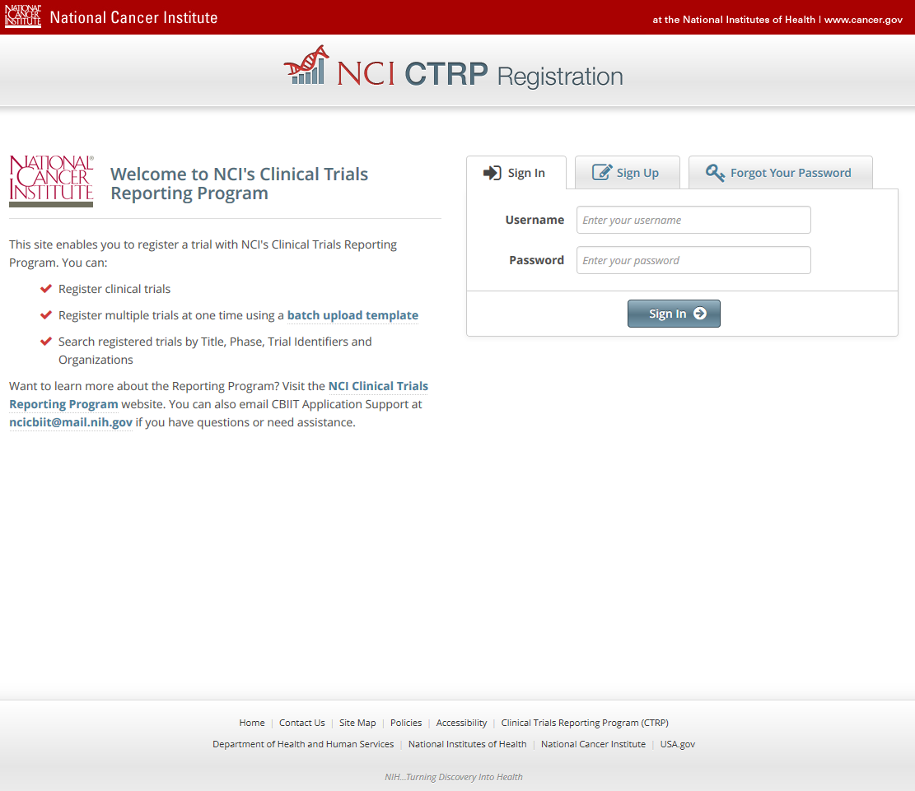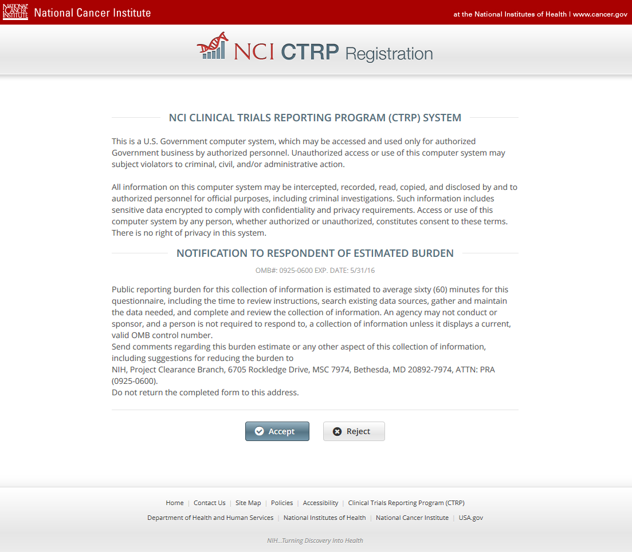

**CTRP Home and Login page**

**CTRP Burden Statement**

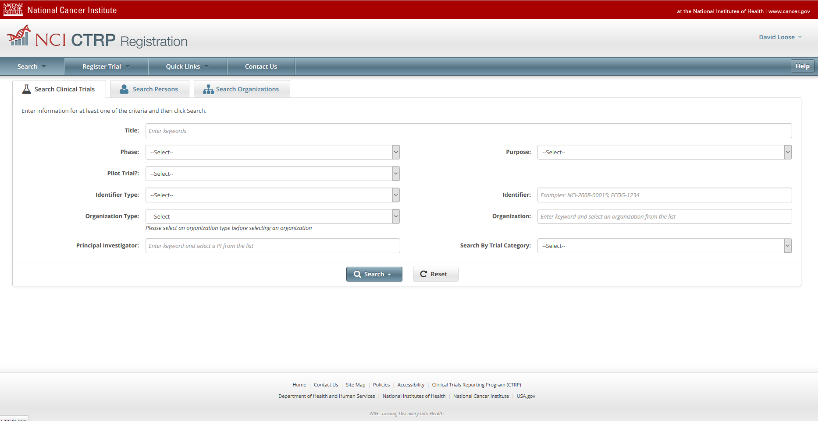

**Search Submitted Clinical Trials**

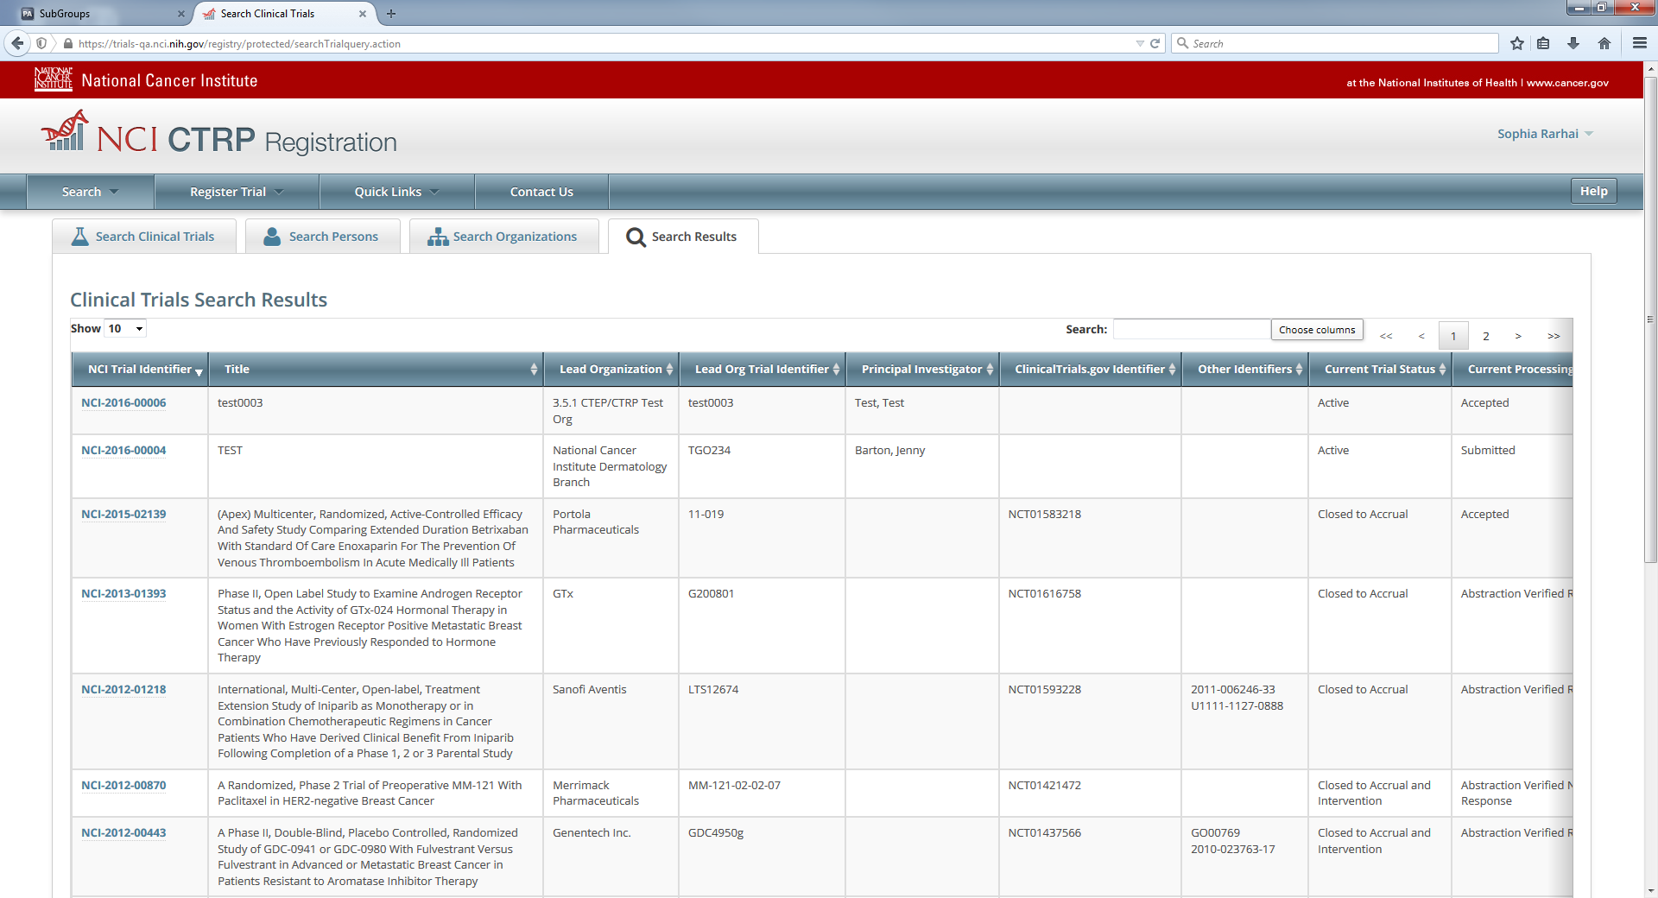

**Update Trial**

