NCI CTRP Attachment 3d

NCI CTRP Accrual Portal Workflow and Screen Shots
Step 1: User accesses the NCI Clinical Trials Reporting Program Accrual website at http://trials.nci.nih.gov/accrual – see screenshot, page 2
Step 2: User enters “Username” and “Password” – see screenshot, page 2
Step 3: User reviews NCI Clinical Trials Reporting Program Accrual burden statement – see screenshot, page 3
Step 4: User selects to “Submit Study Subject Accrual Information” and submits subject level accrual information on a registered trial – see screenshots, pages 4 - 6
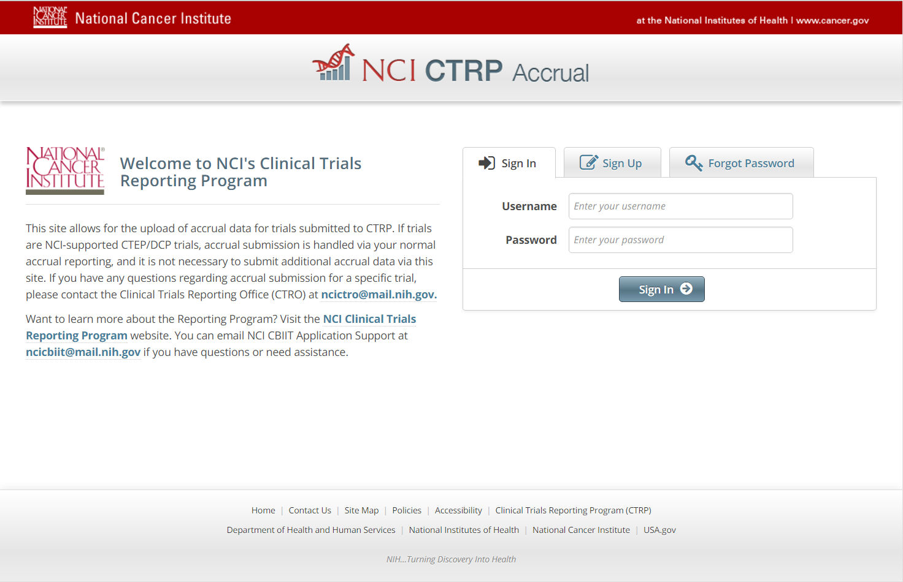
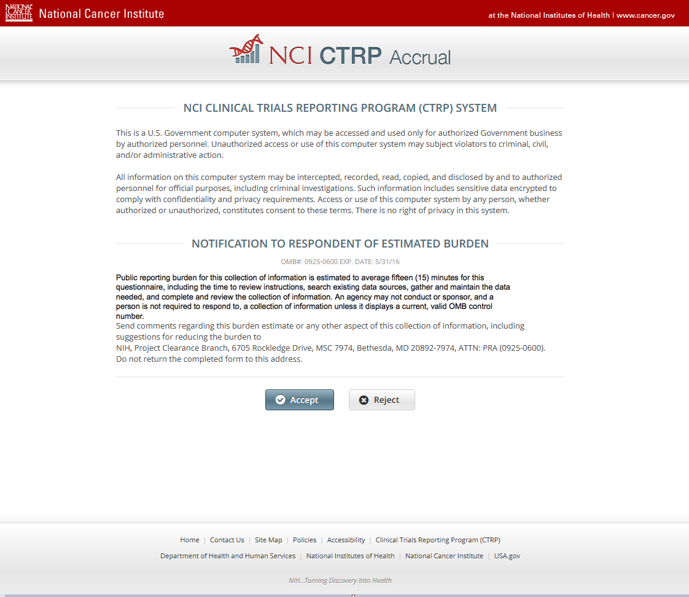
CTRP Accrual Burden Statement
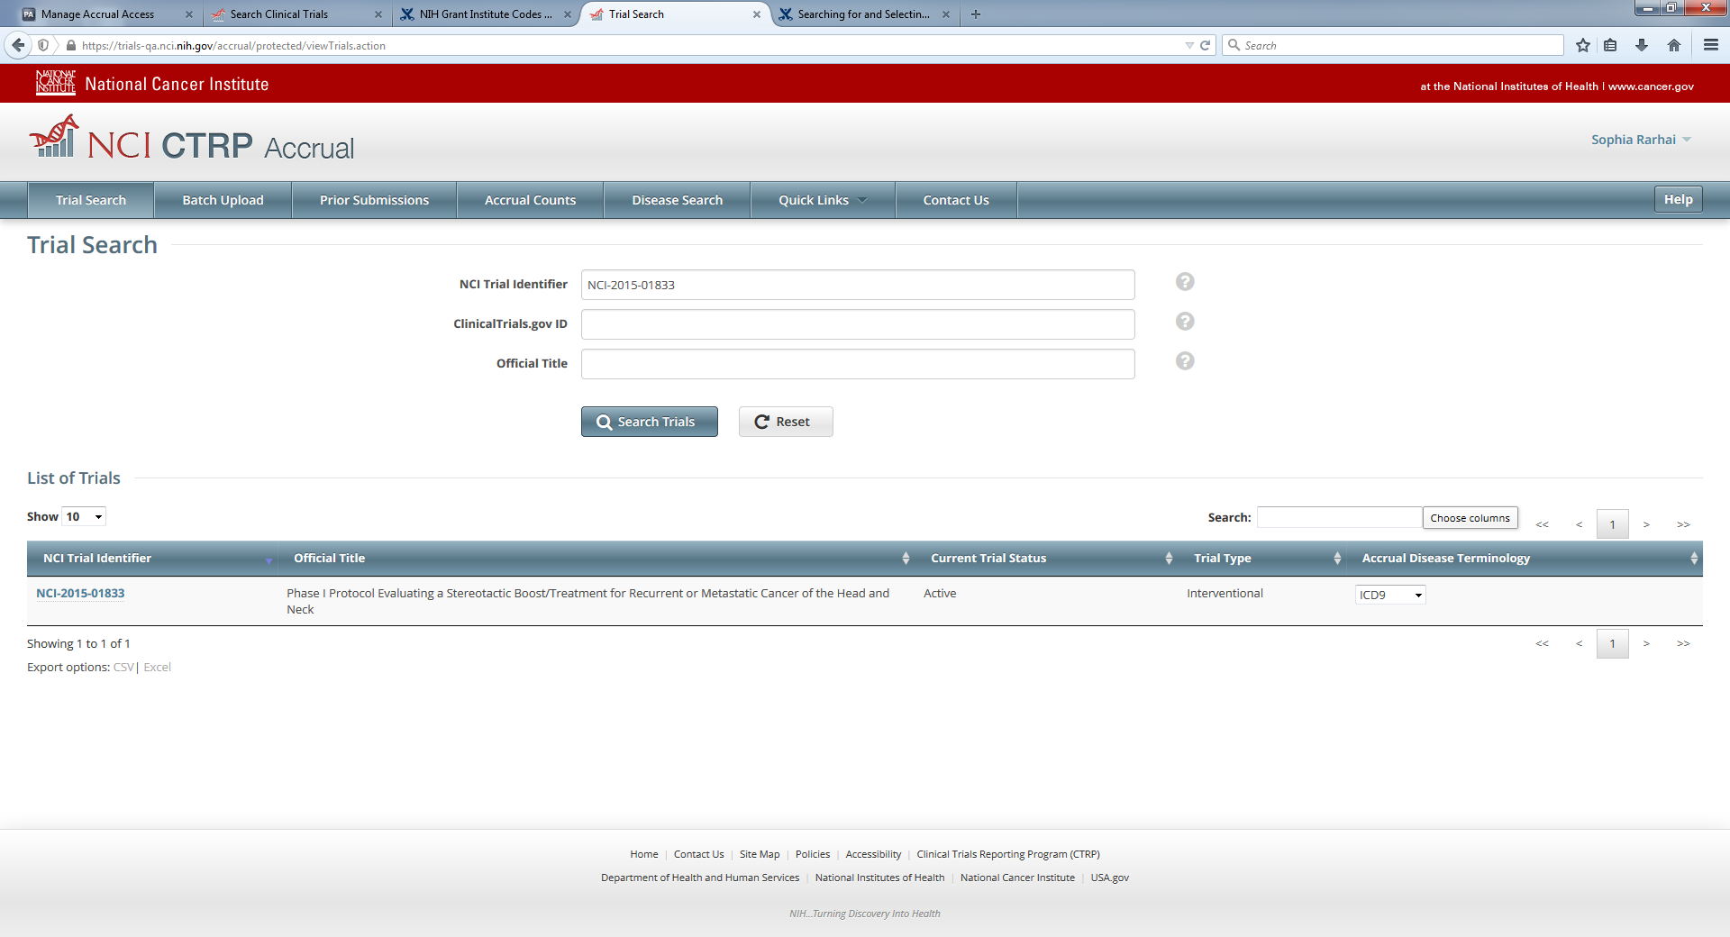
Submit Study Subject Accrual Information

