NCI CTRP Attachment 3e

NCI CTRP Aggregate Accrual Portal Workflow and Screen Shots

Step 1: User accesses the NCI Clinical Trials Reporting Program Accrual website at http://trials.nci.nih.gov/accrual – see screenshot, page 2

Step 2: User enters “Username” and “Password” – see screenshot, page 2

Step 3: User reviews NCI Clinical Trials Reporting Program Accrual burden statement – see screenshot, page 3

Step 4: User selects to “Submit Aggregate Study Subject Accrual Information” and submits aggregate accrual information on a registered trial – see screenshot, pages 4 - 5

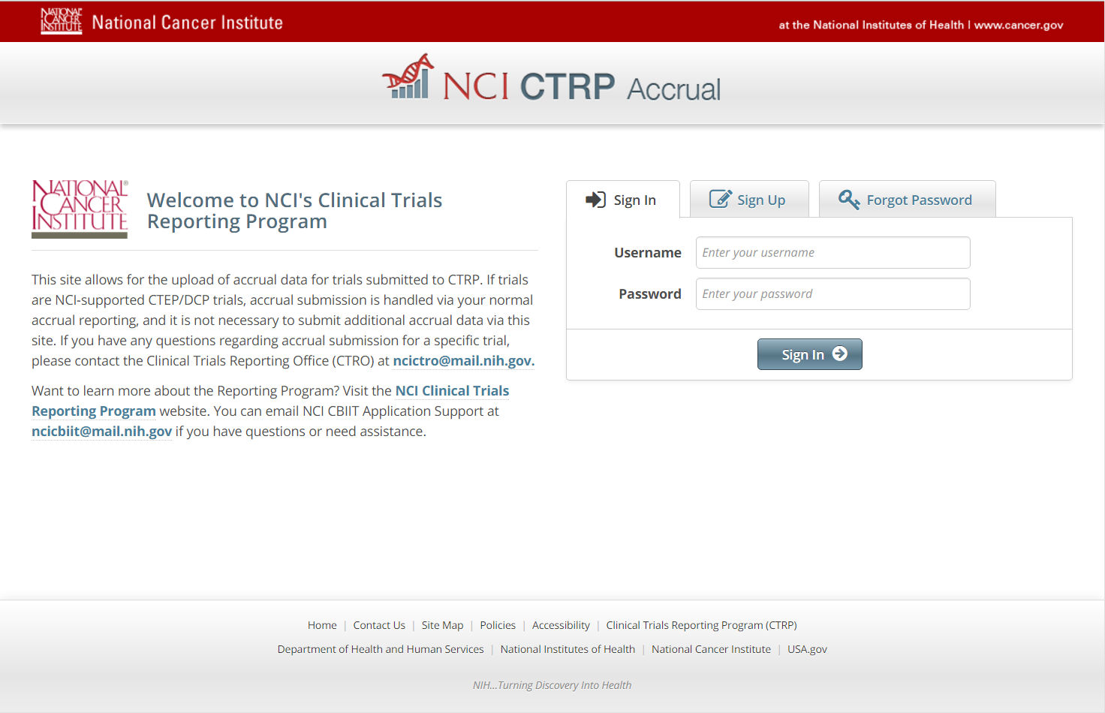

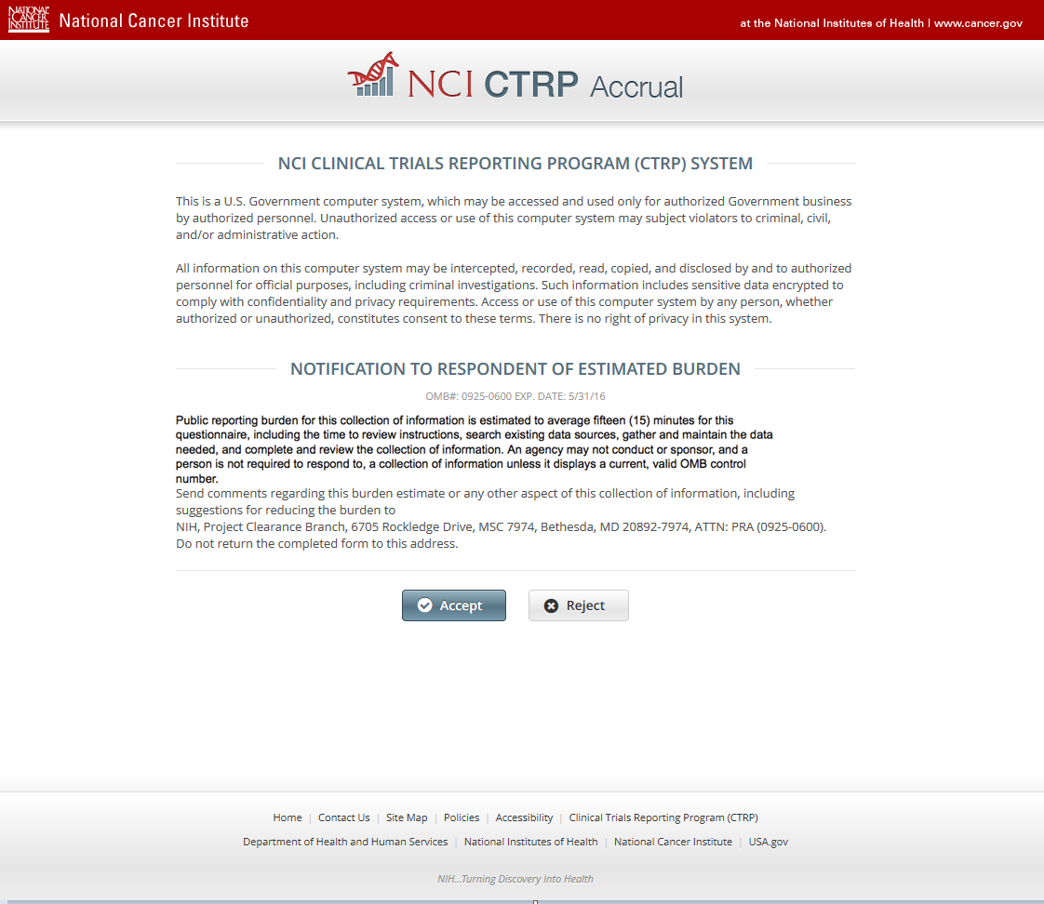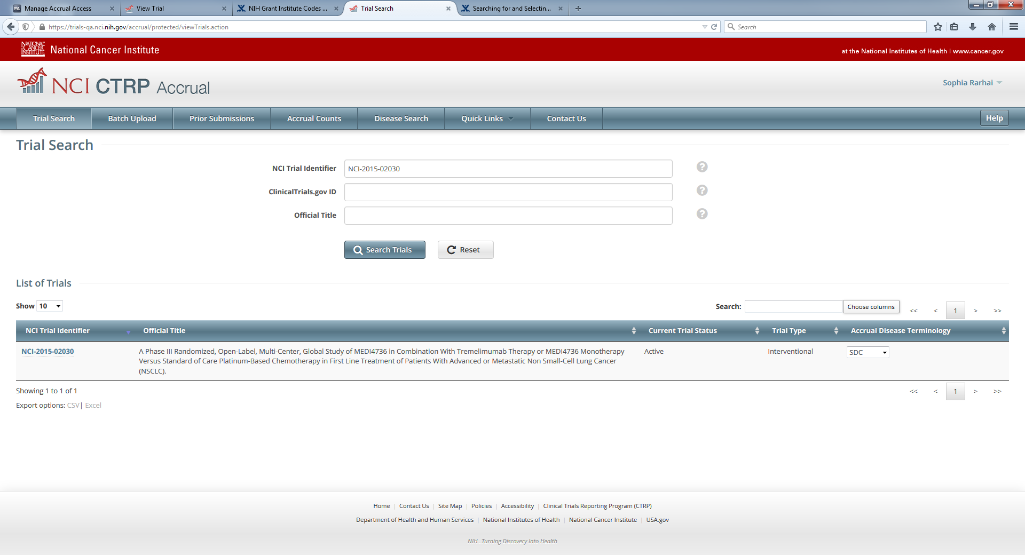

**CTRP Accrual Burden Statement**

**Submit Aggregate Study Subject Accrual Information**

