Intro
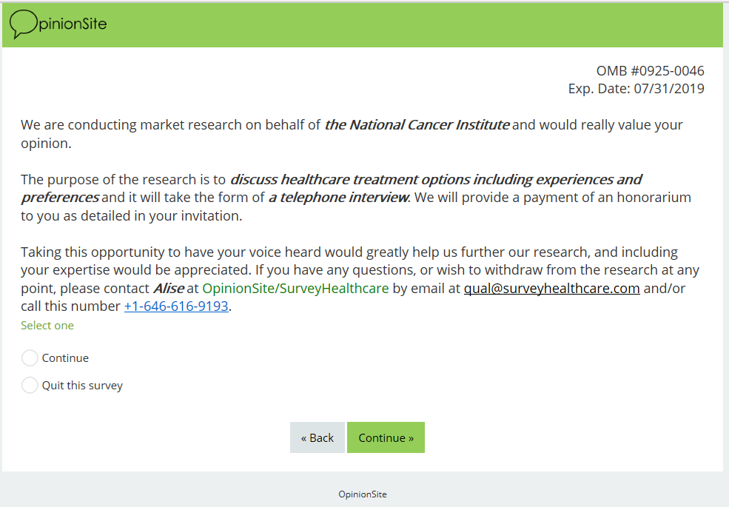

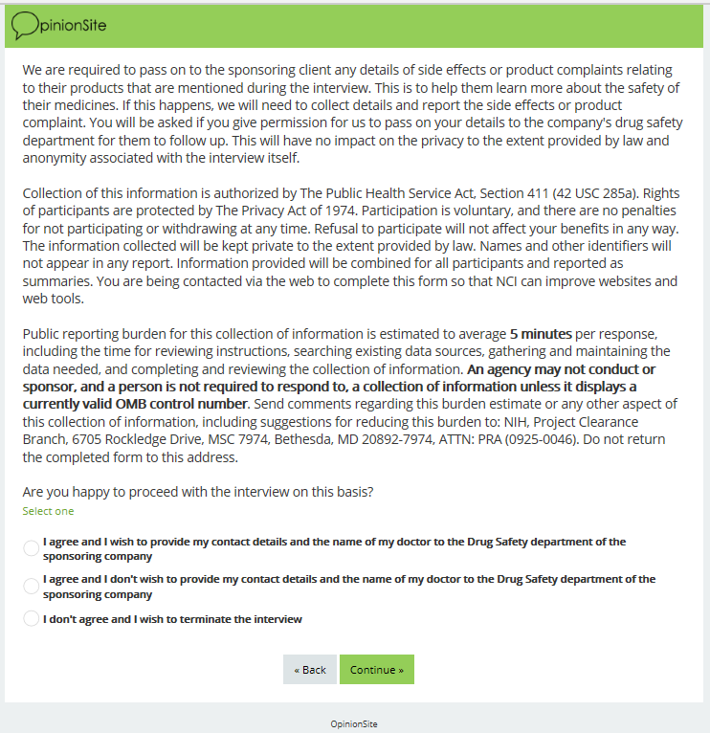
S1.
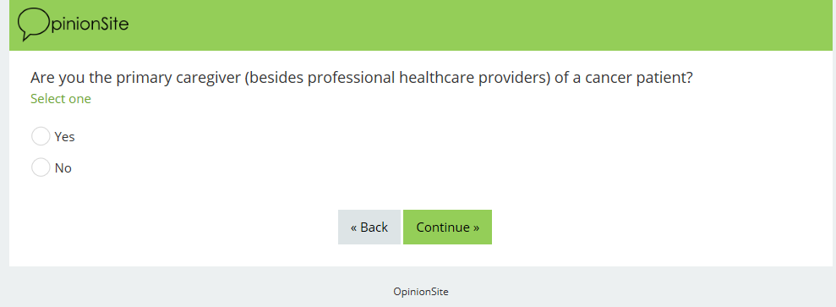

S2.
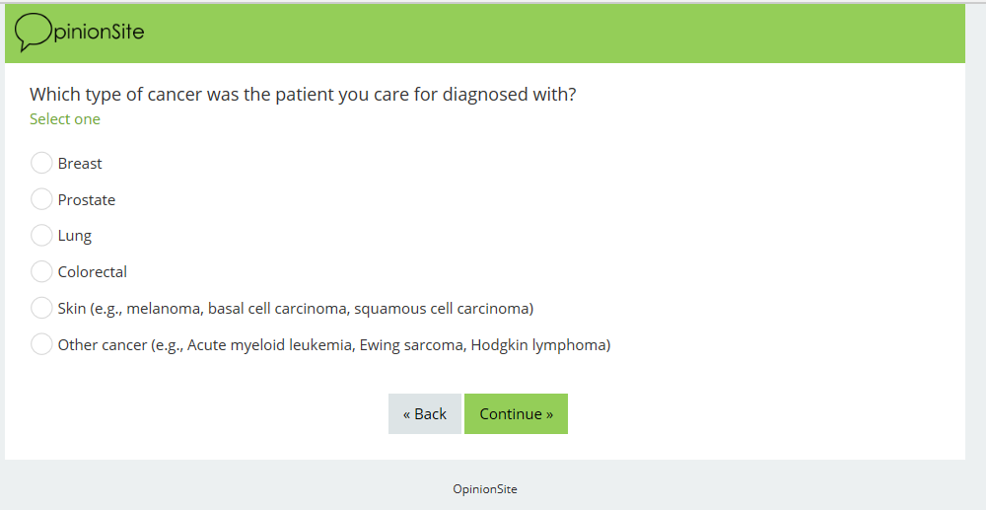
S3.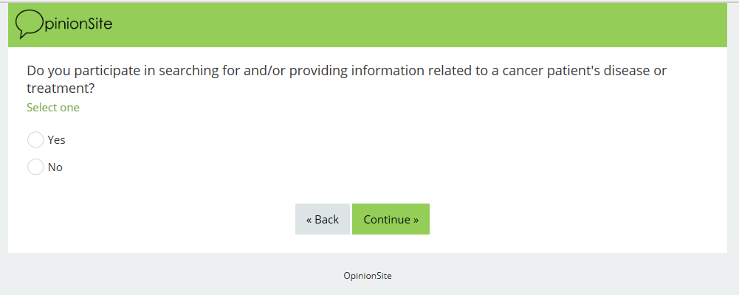
S4.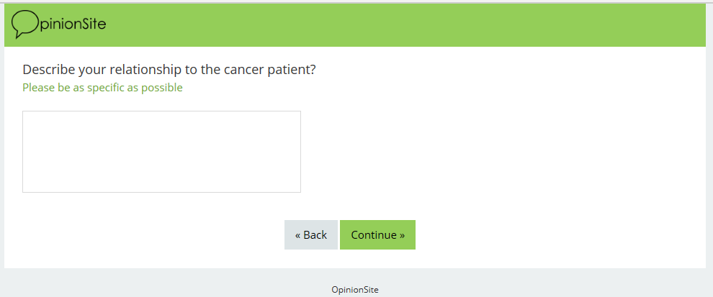

Invite
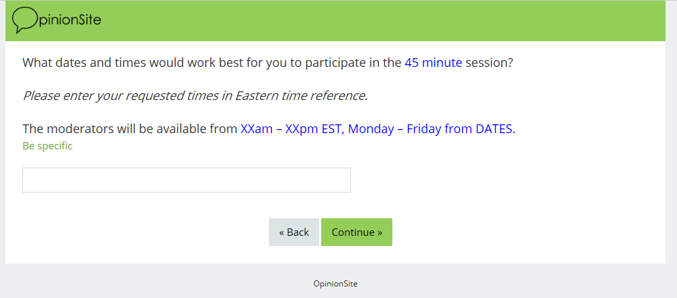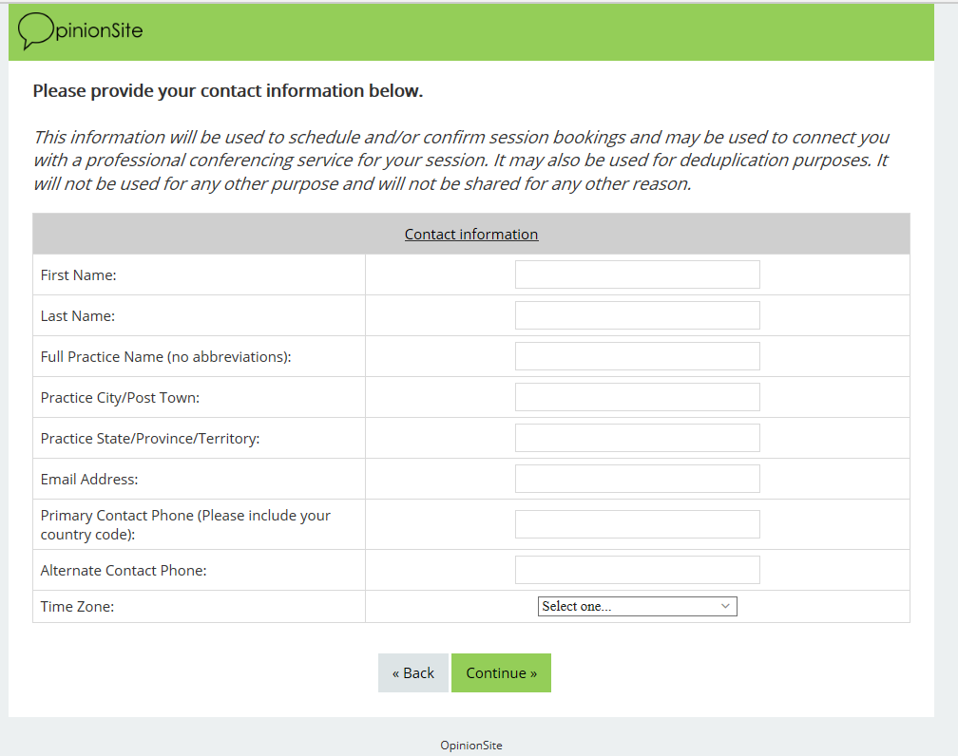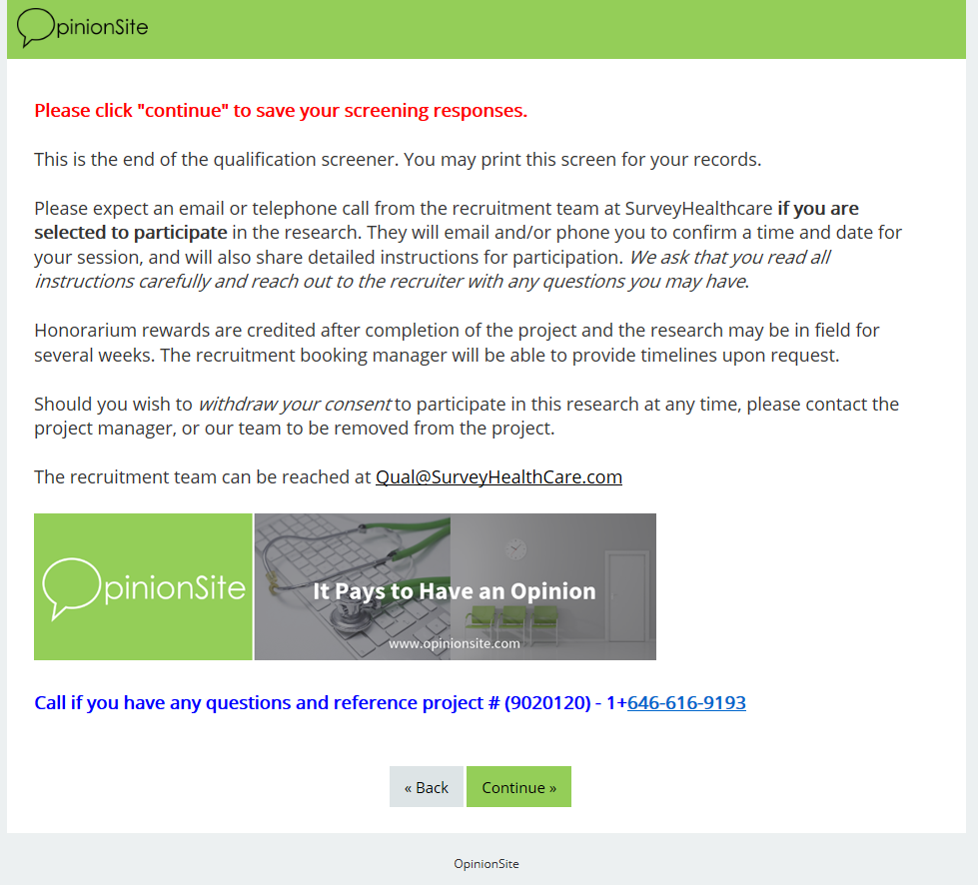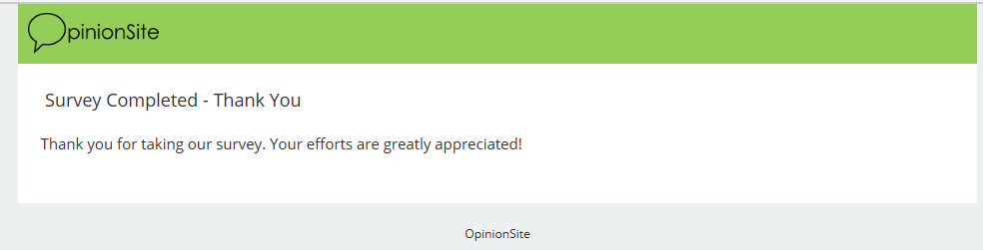

Terminates
Terminate #1: This screen is shown when a respondent terminates on a “hard spec”. Someone that does not qualify at all.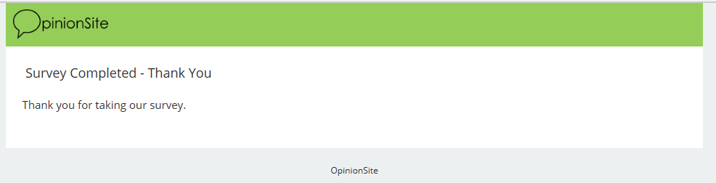

Terminate #2 (2 screens): These screens are shown at the end when a respondent terminates on a “soft spec”. The respondents continues through the survey and is shown this screen after their contact information has been collected. If criteria is loosened, we can contact and include these respondents as possible participants.
