**Attachment 1 – Application (OMB Statement on Home Page, Updated to 20 minutes per response)**

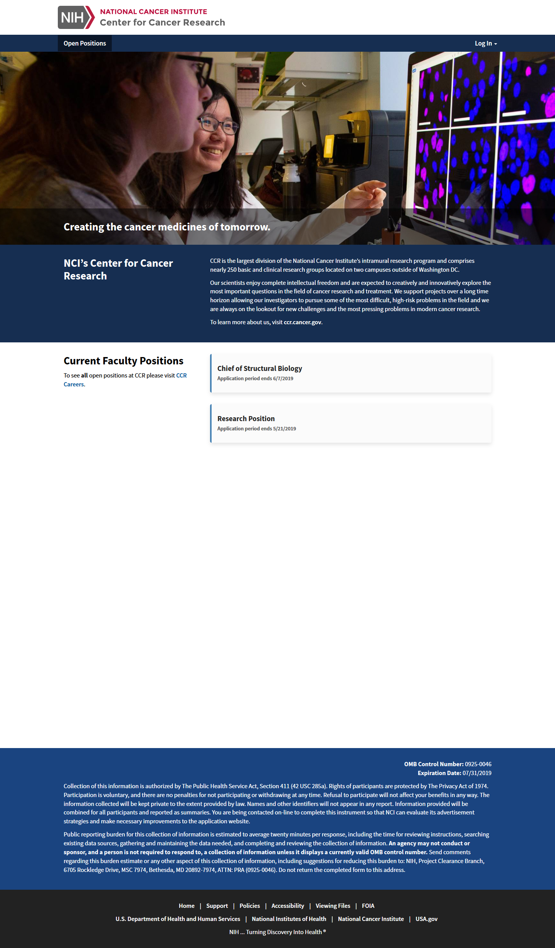

**OMB Statement on Position Description Page**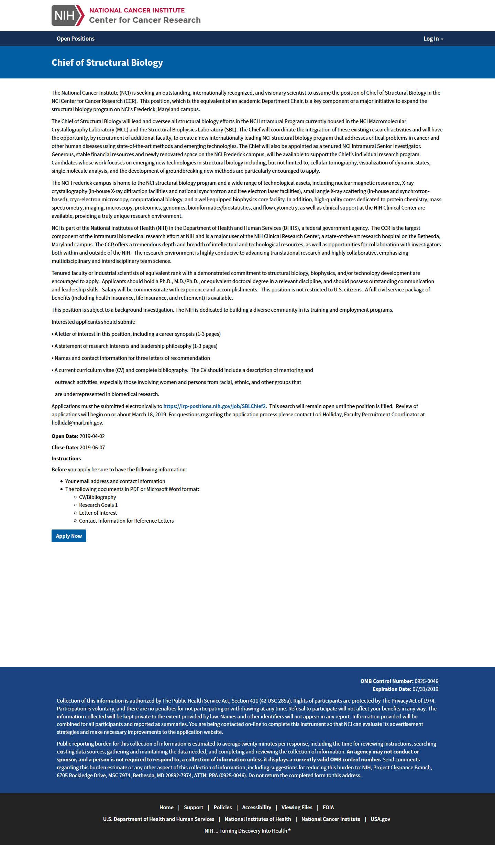

**OMB Statement on Application (updated to 20 minutes)**

