Attachment 1 – Application (OMB Statement on Home Page, Updated to 20 minutes per response)
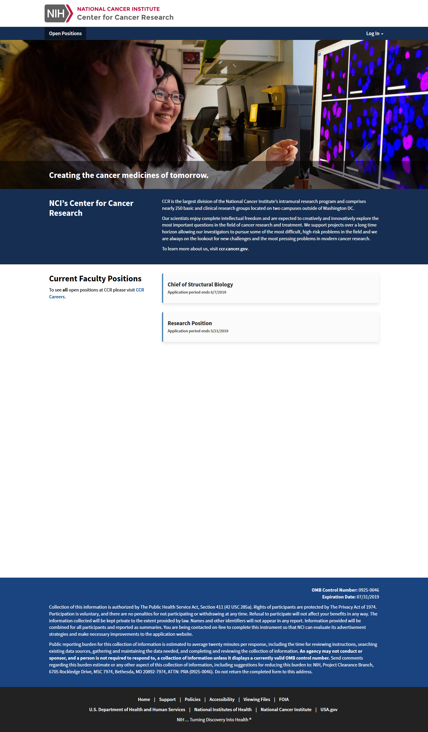

OMB Statement on Position Description Page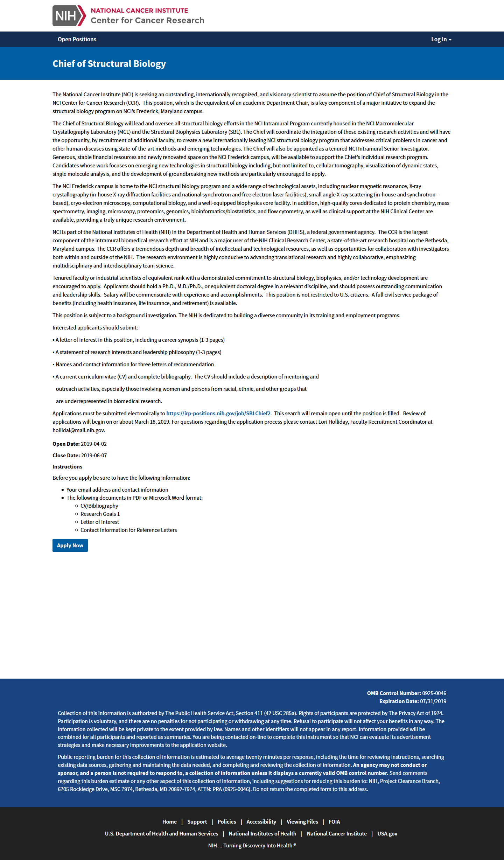

OMB Statement on Application (updated to 20 minutes)
