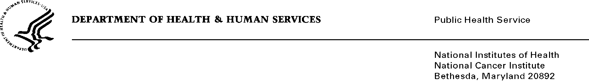
<<DATE>>>>
<<NAME>>
<<ADDRESS1>>
<<ADDRESS2>>
<<CITY, ST, ZIP>>

Dear Dr. _____________ ,

Last fall, the National Cancer Institute invited you to participate in a survey about genomic testing in cancer treatment. However, we did not receive a completed survey from you.

To help us understand why you did not complete this survey and how your experiences as an oncologist may compare to those who did, please take a few minutes to answer the 6 questions on the back of this letter. This information will help us put the study results in context and improve the future research that NCI conducts.

NCI is being assisted by RTI International in the fielding of this survey. If you have any questions, please feel free to contact PrecisionMedicine@rti.org or (800) XXX-XXXX.

Thank you for participating in this important research.

Sincerely,

OMB No.: 0925-xxx
Expiration Date: xx/xx/20xx

Collection of this information is authorized by The Public Health Service Act, Section 411 (42 USC 285a). Rights of study participants are protected by The Privacy Act of 1974. Participation is voluntary, and there are no penalties for not participating or withdrawing from the study at any time. Refusal to participate will not affect your benefits in any way. The information collected in this study will be kept private to the extent provided by law. Names and other identifiers will not appear in any report of the study. Information provided will be combined for all study participants and reported as summaries. You are being contacted by mail to complete this instrument so that we can understand how genomic testing results are used to inform cancer treatment.

Public reporting burden for this collection of information is estimated to average 5 minutes per response, including the time for reviewing instructions, searching existing data sources, gathering and maintaining the data needed, and completing and reviewing the collection of information. An agency may not conduct or sponsor, and a person is not required to respond to, a collection of information unless it displays a currently valid OMB control number. Send comments regarding this burden estimate or any other aspect of this collection of information, including suggestions for reducing this burden to: NIH, Project Clearance Branch, 6705 Rockledge Drive, MSC 7974, Bethesda, MD 20892-7974, ATTN: PRA (0925-XXXX). Do not return the completed form to this address.
National Survey of Precision Medicine in Cancer Treatment
Follow-Up Survey

- Please indicate whether you are filling out this form for yourself or on behalf of the oncologist selected to participate in this study
- Completing the form myself
- Completing the survey on behalf of selected oncologist. My title is: ___________________________________

- Which of the following factors were reasons why you did not complete the survey about genomic testing in cancer treatment?
(Please check one box in each row.) | Yes   | No  
- I DID complete the survey
- I did not know about the study/I never received an invitation to participate
- I did not have the time or energy
- The survey was too long
- The survey questions were confusing or difficult to answer
- The topic of the survey was not interesting to me
- The survey did not apply to me
- I did not think the incentive amount was enough
- I generally do not participate in these types of studies
- Other reason #1 (please describe): ______________________________
- Other reason #2 (please describe): ______________________________

- For how many years have you been practicing in your primary specialty, including fellowship? Please specify in whole years, rounding up to the nearest year.

______ Years

- How would you describe your primary practice setting? Check all that apply.
- Academic medical center or medical school
- Medical center not affiliated with a medical school
- Community hospital
- Office-based
- Integrated healthcare delivery system
- Other (Please specify): ________________________
- What is your primary specialty? Please think about the one specialty in which you spend most of your time.
- Medical oncology
- Hematology
- Hematology/oncology
- Pediatric hematology/oncology
- Other (Please specify): _______________________

- On average, how many unique patients do you see for evaluation or treatment each month? Of those, how many are cancer patients? Your best estimate is fine.
______ Total unique patients per month
______ Unique cancer patients per month

Thank you for taking the time to complete this questionnaire.
Please return the questionnaire in the postage-paid envelope provided to you. You may also fax it to (800) XXX-XXXX or scan and email a copy to PrecisionMedicine@rti.org.
If you have any questions about this study please contact us at (800) XXX-XXXX.

