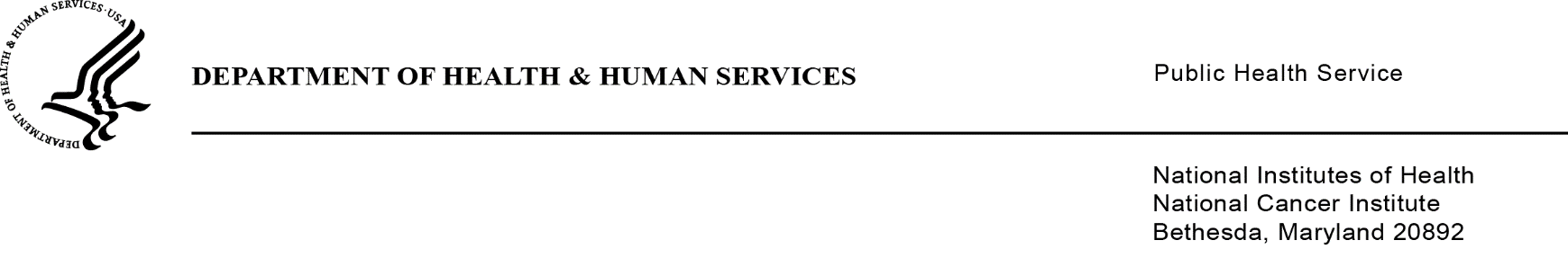
[Date]

Dear Dr. _____________ ,

The National Cancer Institute, in collaboration with the National Human Genome Research Institute and the American Cancer Society and with endorsement from the American Society of Clinical Oncology, is sponsoring The National Survey of Precision Medicine in Cancer Treatment, which is a national survey of oncologists about genomic testing, a component of personalized medicine in cancer treatment. Your participation is important to help us better understand the current and potential use of genomic tests, including single gene and multi-marker tumor panels. Findings from the survey will be used to identify future research needs and to inform the development of educational materials for providers and patients.

You are one of 3,000 oncologists who have been randomly selected to take part in the survey. Participation is voluntary, but it is critical to the success of the survey that everyone chosen takes part. The information you provide will be kept private and your name, address or any other information that could identify you will not be associated directly with your responses. The information you provide will be used only in aggregate, combined with other responses.

We hope you will complete the enclosed survey and return it in the postage-paid envelope. The survey should take around 20 minutes to complete. [IF PREPAID FILL: For completing this survey, we would like to offer you an honorarium of $50 (below).] [IF POST-PAID FILL:] As a token of our appreciation, we will send you a $50 honorarium when we receive your completed survey.

NCI is being assisted by RTI International in fielding this survey. If you have any questions, please feel free to contact us at PrecisionMedicine@rti.org or at (866) 590-7469.

Thank you for participating in this important research.

Sincerely,

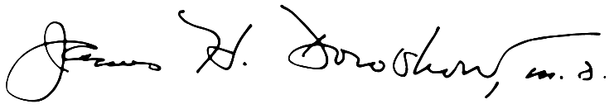

James H. Doroshow, M.D.
Deputy Director for Clinical and Translational Research
National Cancer Institute
National Institutes of Health

<<NAME>>
<<ADDRESS1>>
<<ADDRESS2>>
<<CITY, ST, ZIP>>

Dear Dr. _____________ ,

A few weeks ago, we invited you to participate in The National Survey of Precision Medicine in Cancer Treatment, which is sponsored by the National Cancer Institute in collaboration with the National Human Genome Research Institute and the American Cancer Society and with endorsement from the American Society of Clinical Oncology. [IF PRE-PAID FILL: We also included an honorarium of $50.] If you have already completed and returned the survey, we thank you for your participation. If you have not had the opportunity to complete the survey, enclosed you will find an extra copy of the survey to complete and return at your earliest convenience. The survey should take around 20 minutes to complete, [IF POST-PAID FILL: and we will send you a $50 honorarium when we receive your completed survey.]

You are one of 3,000 doctors who were randomly chosen from a group of oncologists to take
part in the survey. Participation in the survey is voluntary. However, by sharing your experiences and opinions of providing care to individuals with cancer you can help us identify future research needs in the field of precision medicine. The information you provide will be kept private and will be released only as summaries in which no individual’s answers can be identified.

If you would like further information about the survey, please feel free to contact us at PrecisionMedicine@rti.org or at (866) 590-7469.

Thank you in advance for participating in this important research.

Sincerely,

James H. Doroshow, M.D.
Deputy Director for Clinical and Translational Research
National Cancer Institute
National Institutes of Health

First Reminder E-mail

Subject: Reminder to complete NCI National Survey of Precision Medicine in Cancer Treatment

Dear Dr. _____________ ,

In recent weeks we sent you an invitation in the mail to complete The National Survey of Precision Medicine in Cancer Treatment, which is sponsored by the National Cancer Institute in collaboration with the National Human Genome Research Institute and the American Cancer Society and with endorsement from the American Society of Clinical Oncology. To the best of our knowledge, we have not yet received your response.

The completed surveys we have already received show a diversity of opinions and practices regarding the use of genomic testing. We believe these results will be very useful in providing a national picture of the current practices in genomic testing and in informing future research directions in this rapidly evolving area.

We hope that you will complete the survey using the paper copy sent to you previously, or go to the personalized link below to complete the survey online. The survey should take around 20 minutes to complete, [IF POST-PAID FILL: and we will send you a $50 honorarium when we receive your completed survey.]

[Personalized link to survey]

Thank you in advance for participating in this important research.

Sincerely,

James H. Doroshow, M.D.
Deputy Director for Clinical and Translational Research
National Cancer Institute
National Institutes of Health

<<ID>>

<<NAME>>
<<ADDRESS1>>
<<ADDRESS2>>
<<CITY, ST, ZIP>>

Dear Dr. _____________ ,

During the last two months we have reached out to you several times about an important research study, The National Survey of Precision Medicine in Cancer Treatment, which is sponsored by the National Cancer Institute in collaboration with the National Human Genome Research Institute and the American Cancer Society and with endorsement from the American Society of Clinical Oncology.

The study is designed to assess oncologists’ current and potential use of genomic testing in their practice and inform the development of interventions to facilitate patient-physician discussions of the risks, possible benefits, and uncertainties surrounding the application of these tests.

The study is drawing to a close. We are sending this final replacement questionnaire by priority mail because of our concern that we are missing valuable data and the possibility that doctors who have not responded may have different opinions and experiences regarding genomic testing than those who have responded. Your response helps ensure that survey results are as accurate and useful as possible.

We also want to assure you that your responses are both voluntary and private. If you have not treated or evaluated any patients with any type of cancer in the past 12 months, please let us know by marking the check on the cover of the questionnaire and return the otherwise blank questionnaire. This is important and helpful information for us to have.

Finally, as we near the end of this project we appreciate your willingness to consider our request to better understand the experiences and opinions of those specializing in providing care to individuals with cancer. [IF POST-PAID FILL: As a token of our appreciation, we will send you a $50 honorarium when we receive your completed survey.]

Sincerely,
James H. Doroshow, M.D.
Deputy Director for Clinical and Translational Research
National Cancer Institute
National Institutes of Health
Second Reminder E-mail

Subject: Reminder to complete NCI National Survey of Precision Medicine in Cancer Treatment

Dear Dr. _____________ ,

In recent months we invited you by mail to complete an important national physician survey sponsored by the National Cancer Institute in collaboration with the National Human Genome Research Institute and the American Cancer Society and with endorsement from the American Society of Clinical Oncology. The purpose of the survey is to better understand medical oncologists’ experiences, attitudes, and recommendations concerning the integration of genomic testing into oncology.

You may complete the survey using the paper copy sent to you previously, or go to the personalized link below to complete the survey online. The survey should take around 20 minutes to complete, [IF POST-PAID FILL: and we will send you a $50 honorarium when we receive your completed survey.]

[Personalized link to survey]

We appreciate your willingness to consider our request as we conclude this project to better understand current and potential use of genomic tests. The findings from the survey will be used to identify future research needs and will to help inform the development of educational materials for providers and patients. Thank you very much.

Sincerely,

James H. Doroshow, M.D.
Deputy Director for Clinical and Translational Research
National Cancer Institute
National Institutes of Health

<<ID>>

