Dear_________________:

We recently invited you to participate in the U.S. Nuclear Medicine Technologists Feasibility Study. The University of Minnesota is conducting this study in collaboration with the National Cancer Institute, the American Registry of Radiologic Technologists (ARRT), and the Nuclear Medicine Technologists Certification Board (NMTCB). The study will assess the work history and radiation safety practices of nuclear medicine technologists (NMT) who were first certified in nuclear medicine after 1980. Findings from this study will be used to determine the feasibility of conducting a large-scale study of cancer and other disease risks in NMTs. Active, retired and former NMTs are encouraged to participate.

Your participation involves completing an on-line survey about the types and frequency of nuclear medicine procedures you performed and related work practices. A consent information sheet is included below for your records only. You will need to access the consent form online, read it, and sign off if you agree to participate in the study.

Please use the following link to access the consent form and survey:

Link to study: [insert link]
Unique password: [insert password]

Please note that the link and password above are unique to you and should not be shared with anyone else. If you have any problems accessing the survey, please contact the study office at 800-447-6466 or usnmt@umn.edu.

Your prompt response is greatly appreciated. Even if you are retired or no longer working as an NMT your participation is important because your work experiences may be different from others working in the field of nuclear medicine.

Thank you for your valuable assistance. For more information about the study, please visit: [insert website link] or call the study office at 1-800-447-6466.

Sincerely yours,
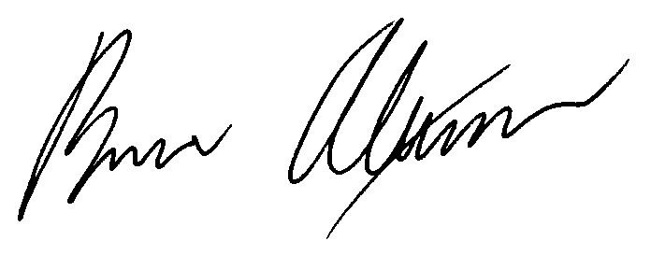
Bruce H. Alexander, Ph.D.
Professor and Principal Investigator

The U.S. Nuclear Medicine Technologists Study is a collaboration between the University of Minnesota, the National Cancer Institute, the American Registry of Radiologic Technologists, and the Nuclear Medicine Technologists Certification Board.

