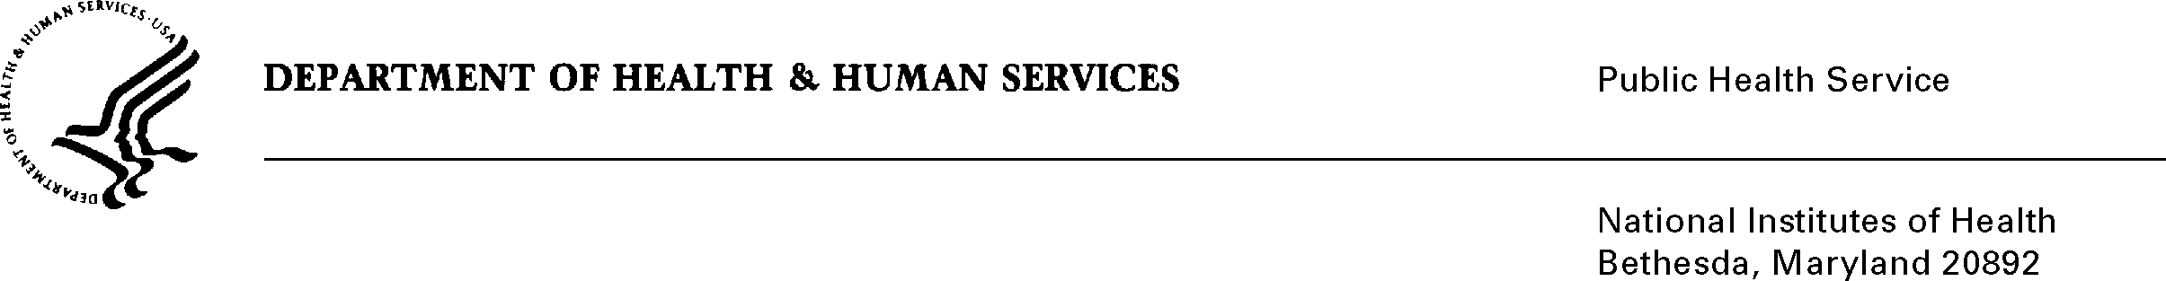

DATE: September 23, 2011

TO: Martha S. Linet, Principal Investigator and Chief
Radiation Epidemiology Branch
National Cancer Institute

FROM: NIH Privacy Act Officer

SUBJECT: Applicability of the Privacy Act: “Cancer Risk in U.S. Radiologic Technologists (USRT): Fourth Survey (NCI)”

I have reviewed the NCI submission to OMB to conduct a fourth survey in an ongoing cohort study of U.S. Radiologic Technologists. The participants include American Registry of Radiologic Technologist (ARRT) registrants certified between 1926-1980 in radiology, nuclear medicine, or radiation therapy.

I have determined that the Privacy Act will apply to this data collection which will collect updated information on cancer, personal medical radiation procedures, and other risk factors. In addition, detailed employment data from subgroups of participants who performed or assisted with fluoroscopically-guided or radioisotope procedures will also be collected. Specific information collected includes name, study ID number, date/state of birth, race, gender, SSN, dates of diagnosis, work and health history, medical outcomes, home address, telephone number and e-mail address, etc.

Records will be linked to the participant by study identification number. All study records/questionnaires will be kept in locked files in locked study offices. Electronic data are stored on password-protected computers. Access to the study offices and computer files is restricted to study staff. Access to data is limited to only those data files needed by staff members to perform their jobs. Data will be stored by ID number in files separate from participant names. Publication of study results will be of an aggregate and statistical nature only. Individuals will not be identified or identifiable in any report from the study.

This data collection is covered by NIH Privacy Act Systems of Record 09-25-0200, “Clinical, Basic and Population-based Research Studies of the National Institutes of Health (NIH), HHS/NIH/OD.”

If you have any questions, please contact my office at (301) 402-6201.

Karen M. Plá

Attachment: NIH Privacy Act Systems of Record 09-25-0200

cc: Vivian Horovitch-Kelley, Project Clearance Liaison, NCI

