**2014 National Mental Health Services Survey**

**Sponsored by the:**

**Substance Abuse and Mental Health Services Administration**

**(SAMHSA)**

**We look forward to your participation in this Survey!**

**Make sure your facility is counted and accessible to those who need it!**

**To complete the survey via the Internet…**

* Go to [**https://survey.nmhss.org**](https://survey.nmhss.org)

(*This is a secure site.)*

* Enter your User ID and Password:
  + **USER ID:**
  + **PASSWORD:**
* Fill out the survey
* Print a copy for your records
* Press “Submit”





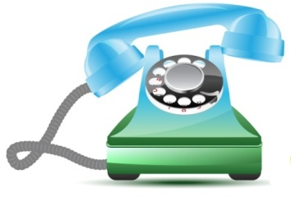OROR

**Any questions?**

Just call us (toll-free) and provide your User ID listed above.

***Call: 1-866-778-9752***