2014 National Mental Health Services Survey

Sponsored by the:
Substance Abuse and Mental Health Services Administration
(SAMHSA)

We look forward to your participation in this Survey!

Make sure your facility is counted and accessible to those who need it!

To complete the survey via the Internet…

- Go to https://survey.nmhss.org
(This is a secure site.)
- Enter your User ID and Password:
  - USER ID:
  - PASSWORD:
- Fill out the survey
- Print a copy for your records
- Press “Submit”



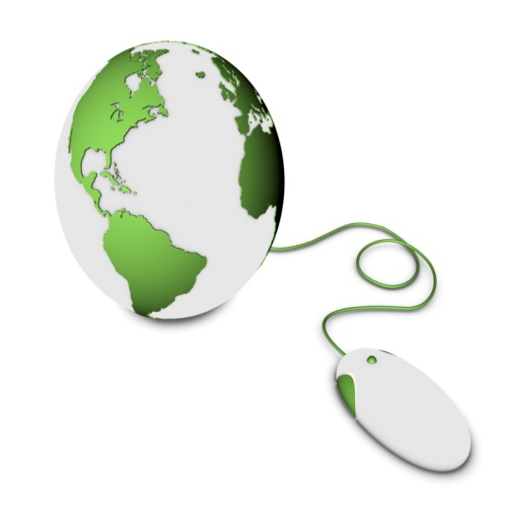

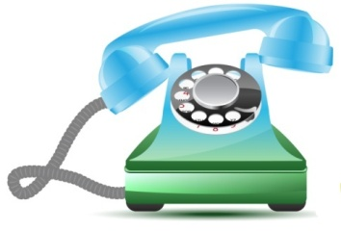
OROR

Any questions?

Just call us (toll-free) and provide your User ID listed above.
Call: 1-866-778-9752

