[fill month] 2016
Dear «Director_FN» «Director_MI» «Director_LN», or Current Facility Director:
Your facility has been approved by your state substance abuse agency to be listed in the Behavioral Health Treatment Services Locator maintained by the Substance Abuse and Mental Health Services Administration (SAMHSA). The newly updated Locator is an online directory that contains listings for both substance abuse treatment facilities and mental health treatment facilities, and can be found at https://findtreatment.samhsa.gov. SAMHSA maintains the Locator as a public service for persons seeking treatment for themselves or family members. There is no charge for being listed on the Locator.
To be listed in the Locator, a substance abuse treatment facility must meet two requirements:
- The facility must respond to SAMHSA’s annual survey of drug and alcohol treatment facilities called the National Survey of Substance Abuse Treatment Services (N-SSATS), and
- The facility must be approved for inclusion by their state substance abuse agency. As noted above, this condition has already been met.
Although data collection for the next N-SSATS is not scheduled to begin until March 2017, facilities that are approved in the interim can be quickly added to the Locator by answering a brief set of questions about the types of treatment and services they offer.
To answer this brief set of questions please follow the steps listed below:
- Log onto: https://minisurvey.nssats.com/
- The utility will ask for a USER ID and PASSWORD. The unique USER ID and PASSWORD assigned to this facility are:
USER ID: [USER ID]
PASSWORD: [PASSWORD]
If you have any questions please call SAMHSA’s contractor, Mathematica Policy Research, at 1-800-685-7623, Monday through Friday between 9 am and 8 pm (ET). This is a toll-free call.
Sincerely,
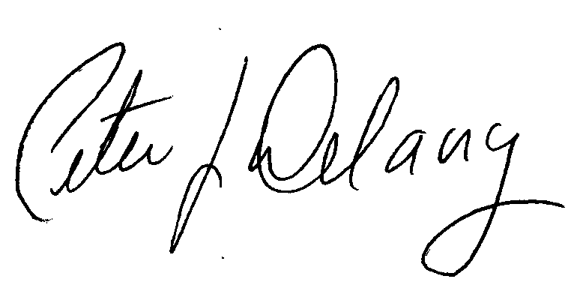
Peter J. Delany, Ph.D., LCSW-C
RADM, U.S. Public Health Service
Director, Center for Behavioral Health Statistics and Quality, SAMHSA

