February 2016

Dear Facility Director:

In early April, you will receive a packet from Mathematica Policy Research, Princeton, NJ, for the National Survey of Substance Abuse Treatment Services (N-SSATS). This is an annual survey sponsored by the Substance Abuse and Mental Health Services Administration (SAMHSA).   
N-SSATS collects information about facility characteristics, the types of services offered, and the number of clients receiving substance abuse services at this facility on March 31, 2016.

Facilities that participate in the 2016 N-SSATS, and are designated as eligible by their State substance abuse agency, can choose to be listed in both the 2016 *Directory* and the online treatment Locator, which can be found at **https://findtreatment.samhsa.gov**.

The packet you will receive will include instructions for completing the questionnaire. If you have any questions about the survey, please call the N-SSATS helpline at **1-888-324-8337.**

We look forward to your participation in the 2016 N-SSATS in April.

Sincerely,

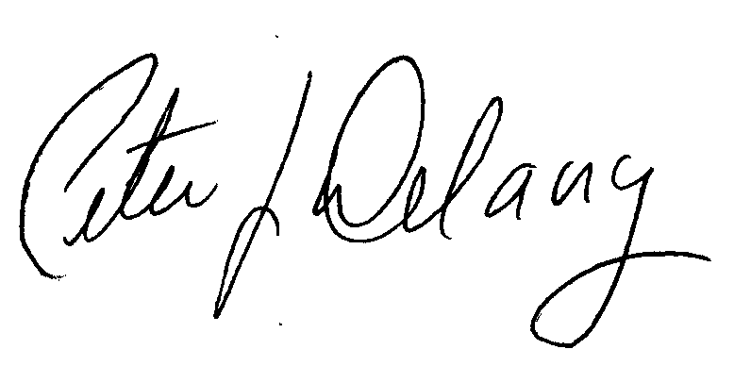

Peter J. Delany, Ph.D., LCSW-C

RADM, USPHS

Director, Center for Behavioral Health

Statistics and Quality, SAMHSA