March 2016

Dear Facility Director:
I am writing to request your participation in the 2016 National Survey of Substance Abuse Treatment Services (N-SSATS). This annual survey, sponsored by the Federal government’s Substance Abuse and Mental Health Services Administration (SAMHSA) and conducted by Mathematica Policy Research, collects data from all known substance abuse treatment facilities in the United States and its jurisdictions.
Your participation in N-SSATS is important. The information you provide will assist SAMHSA, State and local governments, and the public in assessing and analyzing the nature and extent of services provided in substance abuse treatment facilities and in planning for treatment demands, as well as in finding treatment. Facilities that complete the 2016 N-SSATS and are approved by their state can choose to be listed in SAMHSA’s online Behavioral Health Treatment Services Locator (https://findtreatment.samhsa.gov), a searchable database of facilities approved by State substance abuse agencies for the provision of substance abuse treatment.
The survey is designed for easy and efficient completion on the Internet. If you completed the 2015 N-SSATS, you will find that your responses to questions that typically do not change from year to year have already been pre-filled in the 2016 online questionnaire. To complete the questionnaire online, simply follow the instructions on the pink flyer enclosed with this packet. The flyer provides the Internet address to access the questionnaire as well as your facility's unique user ID and password.
Important information about the 2016 N-SSATS. . In an effort to continually reduce the amount of time needed to complete the survey, the client count section will be omitted this year. Collection of these detailed facility data will now only be asked in alternating rounds of the survey. You can preview the 2016 N-SSATS questionnaire by logging into the online survey. This preview will help you identify any data you may need to look-up before completing the survey. A paper copy of the survey can be requested by contacting the N-SSATS Helpline (1-888-324-8337) if you prefer to complete the survey in that manner.
The survey should be completed by you or another person knowledgeable about this facility's daily operations. If you have any questions about the survey, please feel free to call the helpline at
1-888-324-8337 or send an email to nssatsweb@mathematica-mpr.com.
Thank you for participating in this important survey.

Sincerely,
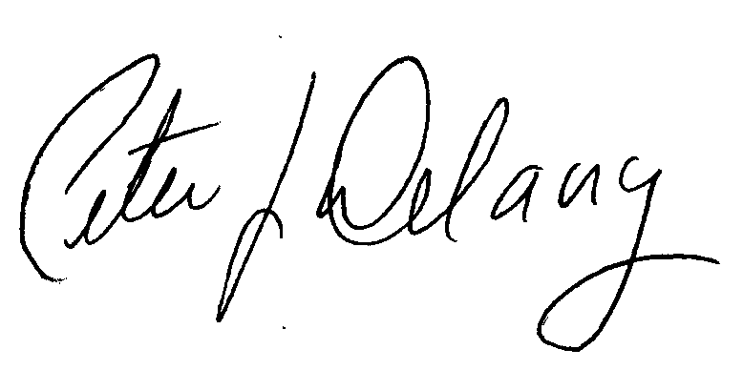

Peter J. Delany, Ph.D., LCSW-C
RADM, U.S. Public Health Service
Director, Center for Behavioral Health Statistics and Quality, SAMHSA

NOTE: The N-SSATS questionnaire is designed to collect information about a single facility at a single location, that is, the facility whose name and address is printed on the enclosed pink flyer. Even if your organization offers treatment services at more than one location, please complete this online questionnaire for this location only.

Complete the 2016 N-SSATS online!

Completing the 2016 N-SSATS questionnaire online is the quickest
and easiest way to participate in the survey.

To Respond on the Internet:
1) Log on at: https://survey.nssats.com (this is a secure site.)
2) Enter your facility’s unique USER ID and PASSWORD:

User ID: [Field 2]
(all numbers)

Password: [Field 3]
(all numbers)

State ID: [Field 1]
Questions? Would you like a paper questionnaire?
Telephone Helpline: (888) 324-8337 (8 a.m. – 8 p.m. EDT)
E-mail: nssatsweb@mathematica-mpr.com
https://survey.nssats.com

[FAC NAME1]: [FAC NAME 2]
[LOCATION ADDRESS 1]
[LOCATION ADDRESS 2]
[CITY], [STATE] [ZIP]

FREQUENTLY ASKED QUESTIONS

- This facility is privately owned. We don’t get any Federal, State, or local funds. Should we participate in the survey? Yes, it is very important to have information about all substance abuse treatment providers so that we can properly describe our national substance abuse treatment network, including service availability.
- Is it mandatory that I complete this survey? Your participation is very important. Because the N-SSATS is the most comprehensive source of data on alcohol and drug abuse treatment facilities in the nation, policymakers at local, State, and Federal levels use information from the N-SSATS to determine the extent of services available and what new or expanded services may be needed. Facilities that respond to the survey and are approved for inclusion by their State substance abuse agency are listed in SAMHSA’s online Behavioral Health Treatment Services Locator, which can be found at: https://findtreatment.samhsa.gov, and also included in the National Directory of Drug and Alcohol Abuse Treatment Programs.
- My facility’s information is the same as last year; why can’t you use that information? Here is some good news! If you completed the 2015 N-SSATS, your responses to questions that typically do not change from year to year will be pre-filled in the online questionnaire. Enclosed in the packet you received in the mail is a pink flyer that provides the Internet address and your facility’s unique user ID and password which are required to access your facility’s questionnaire on the Internet.
- Is alcohol treatment considered substance abuse treatment for the N-SSATS survey? Yes.
- Our facility offers treatment to clients in their homes. It doesn’t seem to fit into any of the categories listed in the N-SSATS—hospital inpatient, residential, or outpatient. What should I do? Home-based programs such as yours are becoming more common. Although you may not consider home-based treatment to be regular outpatient treatment, please count it as such for the purpose of the survey.
- Where can I find more information about terms used in the N-SSATS? Definitions for some of the terms used in the N-SSATS can be found at https://info.nssats.com. You can also call the N-SSATS helpline at 1-888-324-8337.
- We do not provide substance abuse treatment services at this location. Do we still need to complete the questionnaire? We still need to hear from you. However, since your facility does not provide substance abuse treatment services, the number of questions you will be asked to answer is greatly reduced.
- Our facility offers computerized treatment/telemedicine programs to clients; how should this be reported and what modes of service does this include? Computerized treatment / telemedicine programs are growing approaches to substance abuse treatment involving electronic communication between facility and client. This “remote” technological approach includes the use of email, Internet, Web, mobile, interactive video, patient portals and desktop programs. Although you may not consider computerized treatment/telemedicine to be regular outpatient treatment, please count it as such for the purpose of the survey.

