May 2016

Dear Facility Director:

At the end of March, we requested your participation and sent you the materials to complete the 2016 National Survey of Substance Abuse Treatment Services (N-SSATS). The N-SSATS is an annual survey of substance abuse treatment facilities sponsored by the Substance Abuse and Mental Health Services Administration (SAMHSA). If you have already responded to this survey, thank you for your response. If by chance your survey materials have been misplaced, we are resending the information needed to complete this important survey.

We encourage you to complete the 2016 N-SSATS questionnaire on the Internet. If you completed the 2015 N-SSATS, you will find that responses to questions that typically do not change from year to year have already been “pre-filled” in the 2016 online questionnaire. As a reminder, in an effort to reduce the time needed to complete the survey, the client counts section has been omitted this year. We will now only be asking for this information every other round of the survey. The enclosed pink flyer provides this facility's unique User ID and Password for accessing the questionnaire on the Internet. However, a paper copy of the survey can be requested by contacting the N-SSATS Helpline should you prefer to respond to the survey in that manner. It is important that we receive your response as soon as possible.

If you have any questions about the survey or how to complete the questionnaire on the Internet, please call the helpline at 1-888-324-8337 or send an email to nssatsweb@mathematica-mpr.com.

Thank you for your participation in this important survey.

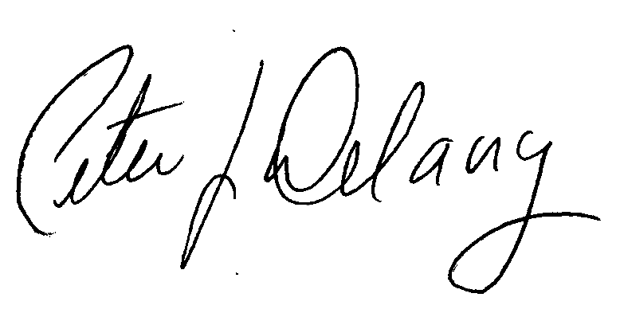
Sincerely,

Peter J. Delany, Ph.D., LCSW-C
RADM, U.S. Public Health Service
Director, Center for Behavioral Health Statistics and Quality, SAMHSA

Enclosures

NOTE: The N-SSATS questionnaire is designed to collect information about a single facility at a single location, that is, the facility whose name and address is printed on the enclosed pink flyer. Even if your organization offers treatment services at more than one location, please complete this on-line questionnaire for this location only.

