[DATE]

[Thank-you Recipient]

[Facility Name 1]

[Facility Name 2]

[Location Street Address]

[Location City], [Location State] [Location Zip]

Dear [Thank-you Recipient]:

I am writing to express my personal appreciation for your facility’s participation in the **2016 National Survey of Substance Abuse Treatment Services (N-SSATS)**.

Your participation helps assure that the results of the 2016 survey are complete and accurate. The information you provided helps SAMHSA and other Federal agencies assess the current condition of substance abuse treatment and services, as well as identify unmet facility and client needs in the United States.

We appreciate your support and commitment of time and effort involved in responding to this important national survey.

Thank you again and I hope we can count on your continued participation in the future.

Sincerely,

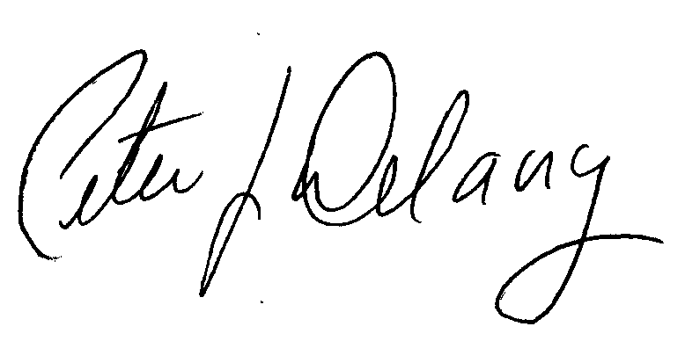

Peter J. Delany, Ph.D., LCSW-C  
RADM, U.S. Public Health Service   
Director, Center for Behavioral Health

Statistics and Quality, SAMHSA