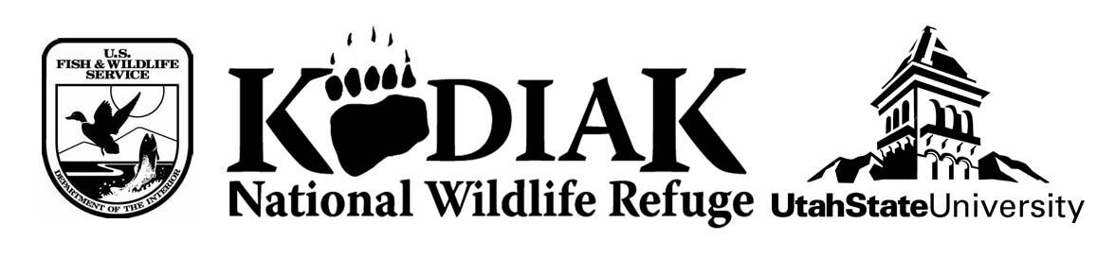
OMB Control No. 1018-XXXX
Expires: XX/XX/2019

Protocol for Commercial Air Taxi Operators and Guides
Assisting with Survey Distribution

Note: Since permitted air taxi operators and guides play a crucial role in successful distribution and collection of the first phase of the survey, the Refuge will hold a mandatory training before remote lodge owners and guides depart to the field for the season. This training will cover how to identify a bear-viewing client, the strictly voluntary nature of the study, ethics including only involving individuals above the age of 18, how to explain the study to the public, and where to direct members of the public should they have questions or concerns about the nature of the study. All operators and guides will be equipped with a box with a slot for inserting completed survey cards so that visitor responses are kept private. The training will involve distribution of the following script to be used when clients return to the air taxi offices after their trip to the Refuge.

Script for commercial operators assisting in survey distribution:

The Kodiak National Wildlife Refuge is conducting a survey of visitors who go bear viewing on the Refuge this summer in order to gauge trends in public use and understand how they can better improve bear viewing opportunities. Since you are just getting back from a bear viewing trip, would you be willing to fill out a brief survey card about your experience? It should take less than two minutes to complete. Your participation is completely voluntary, and you can stop taking the survey at any time. There is also an option to provide an email address in order to participate in a more in-depth online survey, which would really help the refuge understand how visitors are enjoying the current bear viewing programs available to the public.

Paperwork Reduction Act Statement: OMB has approved this information collection and assigned OMB Control No. 1018-XXXX. We estimate that it will take you about 2 minutes to complete this survey, including time to maintain records, gather information, and complete and submit the survey. If you elect to participate in the online survey, we estimate that it will take you approximately 15 minutes to complete that survey. You may send comments on the burden estimate or any other aspect of this form to the Information Collection Clearance Officer, U.S. Fish and Wildlife Service, MS BPHC, 5275 Leesburg Pike, Falls Church, VA 22041-3803.

We are working with the Refuge to collect responses, so once this card is filled out you can deposit it in this box. Your information will not be seen by anyone except for the research team.

