Department of Justice
Bureau of Alcohol, Tobacco, Firearms and Explosives

Supporting Statement
Information Collection Request
1140-0102
FEL Out of Business Records

A. Justification

- Federal Explosives Licensees (FEL) and permittees are required to keep explosives records of importation, production, shipment, receipt, sale, or other disposition, whether temporary or permanent, of explosive materials as prescribed by 27 CFR 555.121. Per 27 CFR 555.128 where an explosive materials business or operations is discontinued the records must be delivered within 30 days following the business or operations discontinuance to the ATF Out of Business Records Center. Per 27 CFR 555.61 FELs and permittees are required to furnish notification of the discontinuance or succession and submit his license or permit and any copies furnished with the license or permit to the Chief, Federal Explosives Licensing Center within 30 days following the discontinuance.

- The records are of importance because they will aid ATF field personnel in conducting investigations. Per 27 CFR 555.128, where an explosive materials business or operations is discontinued and succeeded by a new licensee or new permittee, the records will reflect that fact and be delivered to the successor. Where discontinuance of the business or operations is absolute, the records must be delivered within 30 days following the discontinuance to any ATF office located in the region where the business was located, or to the ATF Out of Business Records Center, 244 Needy Road, Martinsburg, WV 25405.

- FEL records are normally maintained by respondents in paper format. The records ATF receives will be imaged for retrieval. Once the images have been verified as legible, the paper copies are destroyed. ATF will continue to explore and work toward possible alternative methods such as the option of allowing FEL/permittees to submit records via email. However, due to security, possible risks and other limitations currently placed on email from outside of the agency, it does not appear feasible at this time. Limitations include DOJ file size limit of 20 megabytes from external sources and Spam filters would prohibit files from coming through the firewall. Additional research will need to be performed to determine if an exception can be made on the size requirements and there is no security risk or other products such as such as Justice Enterprise File Share that might be acceptable for use.

- The collection of FEL records is for out-of-business records submitted to ATF and does not require the completion of an ATF form. Per ATF Ruling 2007-1, it is also acceptable for licensees/permittees to maintain required records using a combination of a computer program, commercial invoices, and other documents, provided that all of the required information is maintained in the records in permanent form. However, each particular transaction must be self-contained with all the required information in the same recordkeeping medium.

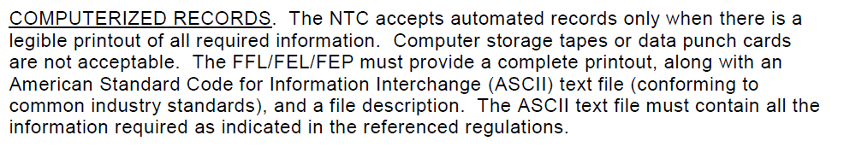

- ATF uses a uniform subject classification system for forms to identify duplication and to ensure that any similar information already available cannot be used or modified for use for the purpose of this information collection.

- The collection of information has no significant impact on small businesses or other small entities.

- The consequence of not conducting this information collection would result in ATF not having access to explosives information that will be used by ATF field personnel in their investigations.

- There are no special circumstances. The data will be collected in a manner consistent with the guidelines in 5 CFR 1320.6.

- A 60-day and 30-day Federal Register notice will be published in order to solicit comments from the general public. No comments were received.

- No payment or gift is associated with this collection.

- The FEL records sent to ATF division offices or to the ATF Out-of-Business Records Center will be kept in a secured location. These records will be viewed by ATF personnel only. Confidentiality is not assured.

- No questions of a sensitive nature are asked.

- There are an estimated 200 respondents associated with this collection. Each respondent answers 1 time. When respondents’ businesses are discontinued it is estimated that an average of 2 boxes of explosives records will be shipped or delivered to ATF. It is estimated to take each respondent 30 minutes to package and ship/deliver the explosives records to ATF. The estimated burden hours to ship/deliver the explosives records are 100 hours (200 respondents x 30 minutes / 60).

- There is no capital/startup cost. The estimated total annual cost for shipping/delivering the explosives records is $12,304 (2 boxes per respondent – 400 boxes x $30.76 shipping rate). There is no annual cost to the National Tracing Center Division (NTC), as the form is generated by the Firearms Explosive License Center (FELC). The annual cost for the Federal Government to generate the OMB 1140-0022 form is as follows:

  - Printing $ 2,300
  - Distribution $430
  - Clerical Costs $2,300
  - Other Salary $1,800
  - (Review supervisory, etc.) ______
  - Total $6,830

- This collection of information requires FELs that discontinue explosives businesses or operations to deliver the explosive records to ATF within 30 days following the discontinuance of business or operation.

- The results of this collection will not be published.

- ATF does not request approval to not display the expiration date of OMB approval for this collection.

- There are no exceptions to the certification statement.

