Top of Form

DHS.gov

 | 

OMB 1651-0123
Expiration: 05/31/2016

Welcome to the Intellectual Property Rights e-Recordation (IPRR) application.

This new method for filing initial trademark and copyright recordation applications will greatly decrease the amount of time and paperwork normally required, thus providing more timely enforcement of your intellectual property rights. (* Please note: An electronic application for trademark and copyright "renewals" and "tradename" recordations is not yet available. For additional information, please review the “Renewals” and “Tradename” sections at the bottom of this page.)
The filing of this electronic application will begin the administrative recordation process with CBP. A separate application is required for each recordation sought. Applications will be processed in the order in which they are received. The recordation fee for copyrights is $190. The recordation fee for trademarks is $190 per International Class of goods. By submitting this application on-line, you agree to supply the documents specified in 19 CFR 133.3 for trademarks, and 19 CFR 133.33 for copyrights, upon request by CBP. Failure to do so will result in your recordation being suspended pending receipt of the documents.
We recommend that you have the following materials and information readily available before you begin the application process:
U.S. Patent & Trademark Office Registration Number or the U.S. Copyright Office Registration Number
Digital images of the protected mark/work in ".jpg" or ".gif" format that accurately depict the right to be protected. Individual image files are limited to 2MB.
Familiarization with the applicable regulations
Trademarks: 19 CFR 133.1 et seq.
Copyrights: 19 CFR 133.31 et seq.

RENEWALS OF EXISTING TRADEMARK AND COPYRIGHT RECORDATIONS
To renew your existing trademark or copyright recordation, please submit an e-mail message to iprr.questions@dhs.gov containing the information provided for in 19 CFR 133.7 and 19 CFR 133.37, respectively. You will be contacted by a representative of the IPR Branch regarding payment of the recordation fee and, if applicable, for additional required information. Note that credit card payment for renewals is not yet available.
TRADENAME RECORDATIONS
To apply for a tradename recordation, please submit an e-mail message to iprr.questions@dhs.gov containing the information provided for in 19 CFR 133.11 et seq. You will be contacted by a representative of the IPR Branch regarding payment of the recordation fee and, if applicable, for additional required informatio. Note that credit card payment for renewal is not yet available.
Paperwork Reduction Act Statement: An agency may not conduct or sponsor an information collection and a person is not required to respond to this information unless it displays a current valid OMB control number and an expiration date. The control number for this collection is 1651-0123. The estimated average time to complete this application is 2 hours per respondent. If you have any comments regarding the burden estimate you can write to U.S. Customs and Border Protection, Office of International Trade, Regulations and Rulings, 799 9th Street, NW, Washington DC 20229
* Please note: The system is set to time-out after 30 minutes of inactivity. Proceeding through the application resets the 30-minute timer on each page. Please complete the application before exiting the system. Incomplete applications will not be processed. Please refrain from entering information just to test the system. Click TRADEMARK or COPYRIGHT if you would like to view the application before you begin.

Bottom of Form
Top of Form

DHS.gov

  
  

Bottom of Form
Top of Form

DHS.gov

U.S. Patent and Trademark Office Registration Number | e.g.,(0,000,000)

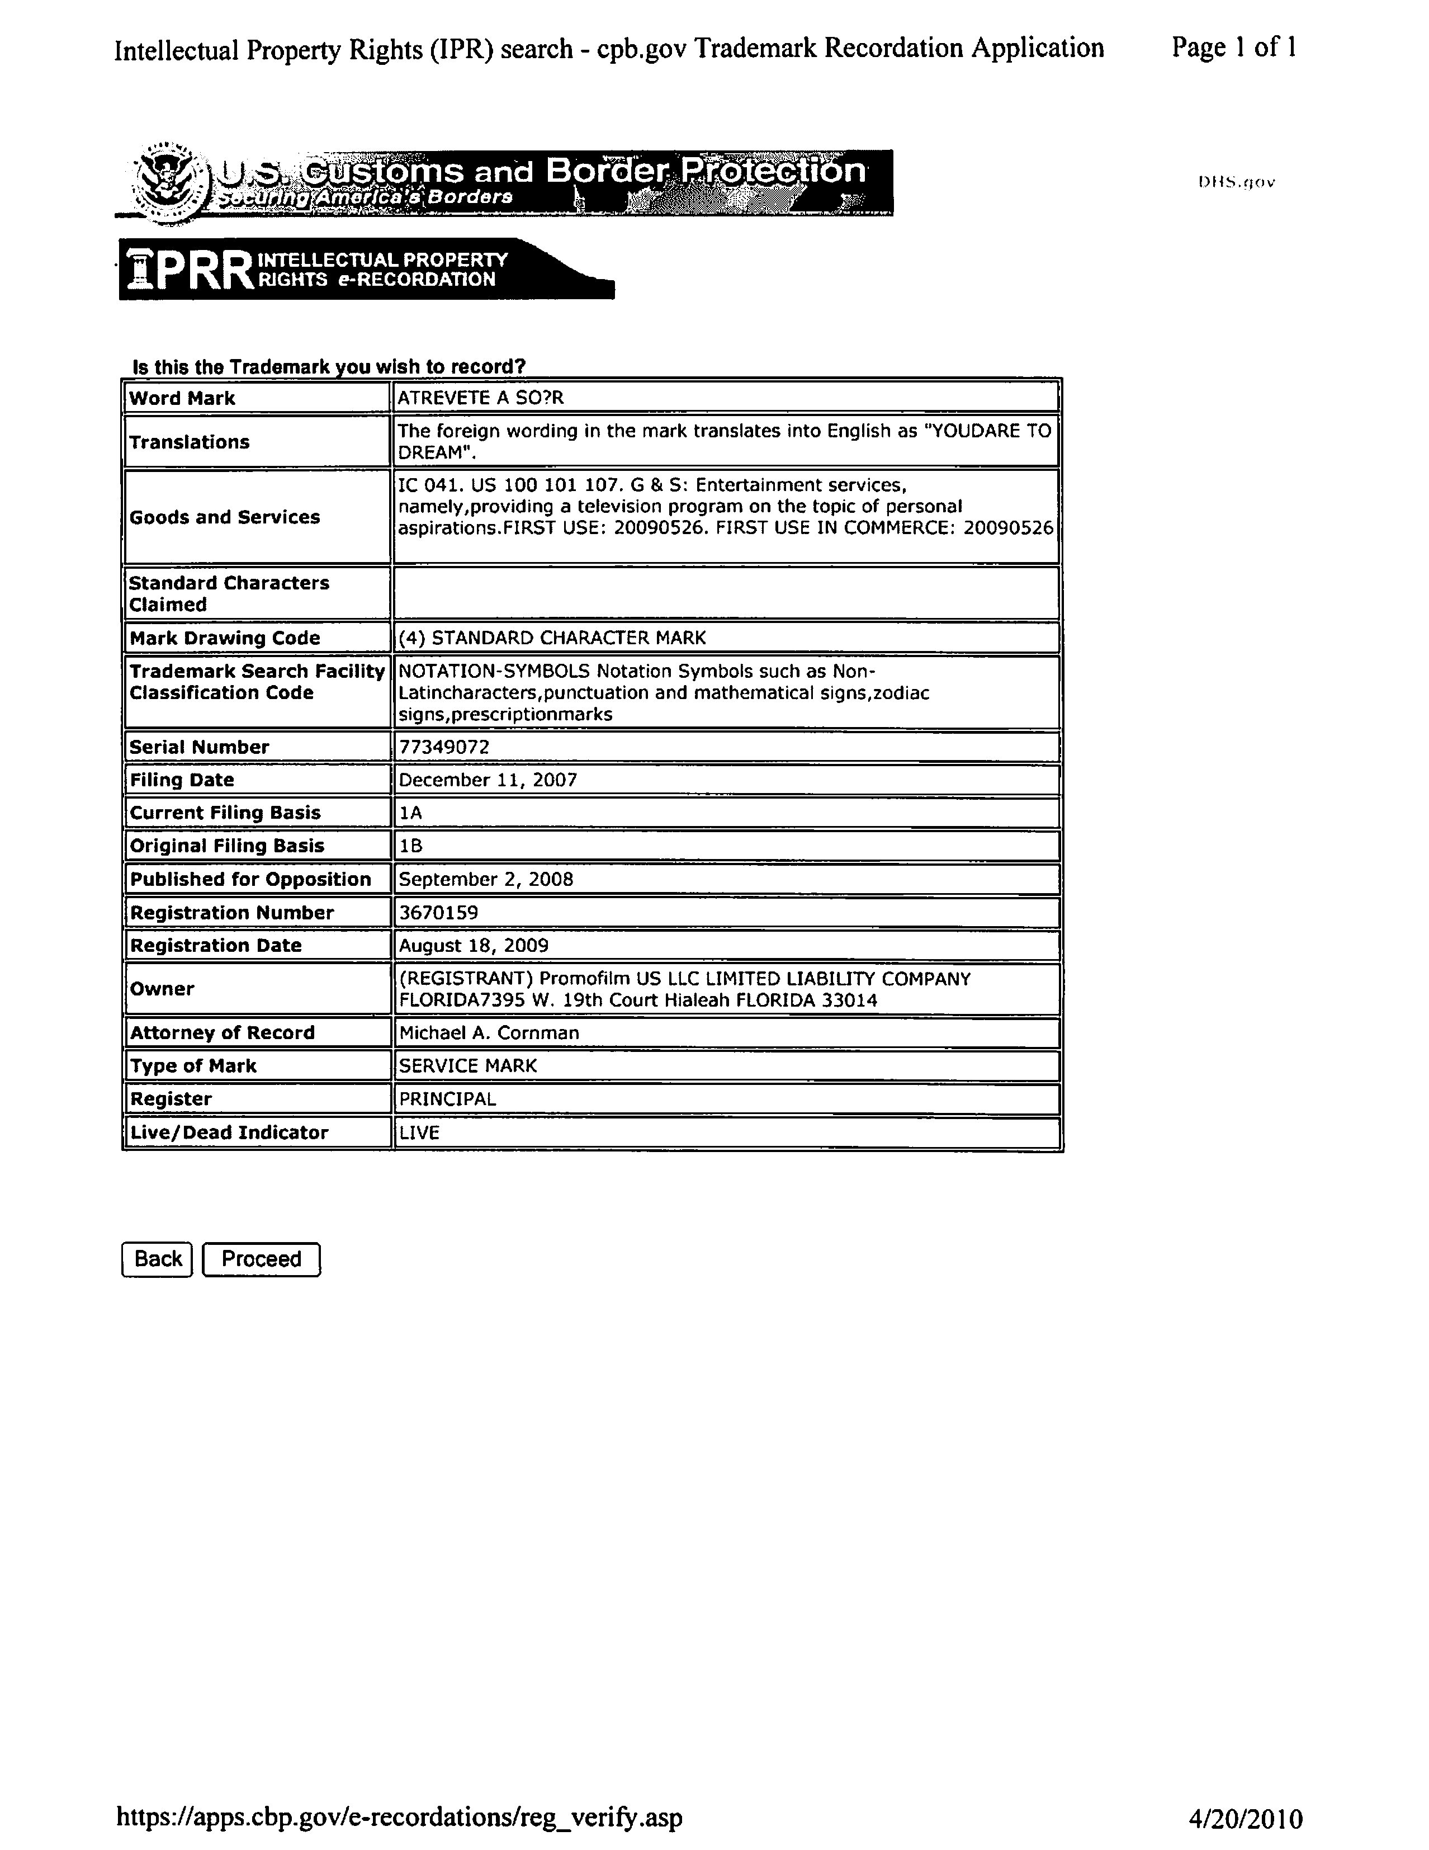
Bottom of Form
