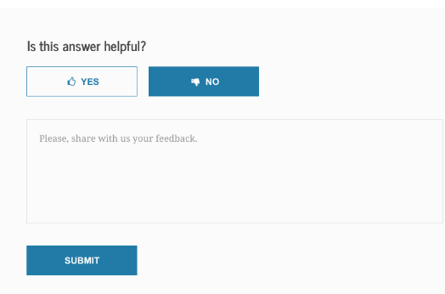

**FAFSA Help Topic Title**

|  |  |
| --- | --- |
| **H3** |  |
| Is this answer helpful? |  |
|  |  |
| **BODY** |  |
| **[CTA Button] [CTA Button]**  YES NO |  |
|  |  |
| **[Note: If the YES Button is selected]**  Thank you for your response. |  |
|  |  |
| [**Note: If the NO Button is selected, text box with 500-character limit appears, with this text above the box:]**  Tell us why not.  **[and this text below the box:]**  Total Characters: 500 Remaining: 500 **[this second number counts down as the site user types their comment]**  Solve this math problem, then select SUBMIT:  **[captcha math problem appears under the text]**  **[If site user enters wrong answer for math problem, message appears saying Oops! Wrong answer. Please try again.]**  **[CTA Button]**  SUBMIT |  |
|  |  |
| **[Note: If the SUBMIT Button selected]**  Thank you for your feedback. |  |