Appendix A. Recruitment Materials
- Information Sheet
- Grantee Letter
- Project Director Invitation Letter

Information About the Study of
School Climate Transformation Grants

What is the Study of School Climate Transformation Grants?  American Institutes for Research (AIR), under contract with the Policy and Program Studies Service (PPSS), U.S. Department of Education, is conducting the Study of School Climate Transformation Grants. This study examines how state departments of education and school districts that have received multiple federal grants coordinate the activities across those grants. School Climate Transformation Grants (SCTGs) aim to improve school safety by supporting schools in the implementation of an evidence-based, multi-tiered system of behavioral supports. Project AWARE grants aim to increase access to mental health services by training adults to notice signs of behavioral health distress and intervene appropriately. School Justice Collaboration Program grants supports courts’ collaboration with schools to implement diversion and similar programs to minimize juvenile detention.  Nine states won both SCTGs and Project AWARE grants. Twenty-eight school districts won both SCTGs and Project AWARE grants. One county won both a SCTG and a School Justice Collaboration Program grant. Each grantee in a site with grant overlap will be invited to participate in the study. The study will explore the nature of coordination across grants, the perceived value of coordination, and challenges and lessons learned.  The research will involve phone or video interviews (whichever the participant prefers) with key grantee staff. We would like to interview the project director for each grant, as well as the staff person who works mostly closely with other grants in that site. We would also like to interview one to two staff members who are engaged in the work of the grant. |  | How will the study involve me?  The research team may ask you to participate in an interview (approximately 45–60 minutes). Participation is voluntary, and any information you provide will be kept private. The project does not involve evaluation of any grantee staff—we are studying coordination across grantees.  Who is conducting the study?  The U.S. Department of Education has contracted with AIR to conduct this study.  When will the study be conducted?  Telephone or video interviews are planned for November–December, 2016.  Privacy  We will protect the confidentiality of the information you provide to the extent provided by law. After we collect your responses, your name will be disassociated from the data. Pseudonyms will be used for each grantee. Your responses will be used to summarize findings in an aggregate manner (across groups of grantees), or will be used to provide examples of program implementation in a manner that does not associate responses with a specific individual. Although we will not identify you by name, readers familiar with your grant may be able to deduce your identity from the information shared. Participating institutions will be acknowledged in the final report, but they will not be identified in the text of any report.  For more information  The study team welcomes your questions. Please feel free to contact Kimberly Kendziora (AIR) at 202-403-5391 or kkendziora@air.org, or Amy Mack (AIR) at 202-403-5863 or amack@air.org.

[Department of Education letterhead]

[Date]

[Name]
[Position]
[Street Address]
[City, State, Zip]

Dear [Grantee Project Director]:
Multiple federal agencies have funded state education agencies and school districts to improve school safety and improve access to mental health care as part of the Now Is the Time initiative. The U.S. Department of Education is sponsoring the Study of School Climate Transformation grants to learn about how states and school districts coordinate activities across multiple federal grants. School Climate Transformation Grants (SCTGs) aim to improve school safety by supporting schools in implementing an evidence-based, multi-tiered system of behavioral support. Project AWARE grants aim to increase access to mental health services by training adults to notice signs of behavioral health distress and intervene appropriately. School Justice Collaboration Program grants supports courts’ collaboration with schools to implement diversion and similar programs to minimize juvenile detention. As a grantee, we look forward to your site’s participation.
The U.S. Department of Education has contracted with American Institutes for Research (AIR) to conduct this study. Participation in this study will consist of two to four grantee staff members participating in 45–60 minute telephone or video interviews. Your participation is strongly encouraged. Indeed, as noted in the grant application, “By submitting an application for this program, applicants agree to fully cooperate with any evaluation efforts conducted by the Department and its contractors” (OMB #1894-0006). We will protect the confidentiality of the information provided to the extent provided by law. After we collect responses, names will be disassociated from the data. Pseudonyms will be used for each grantee. Responses will be used to summarize findings in an aggregate manner (across groups of grantees), or will be used to provide examples of program implementation in a manner that does not associate responses with a specific individual. Although we will not identify respondents by name, readers familiar with your grant may be able to deduce respondents’ identities from the information shared. Participating institutions will be acknowledged in the final report, but they will not be identified in the text of any report.
The result of this effort will be a report that identifies lessons in how grantees can work together across disciplines and programs to produce safer schools and better social, emotional, and behavioral outcomes for students.
A representative from AIR will contact you soon to discuss the study. If you prefer us to contact someone else in your state, county, or district to discuss this study, you may contact AIR’s Study Director, Dr. Kimberly Kendziora, at 202-403-5391 or kkendziora@air.org. If you have questions about the study, please contact Dr. Kendziora, or Nikki Churchwell at the U.S. Department of Education at 202-205-4274 or nikki.churchwell@ed.gov.
We thank you in advance for your cooperation and truly appreciate your willingness to provide the time needed for the success of this important study. We look forward to learning more about the interesting work that you are doing.

Sincerely,

Jennifer Bell-Ellwanger, Director  Policy and Program Studies Service  Office of Planning, Evaluation and  Policy Development | David Esquith, Director  Office of Safe and Healthy Students  Office of Elementary and Secondary Education

According to the Paperwork Reduction Act of 1995, no persons are required to respond to a collection of information unless such collection displays a valid OMB control number. The valid OMB control number for this information collection is xxxx-xxxx. Public reporting burden for this collection is estimated to average 60 minutes per response.

Project Director Invitation/Notification Letter

[Date]

[Name]
[Position]
[Street Address]
[City, State, Zip]

Dear [Project Director]:
We are writing to invite you to participate in an important study sponsored by the Policy and Program Studies Service (PPSS) of the U.S. Department of Education. This study examines how state departments of education and school districts that have received multiple federal grants coordinate the activities across those grants. School Climate Transformation Grants aim to improve school safety by supporting schools in implementing an evidence-based, multi-tiered system of behavioral support. Project AWARE grants aim to increase access to mental health services by training adults to notice signs of behavioral health distress and intervene appropriately. School Justice Collaboration Program grants supports courts’ collaboration with schools to implement diversion and similar programs to minimize juvenile detention. The study will explore the nature of coordination across grants, the perceived value of coordination, and challenges and lessons learned.
As part of the study, we would like to conduct a 45–60 minute interview with you by telephone or videoconference, as you prefer. You have been selected because [your state, city, or town] has been awarded and is implementing two of the three grant types we are studying. We would like to speak with:
- You, the project director
- The person working on your grant who interacts most closely with the work of the other federal grant in your locality. This would be either (1) multi-tiered systems of support in schools, (2) Mental Health First Aid or Youth Mental Health First Aid programming, or (3) family courts. We recognize that in some instances this will also be the project director. We also recognize that the project directors for some states’ and districts’ School Climate Transformation Grants and Project AWARE grants may be the same person.
- One to two staff actively engaged in implementing core grant activities.
Your participation is strongly encouraged. Indeed, as noted in the grant application, “By submitting an application for this program, applicants agree to fully cooperate with any evaluation efforts conducted by the Department and its contractors.” We will protect the confidentiality of the information provided to the extent provided by law. After we collect responses, names will be disassociated from the data. Pseudonyms will be used for each grantee. Responses will be used to summarize findings in an aggregate manner (across groups of grantees), or will be used to provide examples of program implementation in a manner that does not associate responses with a specific individual. Although we will not identify respondents by name, readers familiar with your grant may be able to deduce respondents’ identities from the information shared. Participating institutions will be acknowledged in the final report, but they will not be identified in the text of any report.
The result of this effort will be a report that identifies lessons in how grantees can work together across disciplines and programs to produce safer schools and better social, emotional, and behavioral outcomes for students.
American Institutes for Research (AIR) is conducting the study. Someone from AIR will contact you in the next two weeks to talk with you more about this study and answer any questions you might have. Should you have any questions in the meantime or if you would like to discuss this study, please feel free to contact me at 202-403-5391 or kkendziora@air.org. You may also contact Nikki Churchwell at the U.S. Department of Education at 202-205-4274 or nikki.churchwell@ed.gov.
We thank you in advance for your cooperation and truly appreciate your willingness to provide the time needed for the success of this important study. We look forward to learning more about the interesting work that you are doing.

Sincerely,
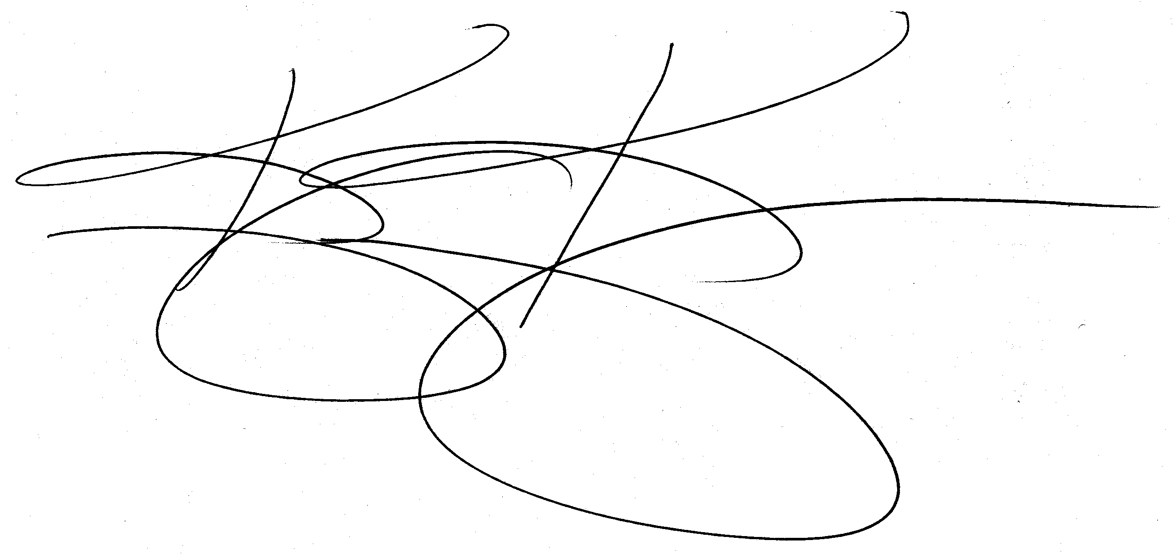

Kimberly Kendziora, Ph.D.
Study Director
American Institutes for Research

According to the Paperwork Reduction Act of 1995, no persons are required to respond to a collection of information unless such collection displays a valid OMB control number. The valid OMB control number for this information collection is xxxx-xxxx. Public reporting burden for this collection is estimated to average 60 minutes per response.

