**Attachment 1**

**Phase 1**

**Individual Innovation Vignettes Questionnaire**

**September 4, 2018**

**Platform ad**

Survey description: This survey is about how survey respondents interpret innovation.

Time allowed: 20 minutes

Expires: 10/29/2018

Qualifications required: Resides in U.S.

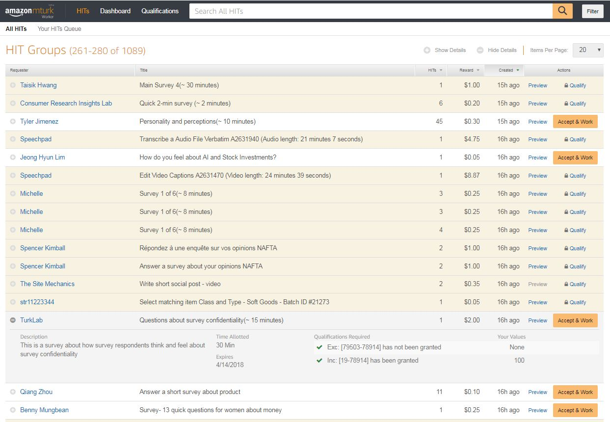

Figure 1. Example ad from previous study

**Vignettes Questionnaire**

*Page 1*

*Introduction*

This survey is conducted by the National Center for Science and Engineering Statistics (NCSES) within the National Science Foundation (NSF). This survey is being collected by NCSES under OMB No. 3145-0174. This survey will take approximately 20 minutes to complete. Your participation is voluntary and you have the right to stop at any time.

Please take your time as you answer these questions. The information you provide will contribute to valuable research at NCSES, one of the principal Federal statistical agencies.

This survey is being administered by Mathematica Policy Research, Inc. and resides on a server outside of the NCSES domain. NCSES cannot guarantee the protection of survey responses and advises against the inclusion of sensitive personal information in any response. By proceeding, you give your consent to participate in this survey.

*Page 2*

The National Center for Science and Engineering Statistics uses the following definition for innovation:

An innovation is a new or improved product (good or service) or process that a person(s) develops on their own time, is not work related, and is used by the developer(s) or has been made available to other potential users. The innovation cannot be a home-built version of an existing product or process currently on the market. However, an innovation may include modifying existing products or processes to create something functionally novel.

To clarify the concept of “work-related”, a product or process is an innovation if someone does not create it for work. However, a person(s) can use their professional experience to create something in their leisure as long as it otherwise meets the definition above.

Using this definition, please classify the following examples as innovation or not innovation.

<Individual respondents will be shown 9 innovation vignettes. For each vignette, they will be asked the set of questions following the table. Respondents will be shown a mix of vignettes from each column, but they will not be shown vignettes from the same row. The last column is for internal use only, and will not be shown to respondents.>

|  |  |  |  |
| --- | --- | --- | --- |
| **#** | **Potentially Individual Innovation** | **Not Individual Innovation** | **Reason for Not being Individual Innovation** |
| 1 | Elizabeth (James) designs apps for smartphones in her spare time. She (He) developed an iPhone camera app that identifies the colors of objects in a scene, and codes them for easy recognition for color blind users. | Elizabeth (James) is professional designer of apps for smartphones. She (He) developed an iPhone camera app that identifies the colors of objects in a scene, and codes them for easy recognition for color blind users. | Work-related |
| 2 | Christina (John) developed a new dog toy using items she (he) had around the house. It tosses a ball across the yard, varying the height and direction so that it doesn't land in the same place every time. Once the dog drops the ball back in the toy, it prepares to launch it again. Christina (John) showed the dog toy to a neighbor who wanted one for his dog, so Christina (John) built a second one and gave it as a gift. | Christina (John) works for a company that creates and sells dog toys. While at work, Christina (John) developed a new toy. It tosses a ball across the yard, varying the height and direction so that it doesn't land in the same place every time. Once the dog drops the ball back in the toy, it prepares to launch it again. | Work related |
| 3 | Mary (Charles) is a TV director and during her (his) spare time she (he) created a new game to make learning multiplication tables into enjoyable play for his children. | Mary (Charles) is a software developer in the gaming industry. During the weekend she (he) created a new computer game to help children learn math. | Work related |
| 4 | Linda (Louis) has cystic fibrosis, which causes a thick and sticky buildup of mucus in the lungs. She (He) experimented with different sound wave frequencies and discovered that certain frequencies helped clear her (his) lungs. She (He) developed a new device to help clear her (his) lungs with sound waves. She (He) then posted this guidance on an on-line community forum for people with cystic fibrosis. | Linda (Louis) creates a machine at work that uses low sound waves to help clear the lungs of cystic fibrosis patients. To help spread word on what she (he) did at work, she (he) posted information about the machine on an on-line community forum for people with cystic fibrosis. | Work related |
| 5 | Barbara (Larry) is a statistician and used old parts from her (his) bicycle to build a device that allows her (him) to pull weeds without bending down. The current options on the market do not have the precision or strength to pull the weeds in her (his) yard. | Barbara (Larry) is a farm tool designer. During some down time at the office, she (he) designed and built a device that allows her (him) to pull weeds in her (his) garden without bending down. | Work related |
| 6 | Nina (Robert) is a robotics engineer. She (he) bought a drone to track her (his) elderly grandmother, who has dementia. She (He) wrote software that uses facial recognition to identify her (his) grandmother and programmed the drone to follow her (his) grandmother when she left the house. The drone then sent a signal to her (his) phone if her grandmother went beyond her predefined boundaries. | Nina (Robert) is a robotics engineer. She (He) has an elderly grandmother who has dementia. She (He) convinced her (his) work team to produce a prototype drone that uses facial recognition software to follow a person around and send a signal to a phone if they go beyond predefined boundaries. | Work related |
| 7 | Frustrated with the inability to program commercial music streaming services, Jennifer (Michael) adapted a service using an algorithm she (he) created to program the genre of music according to different times of the day for her (his) own enjoyment. For example, in the evening she (he) listens only to jazz and in the morning she (he) listens only to country music. | Frustrated with the inability to program commercial music streaming services, Jennifer (Michael) adapted a service using an algorithm she (he) created to program the genre of music according to different times of the day. For example, in the evening the algorithm would only play jazz and in the morning the algorithm would only play country music. Though Jennifer (Michael) adapted a music streaming service to her (his) needs, she (he) found another product she (he) liked better, and never used her (his) own product. | Not used |
| 8 | To keep snails away from her (his) vegetable garden, Ana (William) created a rain-protected gutter filled with table salt. The device doesn’t kill the snails. Ana (William) showed her (his) neighbors how to do the same thing for their homes. | To keep snails away from her (his) vegetable garden, Ana (William) created a rain-protected gutter filled with table salt. The device doesn’t kill the snails. Ana (William) could not prevent salt from leaking from the device. She (He) did not install the device because she (he) was worried about the salt inhibiting grass growth in the nearby soil. | Not used |
| 9 | Julie (David) lives in a studio apartment that only has a shower stall. She (He) developed a way to temporarily seal the stall so it can be used as a bathtub when she (he) wants. | Julie (David) lives in a studio apartment. She (He) developed a way to modify her (his) shower stall so it can be used as a bathtub. She (He) was not able to use the modification because she (he) realized the seal did not hold long enough. | Not used |
| 10 | Maria (Omar) created a modular wall system for her (his) home office that saves space by allowing her (him) to fold the desk up against the wall when she (he) is not working, similar to a murphy bed. | Maria (Omar) created a modular wall system for her (his) home office modeled after something she (he) saw at the Home Depot. | Homemade version of something commercially available |
| 11 | Susan’s (Patrick’s) mother uses a wheelchair. Susan (Patrick) created a new coat that could be easily put on and taken off by a person in a wheelchair. The seams under the sleeves are different from other coats - they open and close using special tape. This enables Susan’s (Patrick’s) mom to easily remove the coat. | Susan (Patrick's) mother uses a wheelchair. Susan (Patrick) saw a coat online that could be easily put on and taken off by a person in a wheelchair. Susan (Patrick) made a similar coat at home. | Homemade version of something commercially available |
| 12 | The online sign-up for a local event was first come, first served and became oversubscribed quickly. Patricia (Richard), a stay-at-home parent, created a computer program that, once running, reloaded the sign-up page until it went live at midnight and then quickly filled in all the information, enabling Patricia (Richard) to register without staying up late. | The online sign-up for a local event was first come, first serve and became oversubscribed quickly. Patricia (Richard), a stay-at-home parent, found a computer program that, once running, reloaded the sign-up page until it went live at midnight and then quickly filled in all the information. This would enable Patricia (Richard) to register without staying up late. However, she (he) did not want to pay the licensing fee, so she (he) coded her (his) own script to replicate the commercial one. | Homemade version of something commercially available |
| 13 | Margaret (Jerry) used the motor from an old drill and a radio-frequency receiver to raise and lower the plastic dog door at home when her (his) dog came up to it wearing a radio-frequency emitting collar. This way, her (his) dog can have outdoor access while Margaret (Jerry) is gone. | Margaret (Jerry) saw an ad for a dog door on TV that opened when a dog wearing a radio-frequency collar got close to it. She (He) modified her (his) existing dog door to open when her (his) dog came up to it with a special radio-frequency collar she (he) purchased from a pet store. | Homemade version of something commercially available |
| 14 | Lena (Charles) and her (his) sister (brother) developed a new game called Gnip-Gnop. The game is played on a ping-pong table, with a ping-pong-ball. However, the ball is suspended from a portable, vertical frame with string. The scoring for Gnip-Gnop is similar to ping-pong, but the style of play is different. They provide the drawings and rules to others on the internet. | Lena (Charles) used string and metal piping to modify a ping-pong table to include a ball suspended from a portable vertical frame. This allowed her (him) to play a game with scoring similar to ping-pong, but with a different style of play. She (He) got the idea from going to a game expo while she (he) was away at college. | Homemade version of something commercially available |
| 15 | Dorothy’s (Clarke’s) grandfather is blind. So that her (his) grandfather can continue to play chess Dorothy (Clarke) carved a chess board and chess pieces out of wood with special grooves to identify not just the piece but also whether or not it is black or white so that her (his) grandfather can determine which pieces are which by the grooves in the pieces. | Dorothy (Clarke) carved a chess board and chess pieces out of wood for her (his) elderly grandfather. | Homemade version of something commercially available |
| 16 | Alexandra (Joseph), a teacher by day, spends her (his) weekends riding motorcycles. She (He) noticed that the bike got too hot for her (him), so she (he) modified the bike in a new way that used water to cool the exhaust, reducing the temperature of the bike while riding. | Alexandra (Joseph), a teacher by day, spends her (his) weekends riding motorcycles. She (He) noticed that the bike got too hot for her (him), so she (he) ordered a kit to modify the bike to use water to cool the exhaust, reducing the temperature of the bike while riding. | Did not create something new |
| 17 | Nancy’s (Jim’s) dog would not take its medicine without hearing Nancy’s (Jim’s) command. She (He) combined an automatic food feeder that opened at a prescribed time with a tablet program that played a pre-recorded message from Nancy (Jim), calling the dog to the dish and then giving the command to eat the treat containing medicine. This enabled Nancy (Jim) not to worry about it while she (he) was at work. | Nancy’s (Jim’s) dog would not take its medicine without her (him) telling her to. She (He) bought an automatic feeder and put her medicine in there with a treat. Then Nancy (Jim) called every day at the prescribed time and commanded her over the answering machine to take her medicine. | Did not create something new |
| 18 | Art student Lisa (Thomas) created an app that searches the web for art show openings and then creates the optimal schedule for her (his) night out at the galleries using distance and preferences. | Art student Lisa (Thomas) uses an app that searches for campus events and creates a schedule for her (him) using distance and predefined interests. She (He) created a filter in the app to only return art galleries. | Did not create something new |

|  |  |  |  |
| --- | --- | --- | --- |
| 19 | Sarah (Christopher) is a small business owner and to maintain copies of her (his) receipts for her (his) business she (he) developed a program that takes her (his) electronic credit card statement and transfers each transaction into an Excel workbook where she (he) can enter the additional information about each transaction that she (he) will need for her (his) business’ tax return. | Sarah (Christopher) is a small business owner and to maintain copies of her (his) receipts for her (his) business she (he) uses her (his) smartphone to take a photograph of each receipt. At the end of the year she (he) provides all the photographs to her (his) accountant for her (his) business’ tax return. | Not new |
| 20 | Karen (Neil) is a high school chemistry teacher and one weekend, while working on some experiments for her (his) class, she (he) develops a new way to produce plastic without using petroleum. | Karen (Neil) is a high school chemistry teacher and one weekend, while working on some experiments for her (his) class and consulting the internet she (he) figures out how to produce plastic at home. | Not new |
| 21 | Betty (Samson) used three pots to create a multiple level pot that allows waste heat from the bottom pot to be used to cook food in the upper level pots. | Betty (Samson) used two pots to create a double boiler because she (he) did not have one at home. | Homemade version of something commercially available |
| 22 | Sandra (Julian) sells cupcakes at a local farmer’s market on weekends. To keep up with growing demand, she (he) started baking her (his) cupcakes in cupcake liners placed in mason jar lids on baking sheets. This way, she (he) does not need to wait for the tray to cool before removing the cupcakes out and reusing it. | Sandra (Julian) sells cupcakes at a local farmer’s market on weekends. To keep up with growing demand, she (he) purchased additional muffin tins. This way, she (he) can bake a second batch of cupcakes while waiting for the first batch to cool. | Did not create something new |
|  |  |  |  |

[For each innovation shown (9 innovations) the following set of questions will be asked.]

1. Do you consider the activity described an innovation?

[Radio button]

1. Yes
2. No
3. How confident are you that your classification is correct?

[Radio button]

* 1. Not at all confident
  2. Somewhat confident
  3. Very confident

1. Please tell us why you chose to classify the example in this way.

[Open Answer]

[Repeat 1-3 for 9 innovations, then go to 4]

1. Are you…

[Radio button]

1. Male
2. Female
3. What is your age?

[Fill In]

Age ___

1. Are you living in the United States, Puerto Rico, or another U.S. territory, or are you living in another country?

[Radio button]

* 1. United States, Puerto Rico, or another U.S. territory
  2. Another country

Thank you for your time.