FORM APPROVED BY OMB No. 0581-0125
 | UNITED STATES  DEPARTMENT OF  AGRICULTURE  Agricultural Marketing Service  Specialty Crops Program |  |  | LOGO USE REQUEST  FOR AUDIT PROGRAMS
FEDERAL AUTHORIZATION: This form is to be completed by authorized personnel in accordance with the specified Specialty Crops Inspection Division audit program(s). All materials which make reference to the audit program(s) design or language are accountable items. Their use is authorized by a contract between the USDA and the participant company. No materials shall bear reference to the audit program(s) design or language without prior written consent of the Specialty Crops Inspection Division.
A. Logo Description
 |  |  | 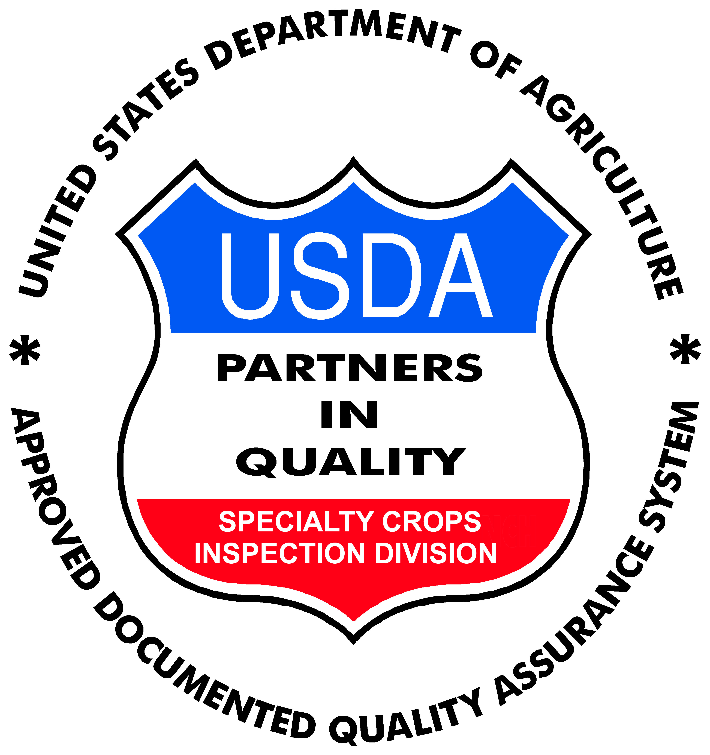 | Type of Logo: □ Black □ Color**  **( GAP&GHP and IP color logos must use Pantone Matching System (PMS) color Green 348. PIQ color logos must use the colors red, white and blue in specified areas. Any other colors used will not be considered an approved audit program logo and will be in violation of the agreement.)
B. Company Information
___________________________________________ _______________________________________________________________
Name of Company Mailing Address of Company
___________________________________________ _________________________ ____________________________________
Name and Title of Person Requesting Logo Use Phone Number Email Address
C. Logo Use
Commodities:_______________________________________________________________________________________________
Select type(s) of use and specify the number of materials that will contain the audit programs logo (Attach Additional Documentation):
□ Containers : __________ □ Publication(s) __________ type(s):___________________________________________
□ Labels/Stickers __________ □ Website(s) __________ web address(es):______________________________________
□ Other : ________________________________________________________________________________________________________________
D. Manufacturer’s Information
___________________________________________ ___________________________________________
Manufacturer’s Name Manufacturer’s Phone Number
_________________________________________________________________________________________
Manufacturer’s Mailing Address
E. Applicant’s Request
As an authorized participant in the Specialty Crops Inspection Division audit program(s), I hereby request that the above materials be approved and produced with the audit program(s) logo. I agree to be responsible for all charges assessed by the manufacturer of the materials for this order. I also acknowledge that all materials containing the audit program(s) logo are in compliance with the audit program(s) logo use requirements and are for the exclusive use as a participant in good standing in the audit program(s) as authorized by the USDA. A copy of the manufacturers’ invoice bearing the exact number of preprinted materials produced with the audit program(s) logo and a signed copy of Section F will be forwarded to the Specialty Crop Inspection Division immediately after the time of receipt.
_________________________________________ _______________
Applicant’s Signature Date
_________________________________________ _______________
Federal Authority Signature Date
F. Applicant’s Receipt
I have received the above listed materials and they are now my responsibility. I certify that only the materials in the above list have been produced and will only be used in accordance with a audit program(s) in good standing.
_________________________________________ _______________
Applicant’s Signature Date
_________________________________________ _______________
Federal Authority Signature Date
According to the Paperwork Reduction Act of 1995, an agency may not conduct or sponsor, and a person is not required to respond to a collection of information unless it displays a valid OMB control number. The valid OMB control number for this information collection is 0581-0125. The time required to complete this information collection is estimated average 20 minutes per response, including the time for reviewing instructions, searching existing data sources, gathering and maintaining the data needed, and completing and reviewing the collection of information.
SC-652 (rev.06-2016)

OMB 0581-0125

In accordance with Federal civil rights law and U.S. Department of Agriculture (USDA) civil rights regulations and policies, the USDA, its Agencies, offices, and employees, and institutions participating in or administering USDA programs are prohibited from discriminating based on race, color, national origin, religion, sex, gender identity (including gender expression), sexual orientation, disability, age, marital status, family/parental status, income derived from a public assistance program, political beliefs, or reprisal or retaliation for prior civil rights activity, in any program or activity conducted or funded by USDA (not all bases apply to all programs). Remedies and complaint filing deadlines vary by program or incident.
Persons with disabilities who require alternative means of communication for program information (e.g., Braille, large print, audiotape, American Sign Language, etc.) should contact the responsible Agency or USDA’s TARGET Center at (202) 720-2600 (voice and TTY) or contact USDA through the Federal Relay Service at (800) 877-8339. Additionally, program information may be made available in languages other than English.
To file a program discrimination complaint, complete the USDA Program Discrimination Complaint Form, AD-3027, found online at http://www.ascr.usda.gov/complaint_filing_cust.html and at any USDA office or write a letter addressed to USDA and provide in the letter all of the information requested in the form. To request a copy of the complaint form, call (866) 632-9992. Submit your completed form or letter to USDA by:
- mail: U.S. Department of Agriculture Office of the Assistant Secretary for Civil Rights 1400 Independence Avenue, SW Washington, D.C. 20250-9410;

- fax: (202) 690-7442; or

- email: program.intake@usda.gov.
USDA is an equal opportunity provider, employer, and lender.

SC-652 (rev.06-2016)

