Attachment J: Taste Test Ballot and Site Operator Script

OMB BURDEN STATEMENT: According to the Paperwork Reduction Act of 1995, no persons are required to respond to a collection of information unless it displays a valid OMB control number. The valid OMB control number for this information collection is 0584-0524. The time to complete this information collection is estimated at 1 minute, including time for reviewing instructions and completing the information.
Site Operator Script
Today we tried a snack and I would like to know what you think. I’ll read each question, and you touch the face that shows how you feel about the food we tried. There are no right or wrong answers. We just want to make sure we’re making snacks children like you enjoy, so you don’t have to worry about hurting my feelings.
[Note: read the instructions and answer choices]
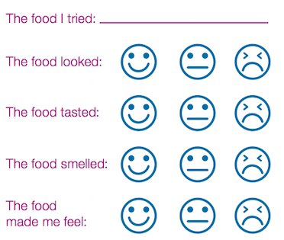

Taste Test Ballot

It’s fun to find new favorite food!

(Note: site operator will enter in menu screen)

Note: Insert Photo of
Prepared Recipe

