  

OMB Number: 0584-XXXX

Expiration Date: XX/XX/XXXX

February, 2016

Dear Sponsoring Agencies and Child Care Centers:

The National CACFP Sponsors Association (NCA), the National CACFP Forum (The Forum) and the Child Care Food Program Roundtable, would like to encourage you to participate in the Erroneous Payments in Child Care Centers Study (EPICCS).

You are one of 450 CACFP child care sponsoring agencies or childcare centers from across the country randomly selected to represent all CACFP childcare centers. As such, your participation is truly critical—participation would not only mean being the voice for other sponsors, providers, parents, and most importantly, children, but would also help ensure the continued financial viability of the CACFP.

EPICCS seeks to assess the amount and sources of errors that occur in the certification and meal claims processes at child care centers participating in the Child and Adult Care Food Program (CACFP). The USDA’s Food and Nutrition Service has contracted Westat, Inc., and its research partners, Kokopelli Associates LLC and Windwalker Corporation.

EPICCS complies with the Healthy, Hunger-Free Kids Act of 2010 and is authorized under the Improper Payments Elimination and Recovery Improvement Act (IPERIA) of 2012, both of which ensure the financial and programmatic integrity of programs such as the CACFP.

We appreciate your participation in this study. Your contribution will help influence policy decisions that impact the future of the CACFP. We want to thank you for your continued support, service and commitment to the well-being of our nation’s children.

Sincerely,

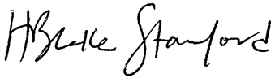

Blake Stanford

National CACFP Sponsors Association — President

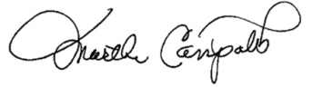

Martha Campolito

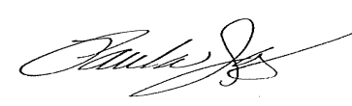National CACFP Forum — President

Paula James

Child Care Food Program Roundtable — Chair

According to the Paperwork Reduction Act of 1995, an agency may not conduct or sponsor, and a person is not required to respond to, a collection of information unless it displays a valid OMB control number. The valid OMB control number for this information collection is 0584-XXXX. The time required to complete this information collection is estimated to average 5 minutes per response, including the time to review instructions, search existing data sources, gather and maintain the data needed, and complete and review the collection of information.