APPENDIX B13. FACT SHEET (FOR SPONSORS AND CHILD CARE CENTERS)

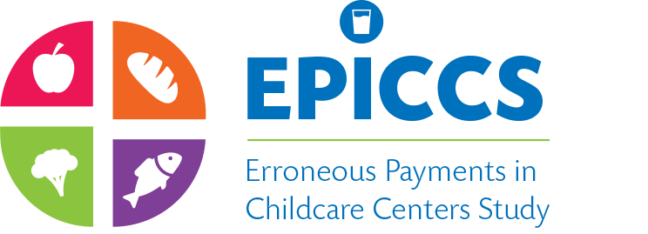

FACT SHEET/FAQs
OMB Number: 0584-XXXX
Expiration Date: XX/XX/XXXX
STUDY OVERVIEW

The Food and Nutrition Service (FNS) of the U.S. Department of Agriculture (USDA), has contracted with Westat and its partnering organizations; Kokopelli Associates LLC and Windwalker Corporation, to conduct the Erroneous Payments in Child Care Centers Study (EPICCS).

The study will collect data on the breakfast and lunch meal programs at CACFP-participating child care centers. Most data will be collected by trained data collectors during up to three visits to sponsor organizations and/or child care centers between October 2016 through July 2017 (at scheduled times). Data collection will include:
- A pre-visit phone interview with sponsors and centers to prepare for data collection
- Abstracting data from income eligibility applications
- Abstracting data from meal counting and claims records
- Abstracting administrative data on enrollment and attendance
- Conducting meal observations
- Conducting in-person (in home) interviews with randomly selected parents/guardians
- Completing a mailed survey that collects operational and organizational details from sponsors

FREQUENTLY ASKED QUESTIONS

- What is the purpose of this study?
The Erroneous Payments in Child Care Centers Study (EPICCS) will review potential sources of error in reimbursements in the Child and Adult Care Food Program (CACFP). This data will be used to maximize the efficiency of meal tracking and reporting within the program, which will, in turn, ensure the integrity, refinement, and continuity of the CACFP.
- Who is sponsoring this study?
This study is sponsored by the U.S. Department of Agriculture (USDA), Food and Nutrition Service (FNS).
- Who is conducting this study?
Westat and its partners; Kokopelli Associates and Windwalker Corporation, are conducting this study. Westat is a private research firm headquartered in Rockville, Maryland with over 50 years of experience conducting surveys and data collection.
- Who will be the participants of this study?
The participants will be randomly selected. They will include 25 State CACFP agencies, about 450 sponsoring organizations, 450 child care centers and 5,400 households with children enrolled in the sampled centers. Sampled child care centers will be equally represented by 150 Sponsored child care centers (SCCCs), 150 Independent Child Care Centers (ICCCs), and 150 Head Start Centers (HSCs).

According to the Paperwork Reduction Act of 1995, an agency may not conduct or sponsor, and a person is not required to respond to, a collection of information unless it displays a valid OMB control number. The valid OMB control number for this information collection is 0584-XXXX. The time required to complete this information collection is estimated to average 10 minutes per response for the sponsor directors and 15 minutes per response for the center directors/managers. These time estimates include the time to review instructions, search existing data sources, gather and maintain the data needed, and complete and review the collection of information.

- What will be the role of the participants in the study?
State CACFP Agencies: The State CACFP Director’s Office will provide the administrative data to construct the sample frame. The State CACFP Director’s office will also be asked to contact the sampled sponsors, and ICCCs, to inform them of their selection, explain why their participation in the study is important, and to encourage their participation.
Sponsors/ICCCs: Sponsors will be asked to provide access to their administrative meal counting and meal claiming procedures and records. If income eligibility applications records are maintained by the sponsor, data collectors will conduct three separate visits to review and abstract application data at the sponsor location. Visits will be scheduled in advance. Sponsors will also be requested to notify their selected child care centers and encourage them to participate in the study. Each sponsor will also be asked to complete a mailed survey on their characteristics, technical training approaches, and the monitoring of the child care centers.
Child Care Centers: Child care centers will be asked to provide data collectors access to their administrative meal counting and meal claiming procedures along with the records that they use for preparation and submission to their sponsoring organizations (or directly to State CACFP agencies, for ICCCs). During the data collection visit, data collectors will also conduct observations of meal preparation and service during breakfast and lunch. If income eligibility applications records are maintained by the child care center, data collectors will conduct three separate visits to review and abstract application data at the child care center. Visits will be scheduled in advance.
Parents/Guardians of Children Attending Selected Child Care Centers: Randomly selected households with a child, or children, attending a CACFP-participating child care center will be invited to complete an in-person interview survey. This component of the EPICCS study is entitled the National Assessment of Meal Eligibility and Services (NAMES) study. Households agreeing to participate will receive $30 or $50, depending on their level of participation, as a token of appreciation.

- Do I have to participate?
Your cooperation with program research and evaluation requested by FNS is in keeping with the provisions of the Healthy, Hunger-Free Kids Act of 2010. In addition, this study is necessary for FNS to meet the Congressional mandates that are part of the Improper Payments Elimination and Recovery Improvement Act of 2012. The results of this study will help inform future legislation and regulations regarding the child care center component of the CACFP.
Your participation is crucial to ensure that the study includes a representative sample and produces scientifically valid findings. It is also an opportunity for you to help influence policy decisions about the future of the CACFP. All information provided by study participants will be kept strictly private, as provided for by law, and will not affect your participation or program benefits in any way.

- Will the information we provide to you be secure and private?
Westat and its partners will take all necessary steps to ensure that your information is protected and secure. All information you provide will be kept private to the extent provided for by law, and will not be disclosed to anyone but the researchers conducting this study. We also implement strict security protocols, use password-protected networks, encrypted flash drives, and possess a secure data storage area. All data will be reported in aggregate without identifying a particular organization or household.

- What if I have more questions? Who do I contact for more information?
If you have additional questions or comments, please contact us at 1-855-272-0058 or EPICCS@westat.com. We are available Monday through Friday from 9am to 5pm Eastern Time.

