The Child and Adult Care Food Program (CACFP)
The Food and Nutrition Service (FNS) of the U. S. Department of Agriculture (USDA) funds the Child and Adult Care Food Program (CACFP). This program provides aid to support child care centers in providing healthy meals to children.
The National Meal Eligibility and Services (NAMES) Study
FNS is now doing the NAMES Study to gather information to help the program work better. One activity of the NAMES Study is a household survey conducted by Westat. Your household was randomly chosen to be in this survey. If you decide to be part of it, we ask you to talk to an interviewer at your home, or other place you choose at a time that is convenient for you.
Survey questions will ask about your child’s experience with the breakfasts and lunches served by your child care center. There are also questions about your household’s income and how your eligibility was collected by and reported to the child care center. We will give you a worksheet and instructions to prepare for survey questions before we visit you for the interview.
Your opinions and experience matter.
APPENDIX B18. NAMES BROCHURE



1600 Research Boulevard
Rockville, MD 20850
www.westat.com,

According to the Paperwork Reduction Act of 1995, an agency may not conduct or sponsor, and a person is not required to respond to, a collection of information unless it displays a valid OMB control number. The valid OMB control number for this information collection is 0584-XXXX. The time required to complete this information collection is estimated to average three minutes per response, including the time for reviewing instructions, searching existing data sources, gathering and maintaining the data needed, and completing and reviewing the collection of information.
OMB Number: 0584-XXXX
Expiration Date: XX/XX/XXXX

National Assessment
of Meal Eligibility
and Services

NAMES
A Household Survey
About the Child Care Center
Meals ProgramN
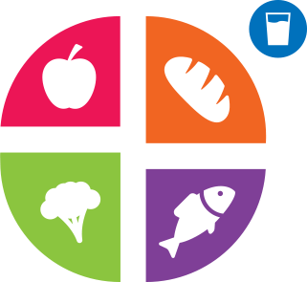
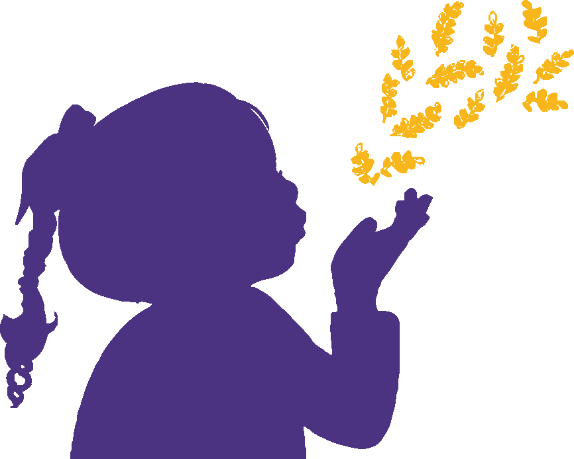

The U.S. Department of Agriculture’s Food and Nutrition Service is conducting this study.
Frequently Asked Questions
Why do this study?
Food and Nutrition Services (FNS), U.S. Department of Agriculture (USDA) is doing this study to learn more about its meals program in Child and Adult Food Care Program (CACFP) child care centers across the country. In particular, USDA wants to know more about how breakfast and lunchtime meals are served and how centers determine household eligibility and report meal claims to the USDA.
Who is doing the study?
The USDA’s Food and Nutrition Service (FNS) contracted with Westat, and its research partners Kokopelli Associates and Windwalker Corporation to do this study.
Why did you choose my household?
Your household was randomly chosen using a scientific method to do the survey from an enrollment list at the child care center your child attends. We want to talk with you so that our findings represent all households that attend child care centers that participate in the CACFP.

What are you asking me to do?
We want you to do an in-person interview. Once your visit is scheduled we ask you to prepare for the interview with materials we send to you.
How much time will this take?
We estimate the interview will take about 45 minutes plus some time to prepare for the interview. As a thank you, you can receive a gift card of up to $50 when you finish the survey.
Where will the interview take place?
We will do the interview at your home, or any place you choose, at a time that is convenient for you.
What questions will you ask?
Survey questions ask about your views on meals offered at the child care center. The survey will also ask about your household size and income.
Do I have to do this study?
No, it is your choice if you want to join or not. You can also skip any question you do not want to answer. However your views are important for helping the USDA improve the CACFP.
Why do you need to ask about income?
Income data helps the USDA know more about the families who may qualify for CACFP meal benefits.

How will you protect my identity?
We are very serious about protecting your privacy to the full extent allowed by law. Anyone working on the study must sign a pledge promising to keep your data private before. This means your personal information cannot be discussed with anyone other than authorized research staff. Nothing you tell us about the child care center or your household is shared with the FNS. All study reports combine your answers with those of others in the study to summarize what was found so that no family or child can ever be identified.
Can this impact any benefits our household gets?
No. The NAMES Study will not share what you say with the child care center, FNS, or any other agency giving you benefits. Thus, being in the study cannot change your child’s status at the center, eligibility in the meal program, or any other benefits you receive.
______________________________
Questions?
Need help scheduling an interview?
Call us toll-free at 1-855-272-0058 or send an email to EPICCS@westat.com.
We are happy to assist you!
National Assessment
of Meal Eligibility
and Services
NAMES

