Attachment E – Lesson Feedback Worksheet for Program Operators
RECIPE

LOCATION

ID#

Prep Time hours: ______ minutes:______
Lesson Time hours: ______ minutes:______
What did you do to prepare for this lesson?

Video observation notes (please note any reactions from students during video)

What went well in this activity?

What did not go well in this activity?

What part(s) of this activity did you find unclear or confusing, if any?

How would you make this activity better?

If Yes – What did you change or how did you customize?

If No – What were you missing?

Did you adapt or customize this activity in any way?
(MARK ONLY ONE)

- Yes
- No

Did you have all the food and supplies you needed to make the recipe? (MARK ONLY ONE)
- Yes
- No

What did the children find challenging about the activity?

How did this recipe taste?
(MARK ONLY ONE)

- Very good
- Good
- OK
- Bad
- Very bad

What ingredients would you change or add?

__________________________

Which sections from the activity guide did you implement?
(MARK ALL THAT APPLY)

- Introduction/Ground Rules
- Handwashing
- All about ingredients
- Nutritious and Delicious MyPlate
- How to read a recipe
- Cooking and Eating
- Cleanup
- Wrap-Up (includes My recipe story and Kitchen tools worksheets)

How many adults participated in this activity? ______ (Record number of adults teaching or assisting)
How many children participated in this activity? ______ (Record number of children)
Was this the ideal number of students? _________ (Yes or No)
Did the participating students take home family handouts?________ (Yes or No)

OMB BURDEN STATEMENT: According to the Paperwork Reduction Act of 1995, an agency may not conduct or sponsor, and a person is not required to respond to, a collection of information unless it displays a valid OMB control number. The valid OMB control number for this information collection is 0584-0524. The time required to complete this information collection is estimated to average 8 minutes per response, including the time for reviewing instructions, searching existing data sources, gathering and maintaining the data needed, and completing and reviewing the collection of information.

How useful do you think this activity is in changing children’s attitudes toward food?
(CIRCLE ONLY ONE NUMBER BELOW)

NOT AT ALL USEFUL EXTREMELY USEFUL 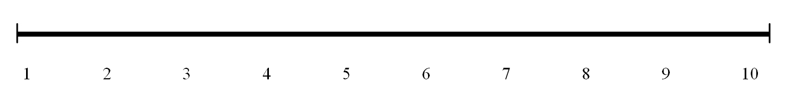
Did you find this activity appropriate for children 8–12 years old?
(MARK ONLY ONE)

- Yes
- No

Why or why not?

