OMB BURDEN STATEMENT: According to the Paperwork Reduction Act of 1995, an agency may not conduct or sponsor, and a person is not required to respond to, a collection of information unless it displays a valid OMB control number. The valid OMB control number for this information collection is 0584-0524. The time required to complete this information collection is estimated to average 20 minutes per response, including the time for reviewing instructions, searching existing data sources, gathering and maintaining the data needed, and completing and reviewing the collection of information.

Attachment K: Survey for 6-12 Year Old Children
Student First Name: _______________________ Gender: __________
Teacher Name: _____________________________ Age: ___________

Section I Instructions: Please read the questions below along with your teacher and answer honestly. There are no right or wrong answers; we just want to know what you think.
QUESTION 1 - Please answer each question below with either Yes, No, or I don’t know. | YES | NO | I Don't Know
Have you tried a new type of vegetable, fruit or grain recently? | Y | N | IDK
Do you like trying new fruits or vegetables? | Y | N | IDK
Do you help with cooking at home? | Y | N | IDK
Have you helped prepare a new recipe at home recently? | Y | N | IDK
Have you tried new foods from another part of the world recently? | Y | N | IDK

QUESTION 2 - How often do you help with the following cooking tasks? | Never | Sometimes | Often | All the time
Wash vegetables and fruits | 0 | 1 | 2 | 3
Wash cooking utensils | 0 | 1 | 2 | 3
Measure ingredients | 0 | 1 | 2 | 3
Peel the skin of vegetables | 0 | 1 | 2 | 3
Mix ingredients | 0 | 1 | 2 | 3
Mash vegetables | 0 | 1 | 2 | 3
Tear leaf vegetables | 0 | 1 | 2 | 3

Section II Instructions: The questions in this section ask for your ideas about new foods. There are statement about foods and images of actual foods. For each one, circle the answer that is the closest to how you feel. There are no right or wrong answers.

QUESTION 3 - Before you try a new food, how much do you think you will like it?
I won’t like it very much | I won’t like it | I am not sure if I will like it | I will like it a little | I’ll like it very much
QUESTION 4 – Look the foods below and answer how much you think you will like each one.

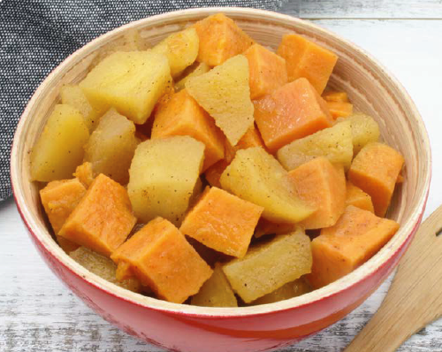 |  |  |  | 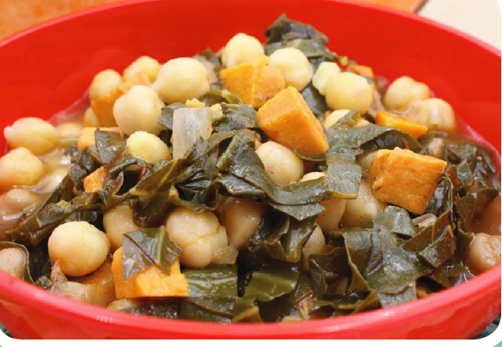 |  | 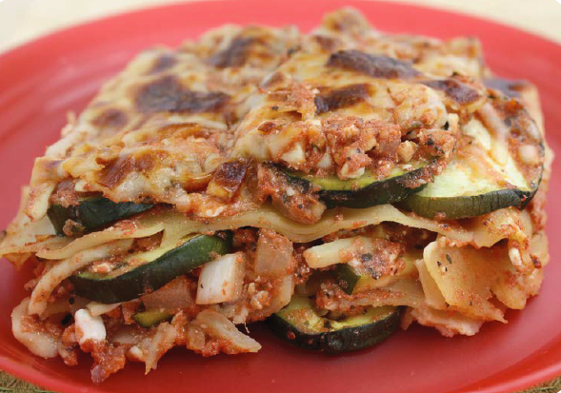 |  | 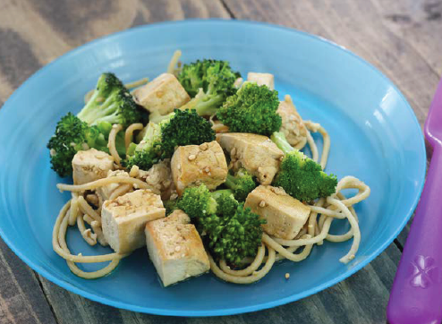
 | I won’t like it very much |  | I won’t like it very much |  | I won’t like it very much |  | I won’t like it very much |  | I won’t like it very much
 | I won’t like it |  | I won’t like it |  | I won’t like it |  | I won’t like it |  | I won’t like it
 | I am not sure if I will like it |  | I am not sure if I will like it |  | I am not sure if I will like it |  | I am not sure if I will like it |  | I am not sure if I will like it
 | I will like it a little |  | I will like it a little |  | I will like it a little |  | I will like it a little |  | I will like it a little
 | I’ll like it very much |  | I’ll like it very much |  | I’ll like it very much |  | I’ll like it very much |  | I’ll like it very much

QUESTION 5 - For each food, circle which face shows how much you like each food.

 |  | 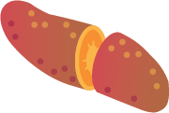
 | I love it! |  | I love it! |  | I love it! |  | I love it! |  | I love it! |  | I love it!
 | I Like It |  | I Like It |  | I Like It |  | I Like It |  | I Like It |  | I Like It
 | It’s Ok |  | It’s Ok |  | It’s Ok |  | It’s Ok |  | It’s Ok |  | It’s Ok
 | I don’t like it |  | I don’t like it |  | I don’t like it |  | I don’t like it |  | I don’t like it |  | I don’t like it
? | What is that? | ? | What is that? | ? | What is that? | ? | What is that? | ? | What is that? | ? | What is that?

