Attachment C – Questionnaire for Student Pre-/Post-Intervention Survey
OMB BURDEN STATEMENT: According to the Paperwork Reduction Act of 1995, an agency may not conduct or sponsor, and a person is not required to respond to, a collection of information unless it displays a valid OMB control number. The valid OMB control number for this information collection is 0584-0524. The time required to complete this information collection is estimated to average 15 minutes per response, including the time for reviewing instructions, searching existing data sources, gathering and maintaining the data needed, and completing and reviewing the collection of information.

NOTE: Researcher will enter unique participant ID at beginning of survey.

ASSENT
We need your help to decide if a new program is good for kids like you. We want to know about the foods you like to eat and what you know about making healthy food. You can tell us what you think about the activities in the program, and that will help us make the program better.

Only we will know the things you tell us. We won’t share your answers with your teachers, family, or friends.

You can decide if you want to help us, and you can stop at any time. You do not have to answer any questions you do not want to.

If you have any questions about this, you can call Fors Marsh Group at 571-858-3817 or email us at ux@forsmarshgroup.com.

Do you want to participate in the study?
- Yes
- No

PART I: INTRODUCTION

Thank you for agreeing to help us today! We will ask you about food and healthy eating.

How to Answer

You can touch the screen to tell us what you think. Let’s try it!

○ | ○ | ○ | ○
What color do you like best?

PART II: DEMOGRAPHICS

Great! Now tell us a little bit about yourself.

S1. How old are you?
(Demographic question adapted for TNC; Kelder et al., 2005)
- 7 years old or younger
- 8 years old
- 9 years old
- 10 years old
- 11 years old
- 12 years old
- 13 years old or older

S2. What grade are you in?
(Demographic question adapted for TNC; Kelder et al., 2005ª)
- 2nd grade
- 3rd grade
- 4th grade
- 5th grade
- 6th grade

PART III: Food Preparation

Q1. Have you ever made food or helped someone make food at home? (Social Norms, Behavior)
- Yes
- No [If no, skip to Q4_A]

Q2. Do you make food yourself or help someone else make food? (Social Norms, Behavior)
- Yes, a lot
- Yes, sometimes
- No, not really

Q3. How much do you enjoy making food or helping someone make food? (Enjoyment)

 |  | 
A. A lot | B. A little | C. I don’t enjoy it
Thank you! Now please tell us what you think about these statements.

Q4_A. I know how to make a snack.
(Self-efficacy; tailored from De Bourdeaudhuij et al., 2005)





A. Yes, I do | B. I think I do | C. I am not sure | D. I don’t think I do | E. No, I don’t

Q4_B. I can make a snack without much help. (Self-efficacy)

A. Yes, I can | B. I think I can | C. I am not sure | D. I don’t think I can | E. No, I can’t

PART IV: Healthy Eating
Q5. What are your 3 favorite foods? (pre- and post-preferences)

Q6. What are your 3 favorite healthy foods? (pre- and post-healthy preferences and knowledge check)

Q7. What are 3 foods you DO NOT like? (pre- and post-preferences)

Q8. Please give 3 examples of healthy foods that you can eat as much as you like.
(Pre- and post-knowledge check)

Q9. Please give 3 examples of less healthy foods that you should limit how much you eat.
(Pre- and post-knowledge check)

Q10. How much do you like: Apples
[Adapted from Cullen 2003; Baxter 2002]
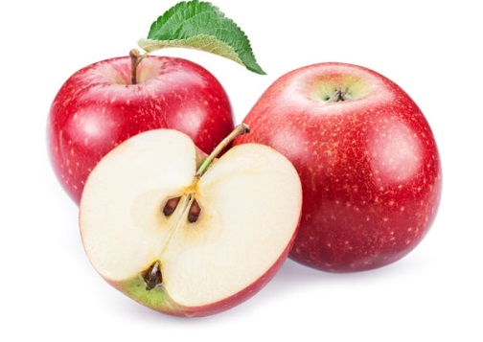

 |  |  | 
A. I like them a lot | B. I like them a little | C. I don’t like them | D. I don’t know what these are or I have never had them

Q11. How much do you like: Corn

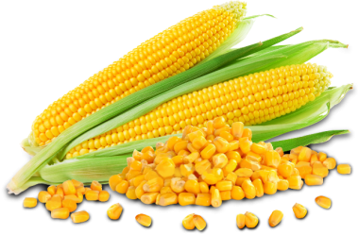

A. I like it a lot | B. I like it a little | C. I don’t like it | D. I don’t know what this is or I have never had it

Q12. How much do you like: Quinoa (“Keen-wa”)
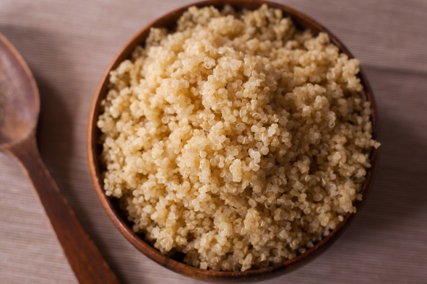

A. I like it a lot | B. I like it a little | C. I don’t like it | D. I don’t know what this is or I have never had it

Q13. How much do you like: Zucchini

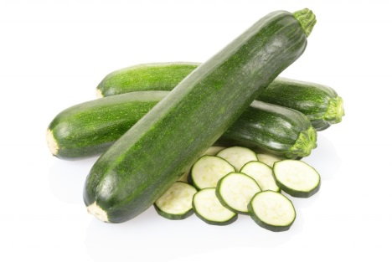

A. I like it a lot | B. I like it a little | C. I don’t like it | D. I don’t know what this is or I have never had it

Q14. During the past 3 days, how many times did you eat French fries or chips?
(Pre- and post-dietary intake; Youth Risk Behavior Survey; Kelder et al., 2005ª)
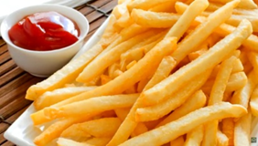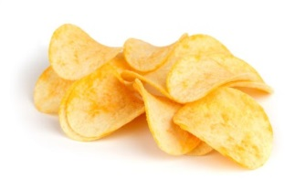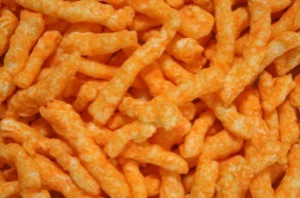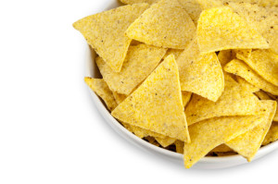

A. None
B. One time
C. Two times
D. Three times
E. Four times or more

Q15. During the past 3 days, how many times did you eat vegetables? Do not count French fries or chips.
(Pre- and post-dietary intake; Adapted from Youth Risk Behavior Survey; Kelder et al., 2005ª)
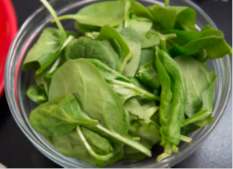
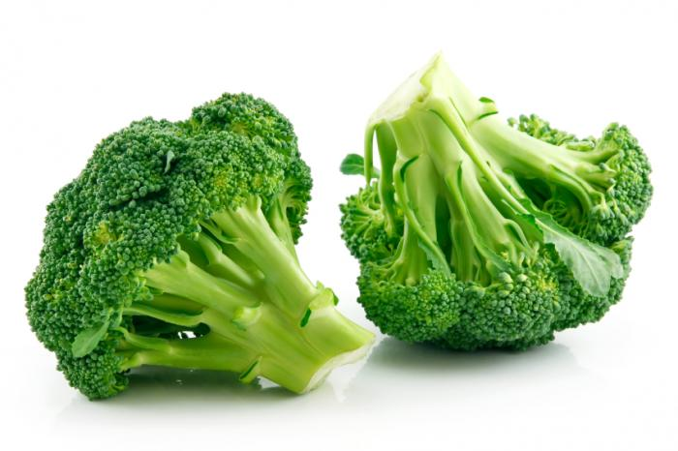
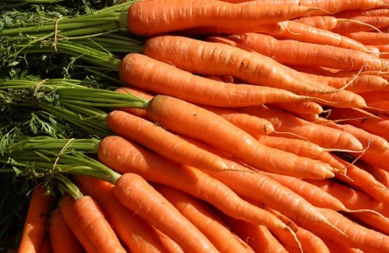
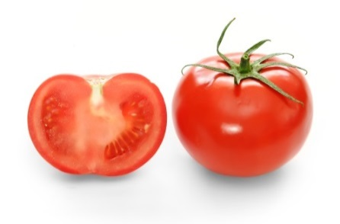
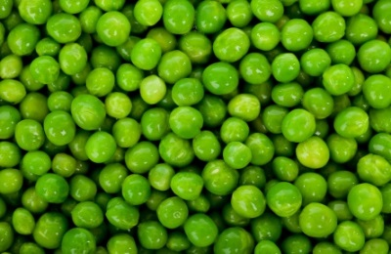
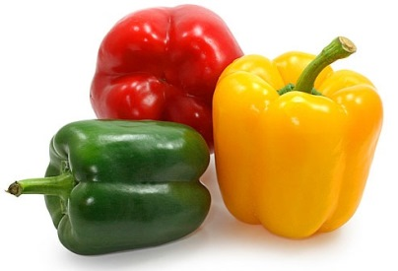
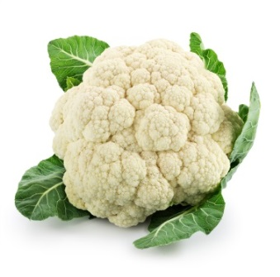
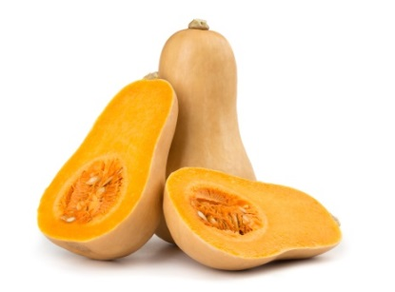

A. None
B. One time
C. Two times
D. Three times
E. Four times or more

Q16. During the past 3 days, how many times did you eat fruit? Do not count fruit juice.
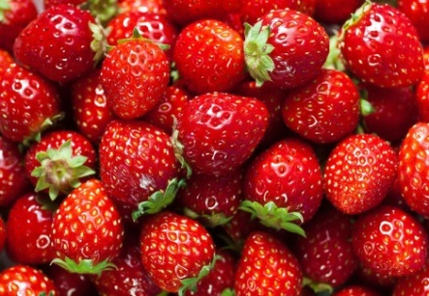
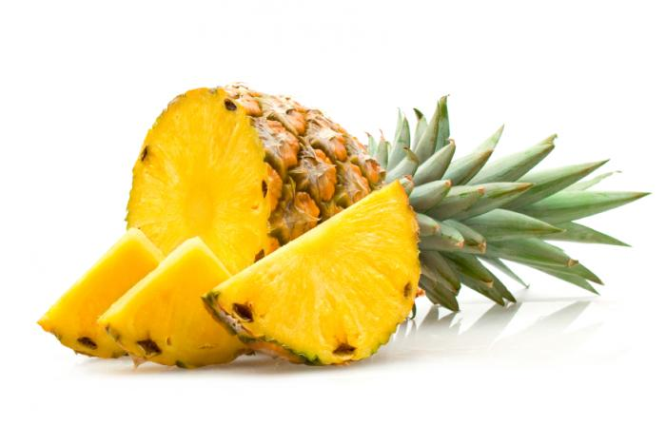
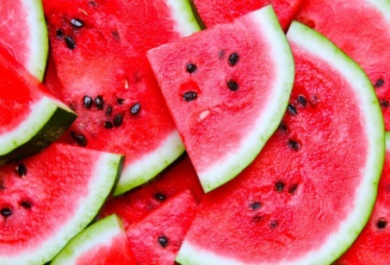
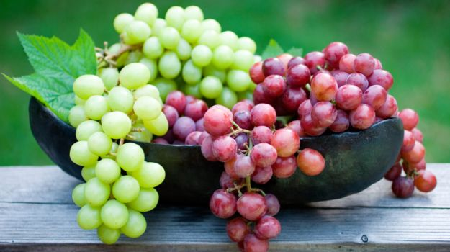
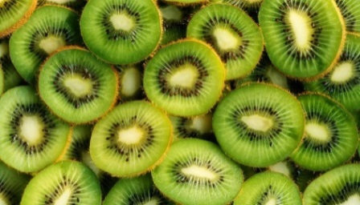
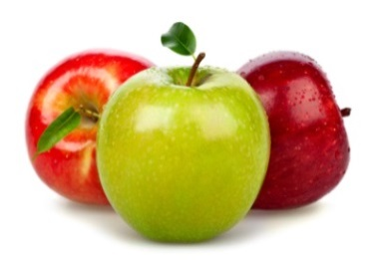
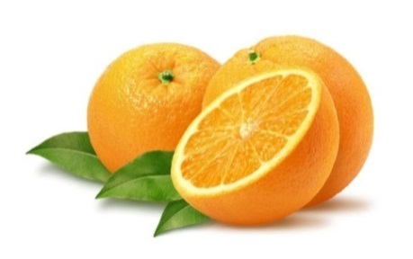
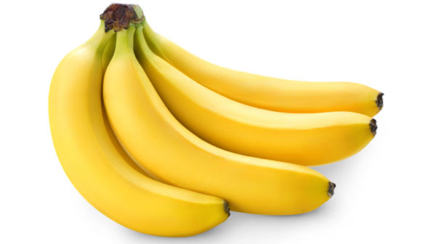
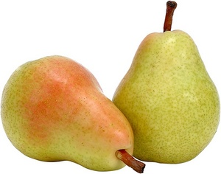
(Pre- and post-dietary intake; Adapted from Youth Risk Behavior Survey; Kelder et al., 2005ª)

A. None
B. One time
C. Two times
D. Three times
E. Four times or more

Q17. During the past 3 days, how many times did you drink fruit juice? Do not count punch, Kool-Aid, or Gatorade.
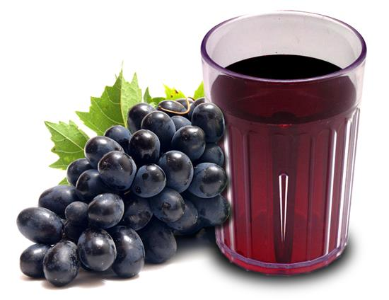
(Pre- and post-dietary intake; Adapted from the Youth Risk Behavior Survey; Kelder et al., 2005ª)
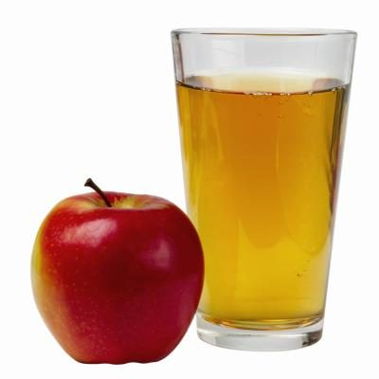
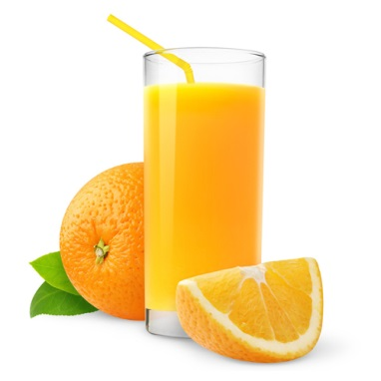
A. None
B. One time
C. Two times
D. Three times
E. Four times or more

Q18. During the past 3 days, how many times did you eat sweets?
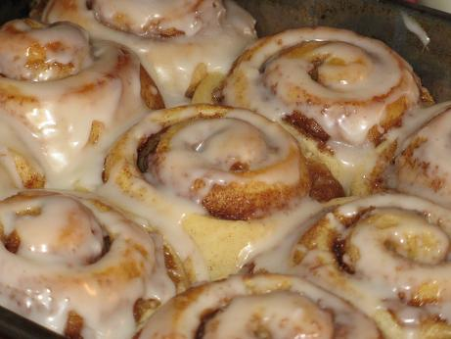
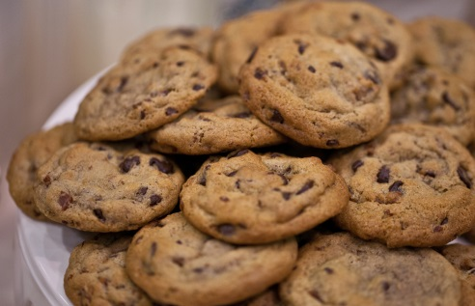
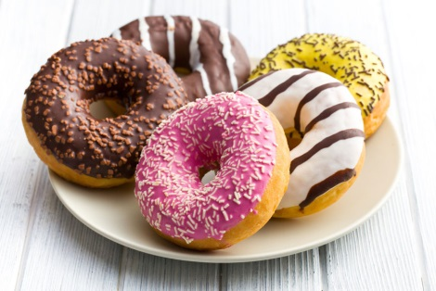
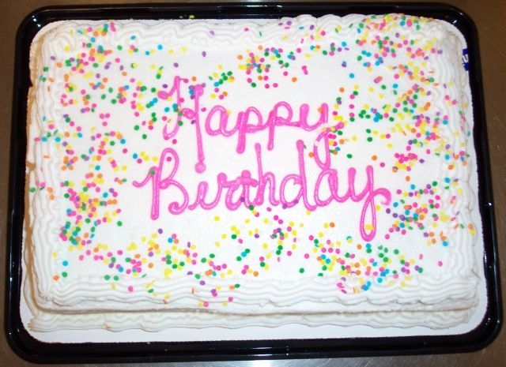
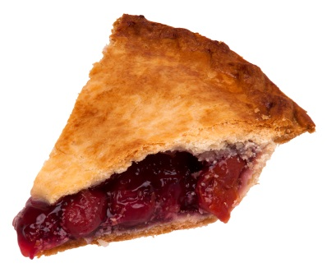
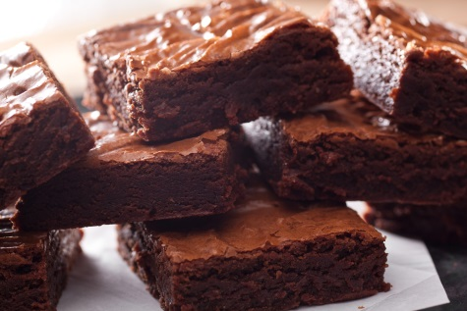
(Pre- and post-dietary intake; Adapted from the Youth Risk Behavior Survey; Kelder et al., 2005ª)

A. None
B. One time
C. Two times
D. Three times
E. Four times or more

Q19_A. Which foods are healthy? You can pick one or more.
(Healthy eating knowledge from TNC)

a. | 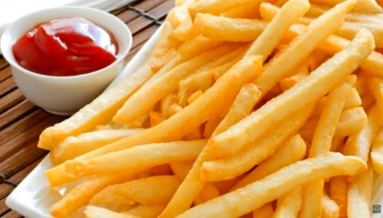  b. | c. 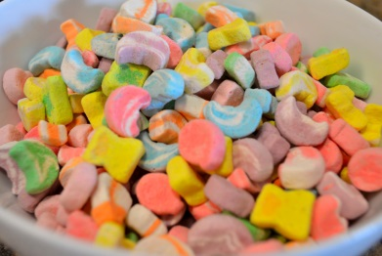
d. 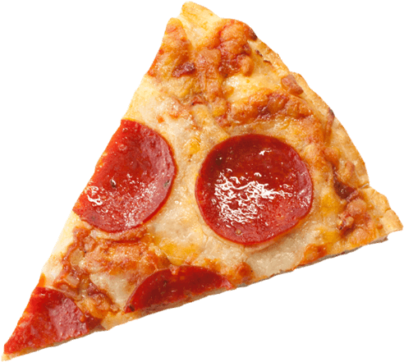 | e. 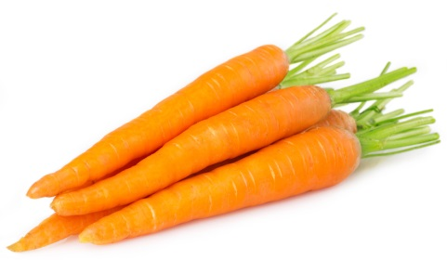 | f.

Q19_B. Which foods are healthy? You can pick one or more.
(Healthy eating knowledge from TNC)

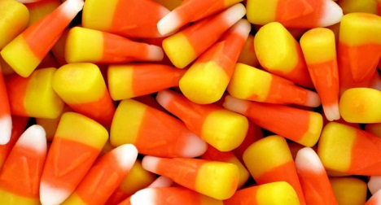  a. | b. | c. 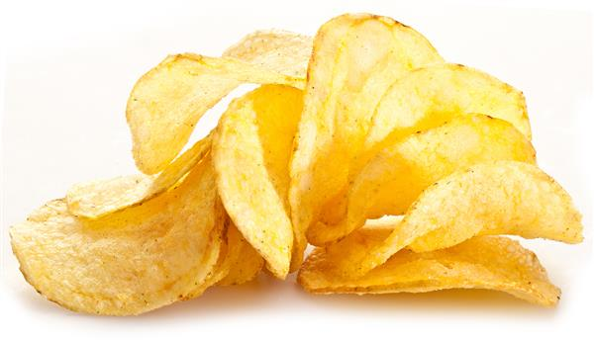
d. 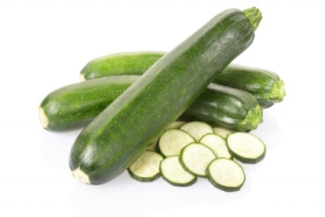 | e. 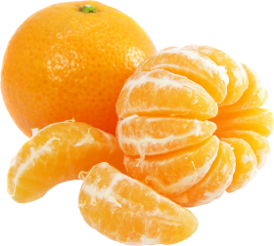 | f.  

Q19_C. Which foods are healthy? You can pick one or more.
(Healthy eating knowledge from TNC)

a. | 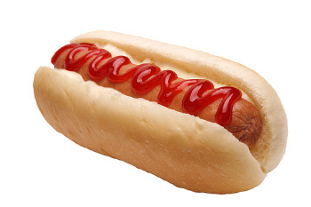  b. | c. 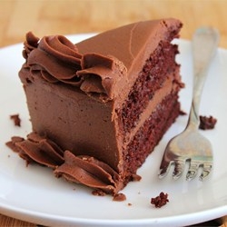
d. 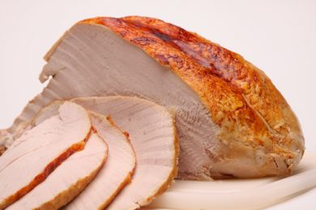 | e. 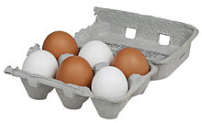 | f.  

Next, we will ask you about things you might or might not know about food and cooking. Just make your best guess.

Q20_A. What is the name of this kitchen tool?
(Knowledge of kitchen tools from TNC)

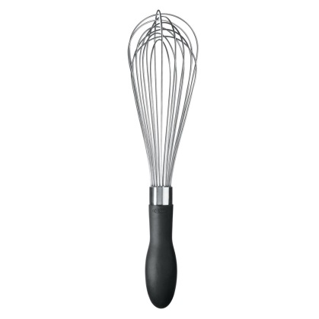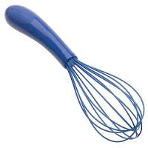

- Wooden spoon
- Whisk
- Butter knife
- I am not sure
Q20_B. What is this kitchen tool used for?
(Knowledge of kitchen tools from TNC)
- To mix together ingredients
- To measure ingredients
- To remove the skin from fruits and vegetables
- I am not sure

Q20_C. What is the name of this kitchen tool?
(Knowledge of kitchen tools from TNC)
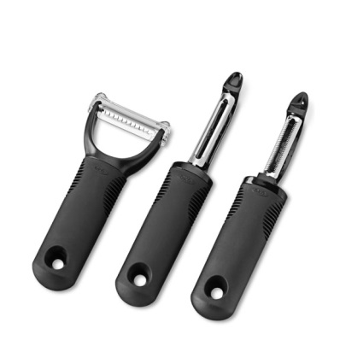
- Spatula
- Peeler
- Whisk
- I am not sure

Q20_D. What is this kitchen tool used for?
(Knowledge of kitchen tools from TNC)

- To mix together ingredients
- To measure ingredients
- To remove the skin from fruits and vegetables
- I am not sure

Q20_E. What is the name of this kitchen tool?
(Knowledge of kitchen tools from TNC)

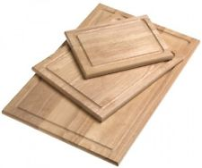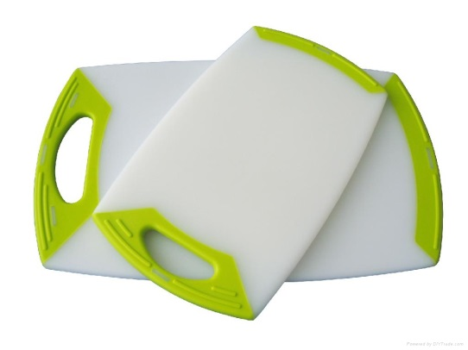
- Skillet
- Bowl
- Cutting board
- I am not sure

Q20_F. What is this kitchen tool used for?
(Knowledge of kitchen tools from TNC)

- To measure ingredients
- To slice and chop ingredients
- To remove the skin from fruits and vegetables
- I am not sure

For the next few questions, please answer true or false—or you can say that you’re not sure if you don’t know the answer.

Q21. When washing your hands before touching food, you should scrub your hands for 10 seconds.
(Knowledge of food preparation from TNC)

- True
- False
- Not sure

Q22. When peeling fruits and vegetables, you should peel away from yourself.
(Knowledge of food preparation from TNC)

- True
- False
- Not sure

Q23. When dicing or cutting food, keep your fingers tucked in, away from the knife.
(Knowledge of food preparation from TNC)

- True
- False
- Not sure

Q24. When cooking, make sure the pot handle is turned in, toward the center of the stove.
(Knowledge of food preparation from TNC)

- True
- False
- Not sure

Q25. This icon represents…
(Knowledge of MyPlate.gov from TNC)

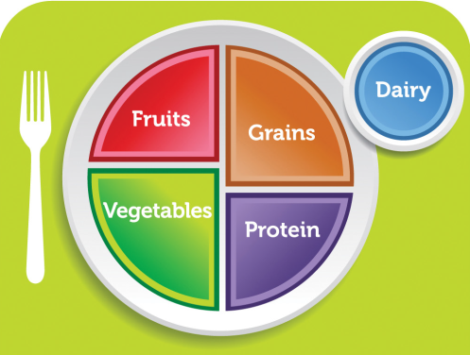

- Healthy eating
- Unhealthy eating
- Not sure

PART V: HEALTH OUTCOME MEASURES

Q26. I like trying new foods. (Attitude)


A. Yes, a lot | B. Yes, a little | C. I am not sure | D. No, not really | E. No, not at all

Q27. I like eating food that is good for me. (Attitude)

A. Yes, I do | B. I think I do | C. I am not sure | D. I don’t think I do | E. No, I don’t

Q28. I feel good when I eat healthy food. (Outcome expectation)

A. Yes, I do | B. I think I do | C. I am not sure | D. I don’t think I do | E. No, I don’t

Q29. Healthy food tastes good. (Belief)

A. Yes, a lot | B. Yes, a little | C. I am not sure | D. No, not really | E. No, not at all

Q30. Eating healthy is important to me. (Attitude)

A. Yes, a lot | B. Yes, a little | C. I am not sure | D. No, not really | E. No, not at all

Q31. I want to eat healthy. (Attitude)

A. Yes, I do | B. I think I do | C. I am not sure | D. I don’t think I do | E. No, I don’t

Q32. I know the difference between healthy and unhealthy foods. (Knowledge)

A. Yes, I do | B. I think I do | C. I am not sure | D. I don’t think I do | E. No, I don’t

Q33. I know how to eat healthy foods every day. (Knowledge/Efficacy)

A. Yes, I do | B. I think I do | C. I am not sure | D. I don’t think I do | E. No, I don’t

PART VI: PROGRAM-SPECIFIC QUESTIONS
[Only show for POST-TEST]

Please tell us what you think about the cooking activities in your afterschool program.

Q34. Have you had fun making food in this program? (Enjoyment)

A. Yes, a lot | B. Yes, a little | C. I am not sure | D. No, not really | E. No, not at all

Q35. Did you try making any of the foods you learned about at home? (Behavior)
A. Yes B. No

Q36. Do you think you will try more new healthy foods? (Behavioral Intention)

A. Yes, lots | B. Yes, some | C. I am not sure | D. No, not really | E. No, not at all

Thank you for telling us what you think! Please hand the tablet back.

Kelder, S., Hoelscher, D. M., Barroso, C. S., Walker, J. L., Cribb, J., & Hu, S. (2005). The CATCH Kids Club: A pilot after-school study for improving elementary students’ nutrition and physical activity. Public Health Nutrition, 8, 133–140. doi: 10.1079/PHN2004678
De Bourdeaudhuij, I., Klepp, K. I., Due, P., Rodrigo, C. P., de Almeida, M. D. V., Wind, M., Brug, J. (2005). Reliability and validity of a questionnaire to measure personal, social and environmental correlates of fruit and vegetable intake in 10–11-year-old children in five European countries. Public Health Nutrition, 8, 189–200. doi: 10.1079/PHN2004673

