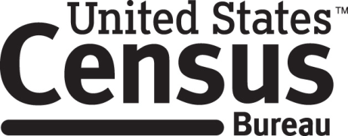

**Consent Form**

**Census Barriers, Attitudes and Motivators Survey Cognitive Interview**

Each year the Census Bureau conducts many different surveys and evaluations. The Census Bureau routinely tests the questions, wording, layout and behavior of products, such as surveys, websites and online questionnaires in order to produce the best information possible.

______________________ [NAME] consents to take part in a study to improve the questions and design of the Census Barriers, Attitudes and Motivators Survey. In order to have a complete record of your comments, the interview session will be audio and video-recorded. The Census Bureau plans to use the recordings to improve the questionnaire. Only staff directly involved in the research project will have access to the tapes. Participation is voluntary and answers will remain strictly confidential.

This study is being conducted under the authority of Title 13 USC. The OMB control number for this study is 0607-0725. This valid approval number legally certifies this information collection.

I have agreed to participate in this Census Bureau questionnaire design study, and I give permission for my recordings to be used for the purposes stated above.

____________________________ ___________________________

Participant's Signature Researcher's Signature

____________________________ __________________________

Printed Name Printed Name

___________________________ _______________________

Date Date