ROBOTIC EQUIPMENT ASSETS AND EXPENDITURES
A robot is an automatically controlled, reprogrammable, and multipurpose machine that is used in automation operations.
Robots may be mobile, incorporated into stand-alone stations, or integrated into the production line.
In manufacturing, robots are commonly used in operations such as welding, material handling, machine tending, dispensing, and pick and place.

A. Number of industrial robots used at this plant in 2018. . . . . . . .
B. Average purchase price of industrial robots used at this plant in 2018 (include software, installation and other one-time costs). . . . . . . . . . . . . . . . . . . . |  | 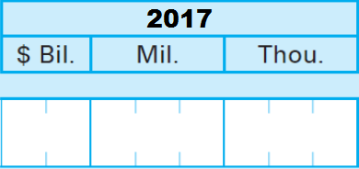
C. Number of industrial robots purchased for this plant in 2018. . .
D. Average purchase price of industrial robots purchased for this plant in 2018 (include software, installation and other one-time costs). . . . . . . . . . .

ROBOTIC EQUIPMENT ASSETS AND EXPENDITURES
A robot is an automatically controlled, reprogrammable, and multipurpose machine that is used in automation operations.
Robots may be mobile, incorporated into stand-alone stations, or integrated into the production line.
In manufacturing, robots are commonly used in operations such as welding, material handling, machine tending, dispensing, and pick and place.

Report the dollar value.

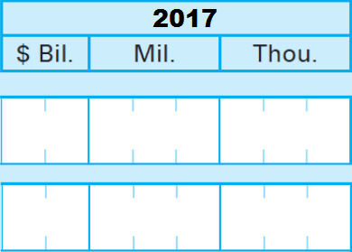
A. Gross value of industrial robotic equipment at the end of 2018. . . . . . . . . . .
B. Capital expenditures in 2018 for new and used industrial robotic equipment, including software, installation and other one-time costs. . . . . . . . . . .

INDUSTRIAL ROBOTIC EQUIPMENT ASSETS AND EXPENDITURES
An industrial robot is an automatically controlled, reprogrammable, and multipurpose machine that is used in industrial automation operations.
Industrial robots may be mobile, incorporated into stand-alone stations, or integrated into the production line.
Industrial robots are commonly used in operations such as welding, material handling, machine tending, dispensing, and pick and place.

