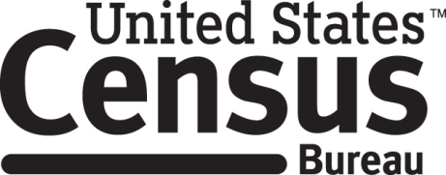

**Consent Form**

**Privacy Act Language Testing**

Each year the Census Bureau conducts many different surveys. The Census Bureau routinely tests the questions used on these surveys in order to produce the best information possible.

______________________ [NAME] consents to take part in a study to improve language that will be used in letters and other communication materials sent to people who are selected for surveys. In order to have a complete record of all comments, the interview session will be audio-recorded. The Census Bureau plans to use the recordings to improve the language. Staff directly involved in this research project will have access to the recordings. Participation is voluntary and answers will remain strictly confidential.

This study is being conducted under the authority of Title 13 USC. The OMB control number for this study is 0607-0725. This valid approval number legally certifies this information collection.

I have agreed to participate in this Census Bureau questionnaire design study, and I give permission for my tapes to be used for the purposes stated above.

____________________________ ___________________________

Participant's Signature Researcher's Signature

____________________________ __________________________

Printed Name Printed Name

___________________________ _______________________

Date Date