- Login Screens (eCorr)
  - Steps to create a new account
  - Creating a profile and answering security questions
  - Entering the authentication code to access your survey
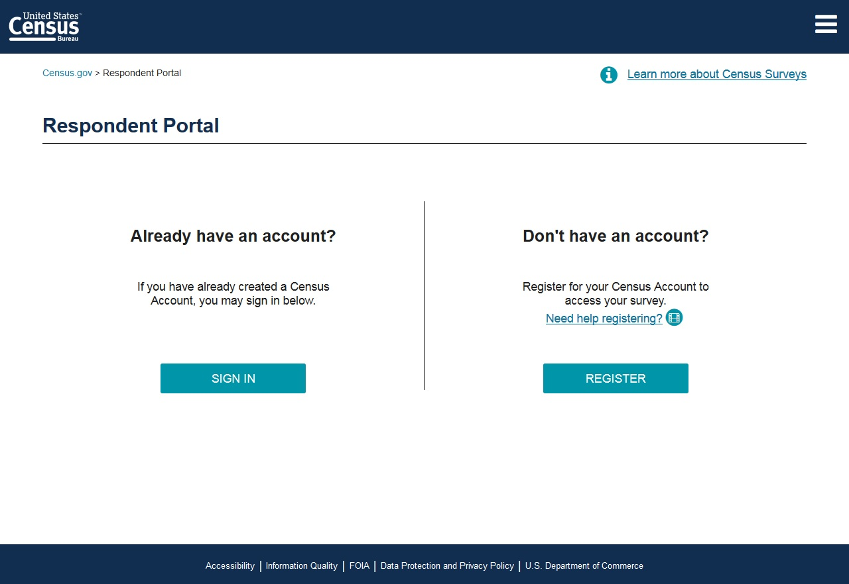

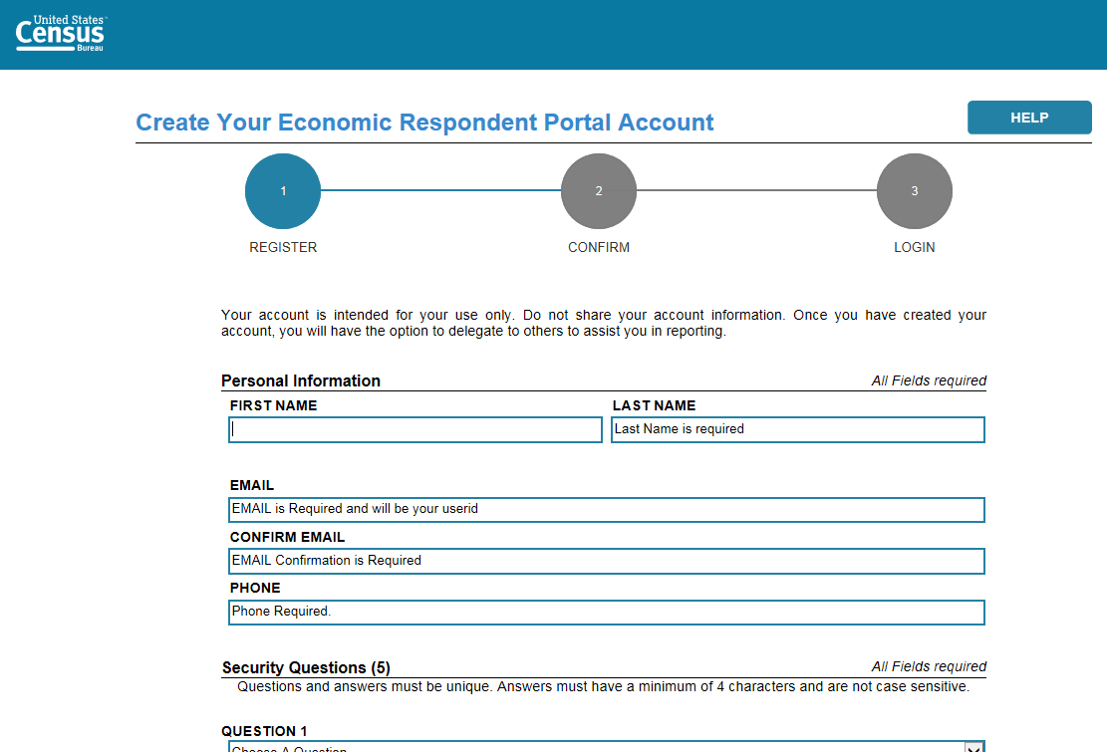

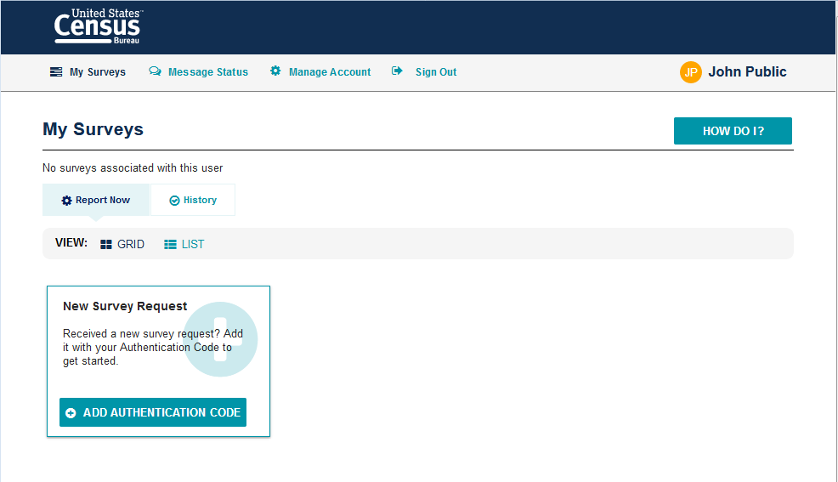

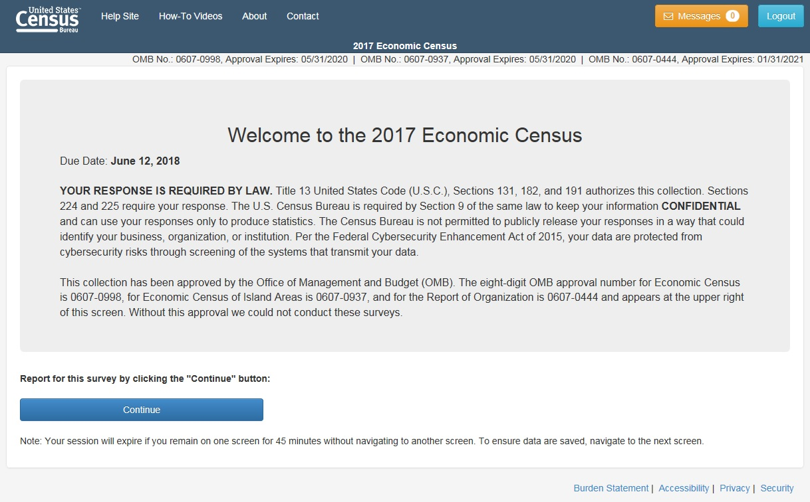

Link to How-To Videos

- Dashboard Overview
  - Overview Page: This page describes the basic steps a respondent needs to take to successfully submit their survey.
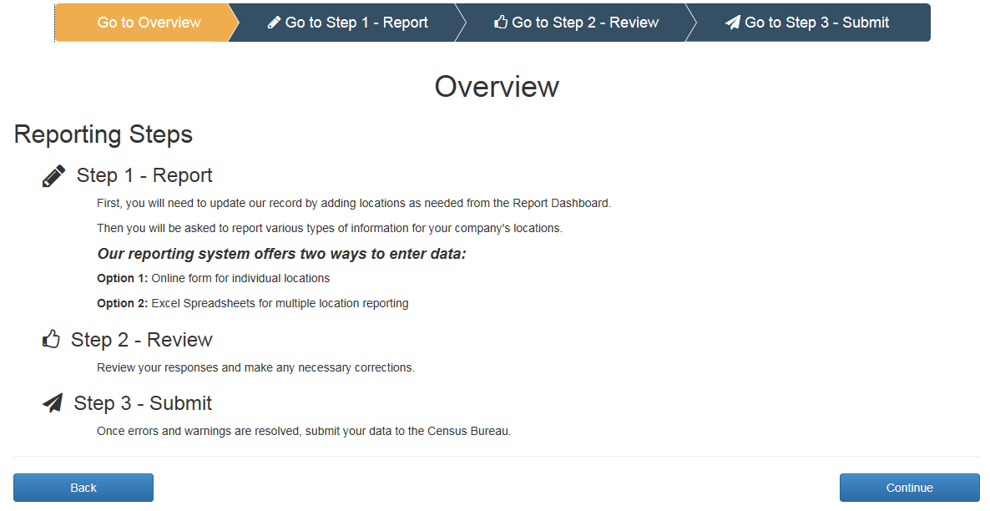
  - Site Navigation
    - The Banner; Horizontal Scrolling; Forward-Back Navigation
  - Main Dashboard Features
    - Filtering and sorting
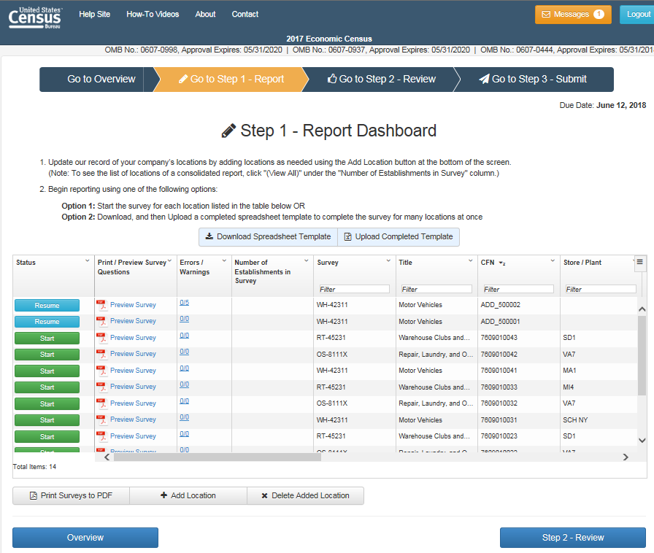

  - How to begin the survey

- Preview of Survey Questions
  - Printing Full Survey
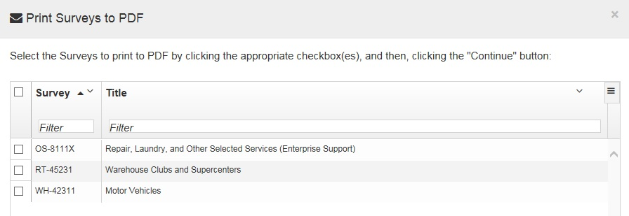

- Add/Delete Locations
  - Adding a New Location
    - Where to find the new information
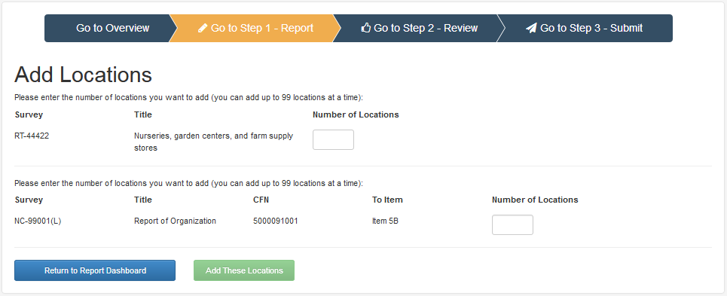
  - Deleting an Added Location
  - Closing a Pre-listed Location

- Messages Feature
  - Location of the messages
  - Types of messages received
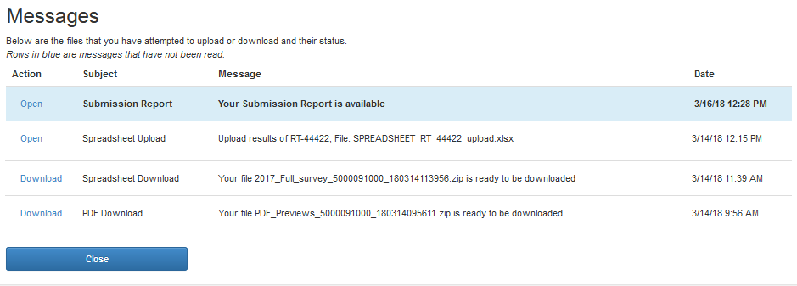

- Downloading Spreadsheet
  - How to download the spreadsheet
  - General guidance for Excel sheet do’s and don’ts
  - All Locations action explanation

- Uploading Spreadsheet
  - How to upload the completed spreadsheet
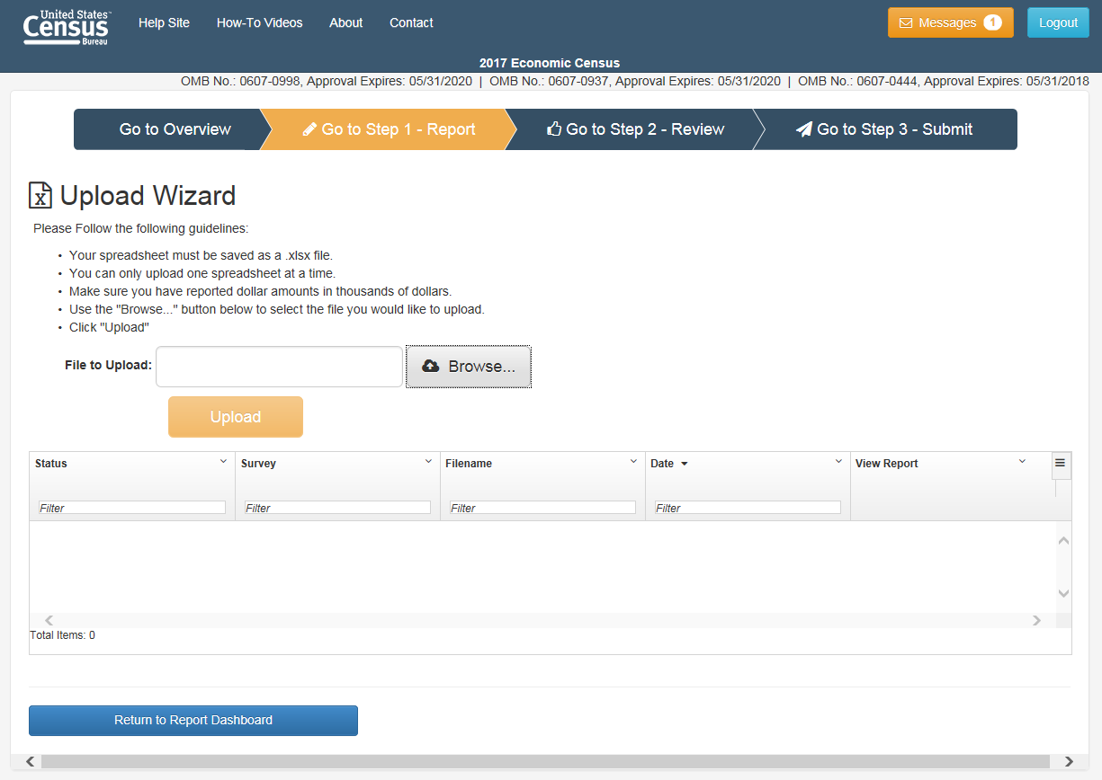

- Reviewing Your Responses
  - Fixing Errors and Warnings
  - Downloading Errors and Warnings
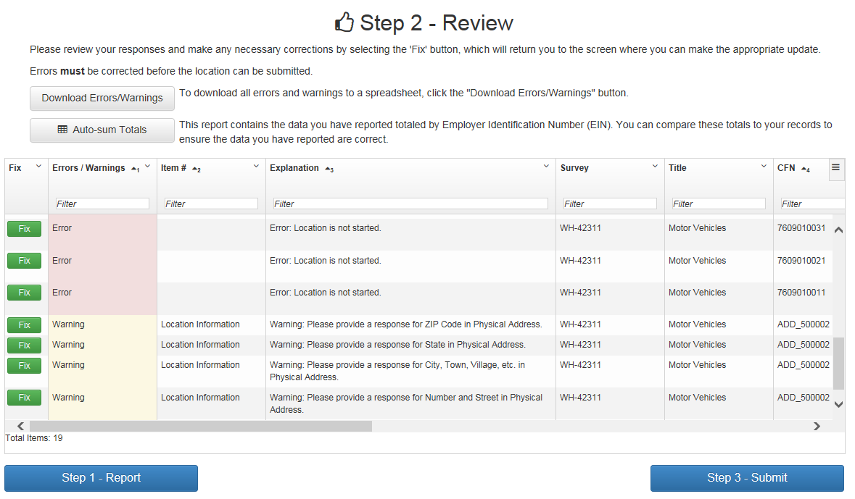

- Submitting Your Survey
  - How to submit the survey
  - Printing the completed survey
  - Confirming survey has been submitted successfully
