Enclosure 1: Exploratory research gathering data on map usage and neighborhood residency knowledge
(The title does not show on the survey and neither do the question numbers.)

Start of Block: Introduction

Q1.1 This is a survey for the U.S. Census Bureau. In the next census in 2020, the Census Bureau is considering asking the public to help identify vacant homes. We are looking for information about how you use online maps such as Google Maps to identify your home and your neighbors’ homes to help us plan for that census. Please take your time as you answer these questions. The information you provide will contribute to valuable research at the Census Bureau.
This voluntary study is being collected by the Census Bureau under OMB No. 0607-0725. This survey will take approximately 10 minutes to complete. Your participation is voluntary and you have the right to stop at any time.

Start of Block: General map usage

Q2.1 First, we would like to learn more about your use of online maps.

Q2.2 When was the last time you used a map on your computer or smartphone?
- Within the last week, including today (1)
- More than a week ago, but less than a month ago (2)
- In the last 1-3 months (3)
- More than 3 months ago (4)
- I don’t use maps on a computer or smartphone (5)

Skip To: End of Block If When was the last time you used a map on your computer or smartphone? = I don’t use maps on a computer or smartphone

Q2.3 How comfortable are you using maps on your computer or smartphone?
- Extremely comfortable (1)
- Somewhat comfortable (2)
- Neither comfortable nor uncomfortable (3)
- Somewhat uncomfortable (4)
- Extremely uncomfortable (5)

Q2.4 In the last few months, have you used maps mostly on a smartphone, mostly on a computer, or equally on a smartphone and computer?
- Mostly on my smartphone (1)
- Mostly on my computer (2)
- Equally on a smartphone and computer (3)

End of Block: General map usage

Start of Block: Cartoon

Q39 Here is one type of map. This map uses an example address. Please imagine seeing your home and your neighbors’ homes on this type of display.

Q65
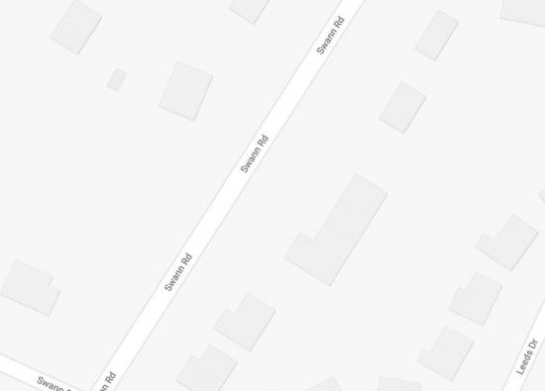

Q4.2 How familiar are you with this type of online map?
- Extremely familiar (1)
- Very familiar (2)
- Moderately familiar (3)
- Slightly familiar (4)
- Not familiar at all (5)

Q4.3 Imagine you were asked to locate your home and your neighbors’ homes on this type of map. How accurately do you think you would be able to do that?
- Extremely accurately (1)
- Very accurately (2)
- Moderately accurately (3)
- Slightly accurately (4)
- Not accurately at all (5)

End of Block: Cartoon

Start of Block: Satellite

Q40 Here is one type of map. This map uses an example address. Please imagine seeing your home and your neighbors’ homes on this type of display.

Q5.1
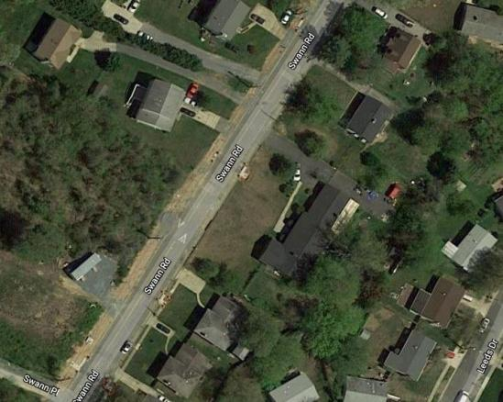

Q5.2 How familiar are you with this type of online map?
- Extremely familiar (1)
- Very familiar (2)
- Moderately familiar (3)
- Slightly familiar (4)
- Not familiar at all (5)

Q5.3 Imagine you were asked to locate your home and your neighbors’ homes on this type of map. How accurately do you think you would be able to do that?
- Extremely accurately (1)
- Very accurately (2)
- Moderately accurately (3)
- Slightly accurately (4)
- Not accurately at all (5)

End of Block: Satellite

This section will have 4 maps, the satellite and the road map, with and without the red pin at 3616 Swann Road
Based on “hallway” pretesting information, we will randomize whether they rank by dragging the images or whether they number the images. The images will be presented in a randomized order.
Start of Block: Map rank drag –

Q6.1
Next, we want to know which of these four map displays you prefer for locating your home and your neighbors’ homes. Imagine that your home is 3616 Swann Road.
Rank the map type you like the most number 1, and the type you like the least number 4.
To move an image, use your mouse or your finger to touch and hold the display that you want to move and drag it up or down.
______ Image:Map1 (9)
______ Image:Map2 (10)
______ Image:Map3 (11)
______ Image:Map4 (12)

End of Block: Map rank drag

Start of Block: Map rank number

Q45
Next, we want to know which of these four map displays you prefer for locating your home and your neighbors’ homes. Imagine that your home is 3616 Swann Road.
Rank the map type you like the most number 1, and the type you like the least number 4.
Type the number in the box to the left of the map.
______ Image:Map1 (9)
______ Image:Map2 (10)
______ Image:Map3 (11)
______ Image:Map4 (12)

End of Block: Map rank number

Start of Block: Descriptive stats and Gallup

Q7.1 For the next census in 2020, the Census Bureau is studying different ways to collect information about people's neighborhoods. The next set of questions is about your neighborhood.

Q7.2 Would you describe the place where you live as rural, suburban, or urban?
- Rural (1)
- Suburban (2)
- Urban (3)
- Not sure (4)

Q7.3 Which of the following best describes the type of place where you live?
- A one-family house detached from any other house (1)
- A one-family house attached to one or more houses (2)
- A building with 2 or more apartments (3)
- A mobile home (4)
- Some other type of residence (5)

Skip To: Q7.5 If Which of the following best describes the type of place where you live? = A building with 2 or more apartments
Skip To: Q7.5 If Which of the following best describes the type of place where you live? = A one-family house attached to one or more houses

Q7.4 Pretend that you are standing at the front door of your home looking out. Can you see the next closest house, apartment building, or mobile home to you from there?
- Yes (1)
- No (2)

Q7.5 Imagine standing at your front door looking out to your right. Picture your neighbor's house, apartment unit, or mobile home immediately to your right. Is anyone living in that home?
- Yes, someone is living there (1)
- No, no one is living there (2)
- I am unsure if someone is living there (3)
- I am unsure of what home this would be (4)
- There is no home to my right (5)

Skip To: Q7.7 If Imagine standing at your front door looking out to your right. Picture your neighbor's house, apa... = No, no one is living there
Skip To: Q7.7 If Imagine standing at your front door looking out to your right. Picture your neighbor's house, apa... = I am unsure if someone is living there
Skip To: End of Block If Imagine standing at your front door looking out to your right. Picture your neighbor's house, apa... = I am unsure of what home this would be
Skip To: End of Block If Imagine standing at your front door looking out to your right. Picture your neighbor's house, apa... = There is no home to my right

Q7.6 Still thinking of your neighbor to the right, do you know the first or last name of one person living in your neighbor's home?
- Yes (1)
- No (2)
- Not sure (3)

Q7.7 Still thinking of your neighbor to the right, do you know the street address of that home?
- Yes (1)
- No (2)

Q7.8 How certain are you that you know the street address of the home to your right?
- Extremely certain (1)
- Very certain (2)
- Moderately certain (3)
- Slightly certain (4)
- Not certain at all (5)

End of Block: Descriptive stats and Gallup

Start of Block: Nearby units

Q67 Think about the houses, apartments, or mobile homes closest to your home (for example, the nearest 5, 10, or 20 homes). How many of them are occupied, how many are vacant, and how many are you not sure about?
Occupied units : _______ (1)
Vacant units : _______ (2)
Units I'm not sure about : _______ (3)
Total : ________

Q68 How certain do you feel about your answer?
- Extremely certain (1)
- Very certain (2)
- Moderately certain (3)
- Slightly certain (4)
- Not certain at all (5)

End of Block: Nearby units

Start of Block: 2020 Census

Q7.9 For the next census in 2020, the Census Bureau is thinking about asking people which houses, apartments, or mobile homes near their home are vacant. Would you be willing to provide this information to the Census Bureau in 2020?
- Definitely would (1)
- Probably would (2)
- Might or might not (3)
- Probably would not (4)
- Definitely would not (5)

End of Block: 2020 Census

Start of Block: Outside neighborhood

Q7.17 Do you know the full street address of any vacant houses, apartments, or mobile homes outside of your neighborhood?
- Yes (1)
- No (2)

Skip To: End of Block If Do you know the full street address of any vacant houses, apartments, or mobile homes outside of... = No

Q7.18 How certain are you that you know the full street address of any vacant houses, apartments, or mobile homes outside of your neighborhood?
- Extremely certain (1)
- Very certain (2)
- Moderately certain (3)
- Slightly certain (4)
- Not certain at all (5)

End of Block: Outside neighborhood

Start of Block: Demos

Q8.1 We would like to learn a little more about you and the place where you live.

Q8.2 In which state do you currently reside?
▼ Alabama (1) ... Wyoming (51)

Q8.3 Is the place where you currently live -
- Rented by you or someone in this household? (1)
- Owned by you or someone in this household? (2)

Q8.4 How long have you lived in the place where you currently live?
- Less than a year (1)
- 1 year to 2 years (2)
- More than 2 years but less than 5 years (3)
- More than 5 years but less than 10 years (4)
- More than 10 years but less than 20 years (5)
- 20 years or more (6)

Q8.5 What is the highest level of school you have completed or the highest degree you have received?
- Less than high school (1)
- Completed high school (2)
- Some college, no degree (3)
- Associate’s degree (AA/AS) (4)
- Bachelor’s Degree (BA/BS) (5)
- Post-Bachelor’s Degree (6)

Q8.6 What is your age?
- 18-24 (1)
- 25-34 (2)
- 35-50 (3)
- 51-65 (4)
- Over 65 (5)

End of Block: Demos

Start of Block: CustomMap This section shows 2 maps customized for the address entered. The street map will always be the first map shown.

Q43 We are almost done with the survey.
Type your address below and press the enter key.
________________________________________________________________

Q46 Now looking at your own neighborhood, which map would you prefer for locating your home and your neighbors’ homes?
- Street Map (4)
- Satellite Map (5)

End of Block: CustomMap

