**ATTACHMENT I: RECRUITING FLYERS**

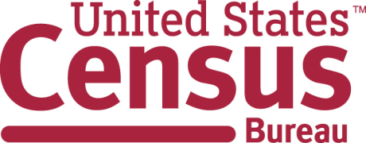

The Census Bureau wants to make sure everyone is counted in the 2020 Census. These counts are used to determine representation in the U.S. House of Representatives, state and county legislatures, school districts, and distribute billions of dollars in funding for health, education and other programs.

We are doing research to improve how we collect this information to try to reduce the numbers of people who are not counted.

We are looking to talk with people in households who meet at least one of these criteria:

* at least 4 people living at the household
* where someone has moved in or out recently
* where not everyone is related to each other
* with 3 or more generations (e.g., grandparents, parents, grandchildren)
* with distant relatives, such as nephews/nieces, cousins, great grandchildren, etc.

Interviews are in-person and will last no more than one hour per person. We would like to talk to at least 2 adults in each household. **Each person will be provided a $40 incentive for their participation.**

We are happy to travel to participants’ homes, meet at community centers, coffee shops, or invite them to travel to the Census Bureau in Suitland, Md., if they prefer.

**We are asking for your assistance in identifying households and families who might be interested in participating in interviews. Please contact us if you would like to discuss the study. Thank you!!**

Joanne Pascale

[joanne.pascale@census.gov](mailto:joanne.pascale@census.gov)

301-763-4920

