**ATTACHMENT IV: CONSENT FORM**

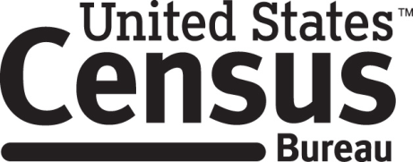

**Consent Form**

**Census 2020 Cognitive Interview**

Each year the Census Bureau conducts many different surveys. The Census Bureau routinely tests the questions used on these surveys in order to produce the best information possible.

______________________ [NAME] consents to take part in a study to evaluate the questions in the 2020 Census. In order to have a complete record of all comments, the interview session will be audiotaped. The Census Bureau plans to use the recordings to evaluate the questionnaire. Only staff directly involved in the research project will have access to the recordings. Participation is voluntary and answers will remain strictly confidential.

This study is being conducted under the authority of Title 13 USC. The OMB control number for this study is ______________. This valid approval number legally certifies this information collection.

I have agreed to participate in this Census Bureau 2020 evaluation, and I give permission for my recording to be used for the purposes stated above.

____________________________ ___________________________

Participant's Signature Researcher's Signature

____________________________ ___________________________

Printed Name Printed Name

___________________________ ____________________________

Date Date