Survey Materials Pretesting

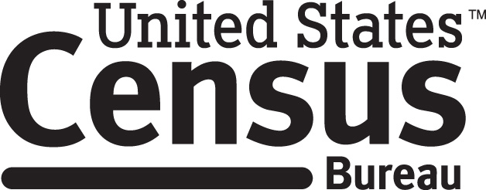

Consent Form
National Survey of Children’s Health

Each year the Census Bureau conducts many different surveys. The Census Bureau routinely tests survey questions and materials used for these surveys in order to produce the best information possible.

You have volunteered to take part in a study to improve the materials used in the National Survey of Children’s Health. In order to have a complete record of your comments, your interview session will be recorded. We plan to use the tapes to improve the materials. Staff directly involved in the materials research project will have access to the tapes. Your participation is voluntary and your answers will remain strictly confidential.

This study is being conducted under the authority of Title 13 USC. The OMB control number for this study is 0607-0725. This valid approval number legally certifies this information collection.

I have volunteered to participate in this Census Bureau materials design study, and I give permission for my recordings to be used for the purposes stated above.

__________________________ ___________________________________
Researcher's Signature Participant's Signature

____________________________ ____________________________________
Researcher’s Name Participant’s Name

__________________ _________________________ Date Date

