**Annual Retail Trade Survey – Revised Inventory Cognitive Testing Protocol**

**July 31, 2019**

**Research Questions**

* Is “LIFO” a familiar concept to respondents?
* Does respondents’ understanding of LIFO depend on their position, training, or location within the company (i.e., at a corporate headquarters versus at a manufacturing establishment)?
* Do respondents have issues with comprehending the terminology used for inventory?
* Are the requested information available in respondents’ records?

**Introduction**

* Thank you for your time today.
* Purpose of meeting – We are currently in the process of revising how we ask for inventories on the Annual Retail Trade Survey. We are proposing to remove and re-order some of the existing content for this section of the questionnaire and wanted to get feedback from respondents on how they would handle this revision.
* Our purpose today is to ask some overall questions about your inventory valuation methods and to get feedback on the proposed revision to see if it makes sense or needs any further improvement.
* I want to emphasize that we are not auditing your past response, but looking for ways to improve our survey form.
* All of your responses will be completely confidential and not shared with anyone not directly involved in this research project. You are free to decline any question you’re not comfortable answering.

**Background questions**

* What is your role in the company?
* What was your role in the preparation of the Annual Retail Trade Survey?
* Did you have access to all the information requested for the inventory question on the form?

**Inventories**

* Do you recall how you went about answering the inventories questions on the previous ARTS questionnaire? Please tell me about your process.
* Did you have to involve any others within your organization? If yes, who? How do you go about contacting them?
* When you reported this information, was it before adjustments?
* Are you providing book numbers or what you reported to the IRS for tax purposes?

I would now like for you to look at the proposed new wording for the inventory questions.

**Item 7 – Value of Inventories**

* How would you go about gathering information to answer Item 7B *(value of merchandise inventory)*? (If applicable, probe on specific reports that may need to be run to answer this question)
* How easy or difficult was it to access the data requested? *(If they answer difficult, try to probe further “tell me more about that.”)*
* What does the phrase “before Last-in, First-out (LIFO) adjustment (if any)” mean to you?
* Would you be reporting at cost or at market value for your inventory figures? Tell us more about that.
* What does the instruction “Exclude inventory held in Foreign Trade Zones or in bond warehouses in the US” mean to you? Are you familiar with the terms?

**Item 8 – Inventory Valuation Method**

* What does the phrase Inventory Valuation Method mean to you?
* At the end of the year, do you do any inventory adjustments? If so, what adjustments do you do? *(Note: only adjustment mentioned should be LIFO, FIFO or Weighted Average)*
* Has the company ever had experience using any other valuation methods? Can you tell me a little about that?
* Did you have to make any adjustments because of a fiscal year to report this information? If yes, what types of adjustments did you have to do? How easy or difficult was it to make these adjustments? *(If they answer difficult, try to probe further “tell me more about that.”)*

**FOR THOSE THAT ANSWERED ‘YES’ TO 8A**

* Please walk me through how you could go about answering item 8B? Where would you go in your records for this information? How easy or difficult was it to access this data in your records? *(If they answer difficult, try to probe further “tell me more about that.”)*
* In your own words, what is LIFO reserve? Is this applicable to any of the EIN’s in your organization? If so, tell me about how you would provide information about LIFO reserve.

**Closing**

* How much time would you estimate that it would take you to complete this revised question, including reading the questions and instructions, retrieving data from records, and discussing the items or getting assistance from others?
* Do you have any suggestions for improving these inventory questions?
* Lastly, I want to refer back to your experience in reporting to the 2018 version of the inventory questions, let’s refer to the second attachment. I want to learn more about your experience reporting to item 7b in particular, requesting the value of merchandise inventories
* How easy or difficult was it to report this information? *Explain*
* How are the records maintained for these data?
* Were you able to break apart these details in item 1 and item 2 (for retail stores and warehouses, offices, or in transit for distribution to retail stores). *Explain*
* Is it clear what the difference is between inventories and merchandise inventories?
* In the revised version we just reviewed, it asks for you to report the total inventories without line items 1 and 2, do you have a preference on how you would like to report these data? *Explain*
* Do you recall if you reported anything in item 2? Tell me more, merchandise inventory in warehouses?  In offices? In transit?
* How do they account for these?

**B. What was the value of merchandise inventories as of December 31 in 2018 (before Last-In, First-Out (LIFO) adjustment, if applicable)?**

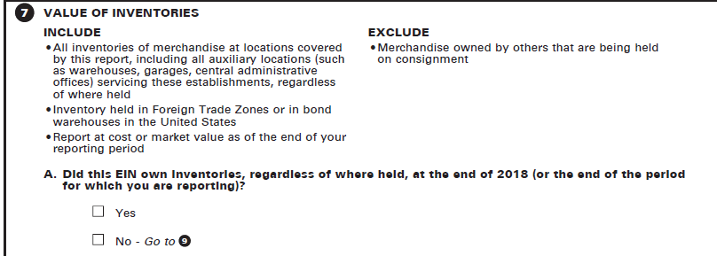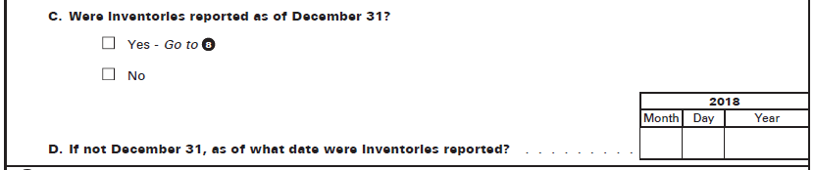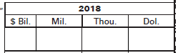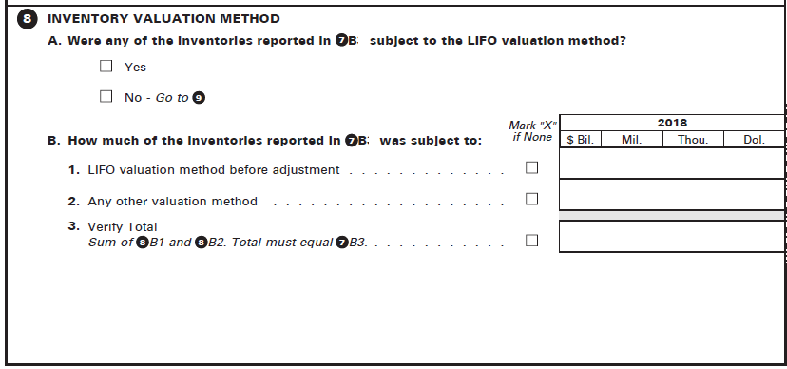

**C. What was the LIFO reserve?**



*C1*

*3*



**1.**

**2.**

