How-To Video Script Outlines
- Login Screens (eCorr)
  - Steps to create a new account
  - Creating a profile and answering security questions
  - Entering the authentication code to access your survey
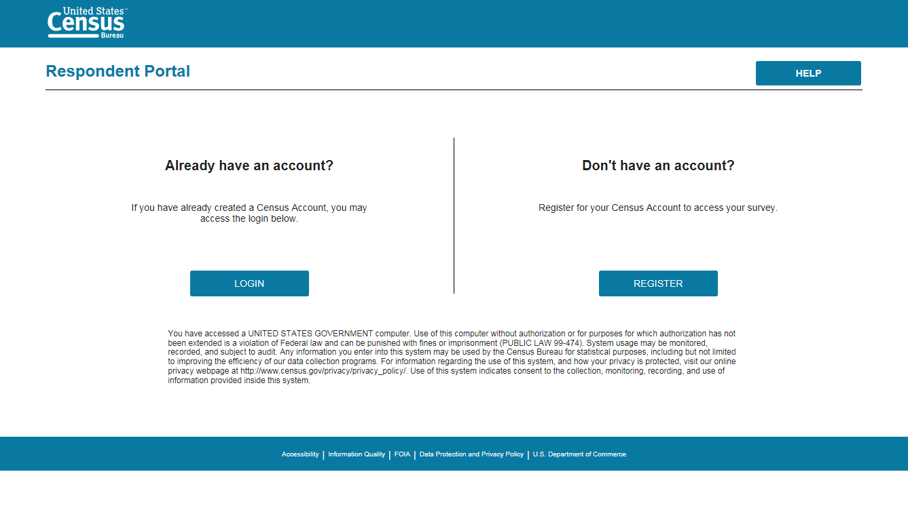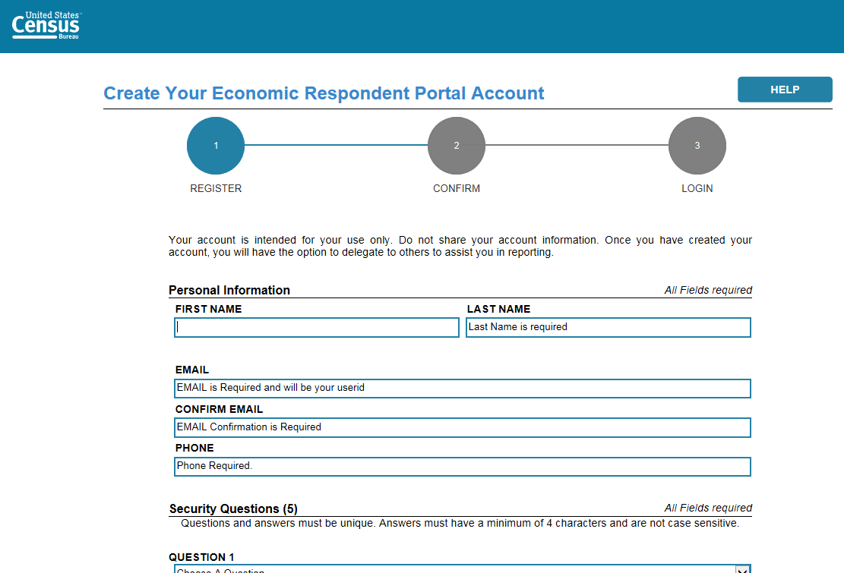
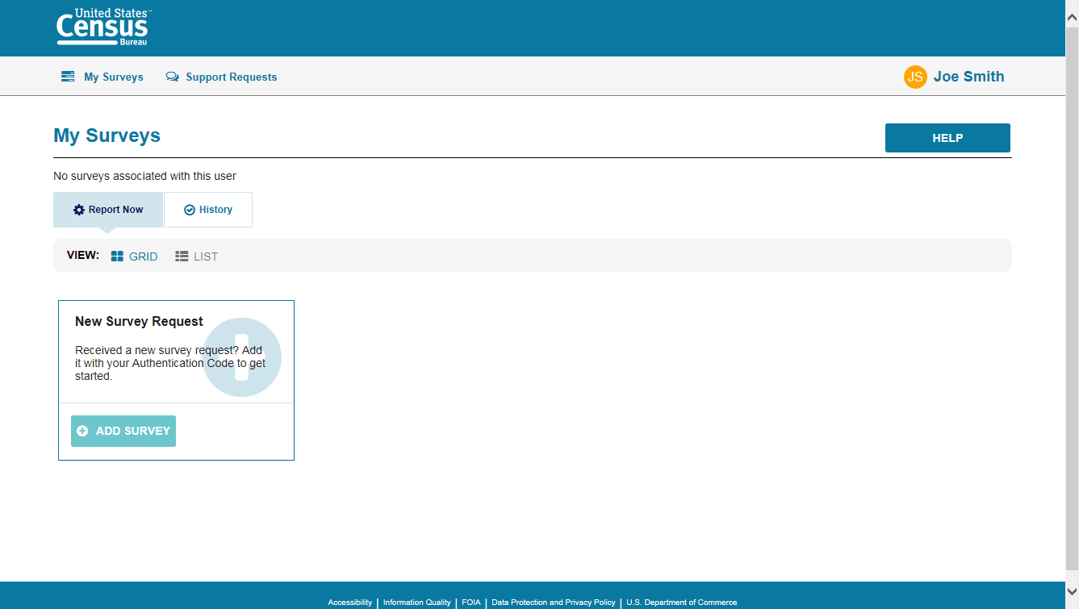
- Dashboard Overview (From here and below are Centurion)
  - Overview Page: This page describes the basic steps a respondent needs to take to successfully submit their survey.
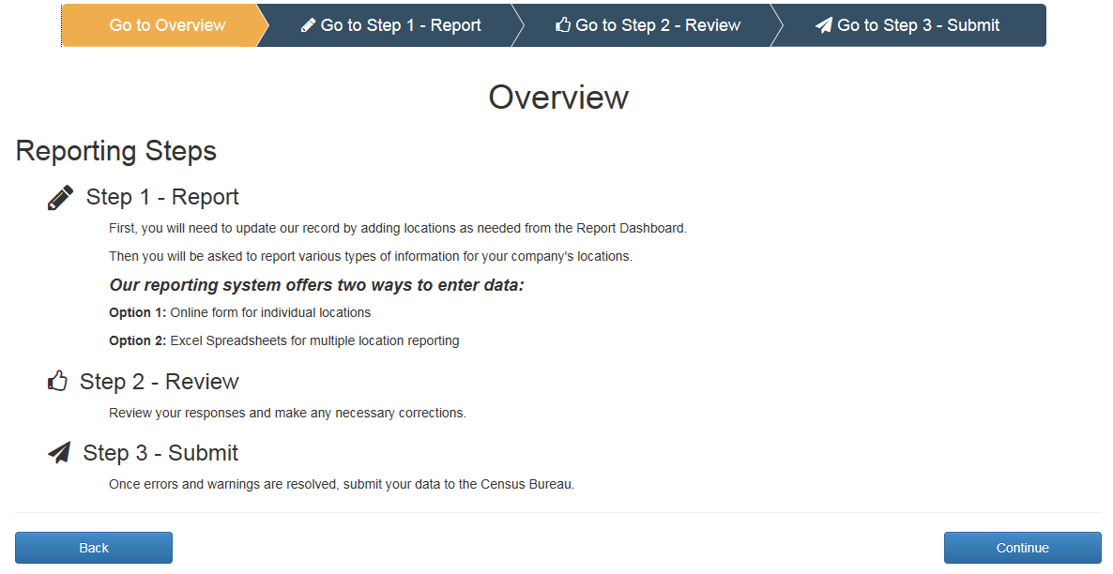
  - Site Navigation
    - The Banner; Horizontal Scrolling; Forward Back Navigation
  - Main Dashboard Features
    - Filtering; Sorting; Undoing Changes
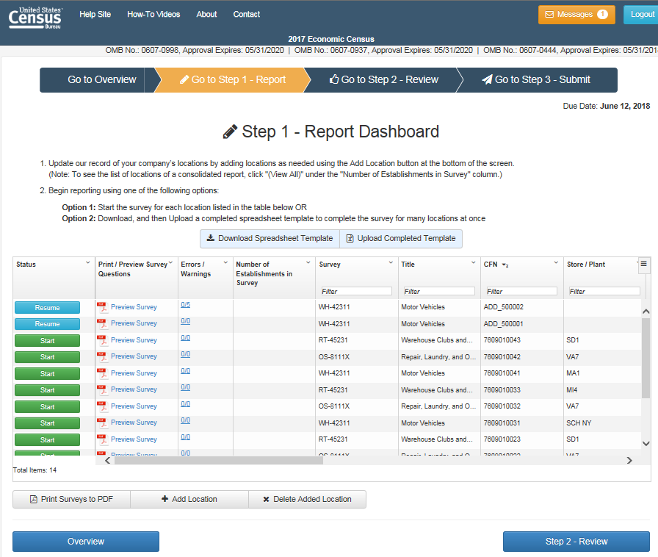
  - How to begin the survey

- Print Preview
  - Printing Full Survey
  - Printing Survey with Responses
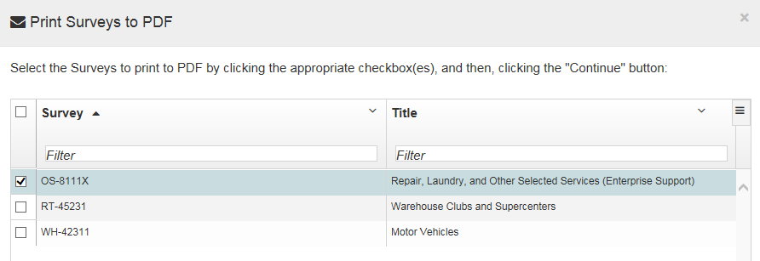

- Add/Delete Locations
  - Adding a New Location
    - Where to find the new information
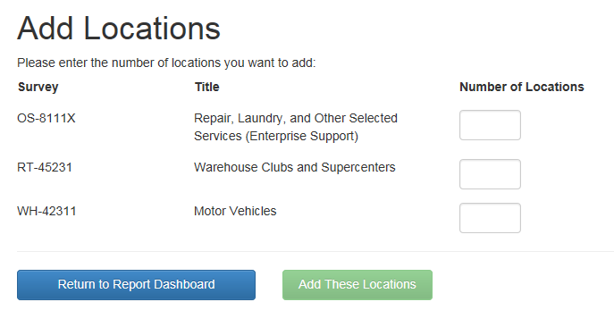
  - Deleting an Added Location
  - Deleting a Pre-listed Location

- Messages Feature
  - Location of the messages
  - Types of messages received
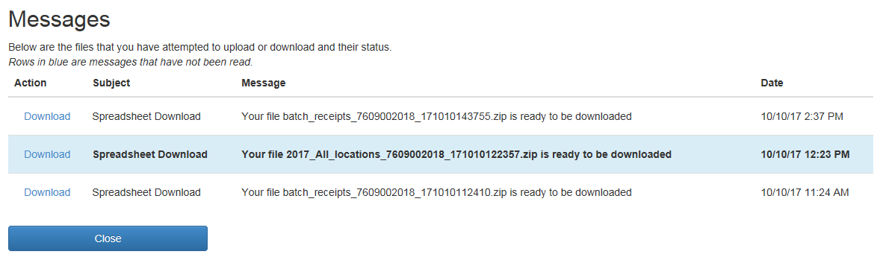

- Downloading Spreadsheet
  - How to download the spreadsheet
  - General guidance for excel sheet do’s and don’ts
  - All locations action explanation
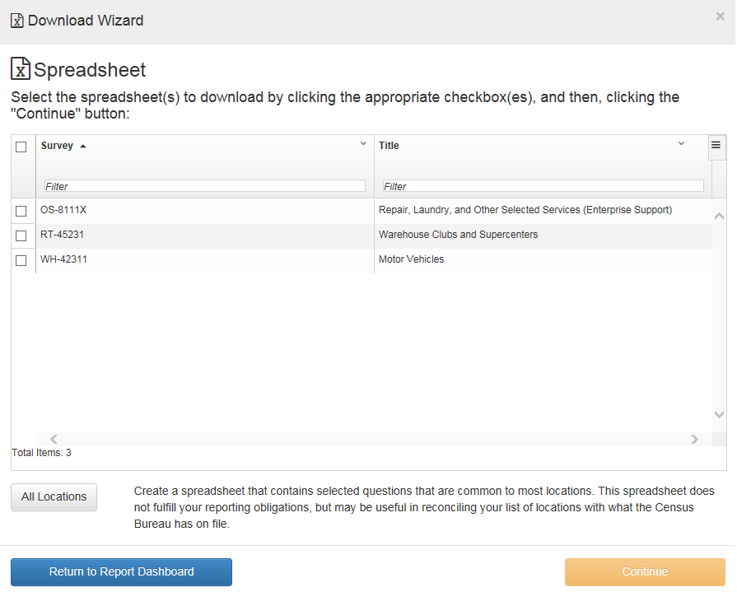

- Uploading Spreadsheet
  - How to upload the completed spreadsheet
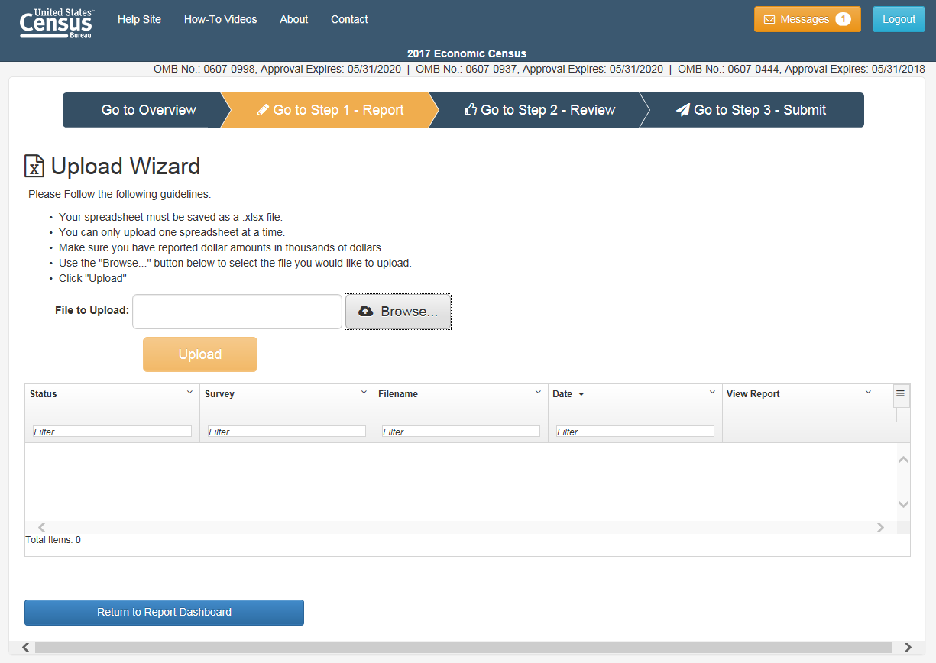
- Reviewing Your Responses
  - Fixing Errors and Warnings
  - Downloading Errors and Warnings
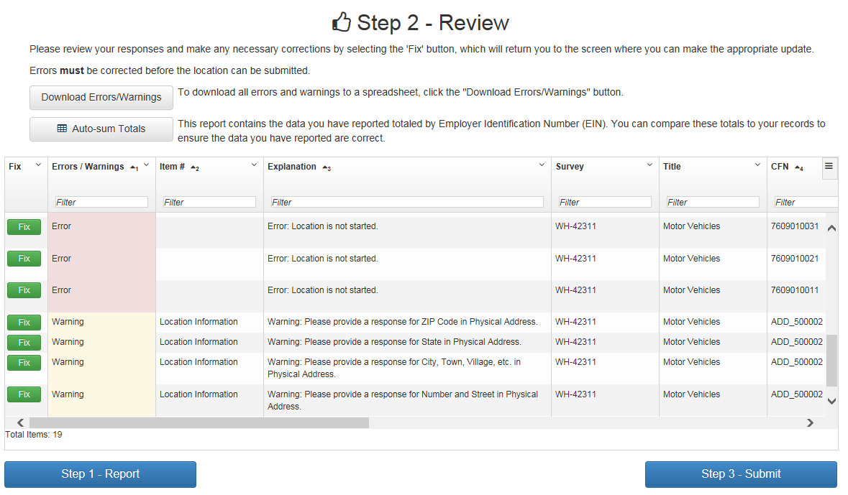

- Submitting Your Survey
  - How to submit the survey
  - Printing the completed survey
  - Confirming Survey has been submitted successfully
