Attachment A: Proposed Telemedicine Questions for the Services Annual Survey

Telemedicine Question:
Variation One: Ambulatory Health Care Services ________________ __________________

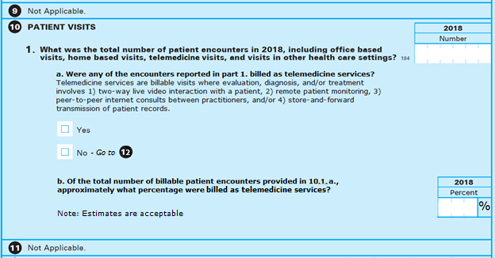

Variation Two: Hospitals _______________________ ______________________________

