Service Annual Survey
OMB Approval Number 0607-0422
Request for Nonsubstantive Change

With the selection of a new sample of respondents for the 2016 Service Annual Survey (SAS), we are planning some survey modifications that we consider to be non-substantive. The sample of respondents for the SAS is re-drawn every 5 years. We typically avoid making modifications to the questionnaires in sample years 2 through 5 because we do not want to disrupt the data gathering and response routines that companies may have developed in year 1. Therefore, our only viable option for making these changes during the current sample is to incorporate them in the survey mailout that will occur in January 2017 (survey year 2016). Our next opportunity will not occur until January 2022.
For SAS, each industry path variation is duplicated with one version for single EIN units and another for multi-EIN units. These two versions are identical except that the single EIN variations ask the respondent to confirm their EIN number. For 2016, we will have 96 sets of distinct industry content in the SAS, and that translates to 192 variations due to the EIN duplication. The phrase "path" in this request is used to refer to the number of distinct sets of industry content (96, not 192).
The requested changes can be categorized as either deleted questions, added questions, or modified questions. For 77 of 96 path variations, all content will remain unchanged or will be affected only by question deletions.
For the other 19 of 96 path variations, we estimate that on net the requested changes will not affect respondent burden since questions are being both added and deleted. Most importantly, nearly all question additions we are proposing are designed to clarify existing questions. In some cases where we had previously asked respondents to identify an aggregate total only, we are now asking them to report on components to the total to assist them in "building up" the reported totals in a clear and consistent way.
Attachments to this request show the prior and new requested path content for NAICS 622, Hospitals. This path has the greatest amount of proposed changes.

We are planning to delete questions about:
1) Interest expenses - this had been on 26 variations of the form. Data from this question is no longer included in any SAS publications.
2) Gross patient revenue in the Health Care sector. This question was provided on all Health Care paths previously to diagnose if the primary revenue figure was correctly recorded on a net basis. However, it was widely misunderstood by respondents.
3) Sources of Brokering and Dealing Equity Revenue in the Finance sector. Data from this question is no longer included in any SAS publications.

We are planning to add questions about:
1) Revenues earned from selected NAPCS products in the Real Estate and Insurance sectors. There were no product revenue questions previously asked for Real Estate and Insurance (apart from Health Insurance) firms, while significant numbers of product revenue questions are asked of firms in other sectors. These form variations are now more similar to those in other sectors.
2) Number of patient visits/stays in the Hospitals industry. This is currently requested on the Quarterly Services Survey (0607-0907), and having annual data will allow for benchmarking and quality checks of this data across time periods. This question is shown on the attached proposed new content for Hospitals (Question 11).
3) Electronic health record systems expenses in the Health Care sector. This is to fill a data gap as requested by the Centers for Medicare and Medicaid Services and the Census Bureau’s Center for Economic Studies. This question is shown on the attached proposed new content for Hospitals (Question 12).

We are planning to modify questions about:
1) E-commerce on selected paths. The industries listed below will be split into two equal panels, with the question unchanged for one panel and modified for the other. The modified question asks for reporting as a percent of total sales rather than as a dollar value to reduce respondent burden. The modified question also has wording changes that were designed to more closely match questionnaires used by Statistics Canada, UK Office of National Statistics, and the US Annual Survey of Manufactures to measure e-commerce. The wording for both questions is shown below. The split-panel design will allow for evaluation of differences in respondent behavior with the modified questions. The selected industries are those where subject matter experts believe that e-commerce data may be under-reported currently:

NAICS 511210, Software Publishing
NAICS 518210, Data Processing, Hosting, and Related Services
NAICS 481, Air Transportation Services
NAICS 484, Truck Transportation Services
NAICS 5231, Securities and Commodities Contracts Intermediation and Brokerage
NAICS 7113, Promoters of Performing Arts, Sports, and Similar Events
NAICS 713110, Amusement and Theme Parks

Current SAS E-commerce question
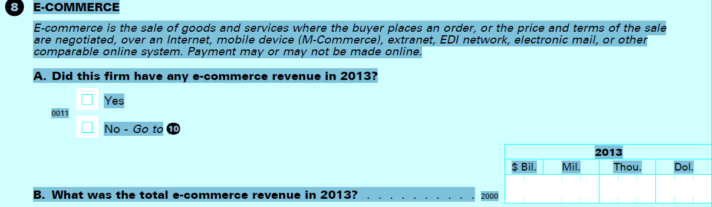

Proposed modified SAS E-commerce question
Section 8 – E-Commerce
A. Did this firm record any operating revenue from sales generated through orders entered directly on the firm’s websites or mobile applications?
Yes / No (Go to C)
B. What was the percentage of total operating revenue recorded in Section 6 that was generated through orders entered directly on the firm’s websites or mobile applications? Please provide an estimate if exact figures are not available.
Percentage
C. Did this firm record any revenue from sales generated through orders entered through third-party websites or mobile applications, EDI systems, e-mail, and other electronic networks?
Yes/ No (Go to Section 9)
D. What was the percentage of total operating revenue recorded in Section 6 that was generated through orders entered through third-party websites or mobile applications, EDI systems, e-mail, and other electronic networks? Please provide an estimate if exact figures are not available.
Percentage

2) Sources of patient revenue by payer in the Health Care sector. We will expand the number of categories from 5 to 9, clarifying how various payment types are to be tabulated. This modification is shown on the attached proposed new content for Hospitals (Question 6).
3) The reporting period for paths in the Health Care sector. The current questionnaire requests that respondents indicate if their data refers to activity in either: 1) the calendar year; or 2) their fiscal year or a portion of the year (both of which they are then asked to specify). We will modify these options to: 1) the calendar year; 2) the fiscal year; or 3) a portion of the year. This will allow us to more clearly investigate the amount of calendar year reports compared to the amount of fiscal year reports for firms in the Health Care sector. This modification is shown on the attached proposed new content for Hospitals (Question 4).
All 2016 SAS questionnaire content must be locked by the end of July 2016 so it can be programmed, tested, and available to respondents in January 2017. Since a quick review is requested, we would be very happy to speak with you to clarify these changes and respond to any questions you have. Please contact Andrew Baer, Assistant Division Chief for Service Sectors, Economy-Wide Statistics Division for further information. He can be reached by phone at 301-763-3183 or by email at andrew.l.baer@census.gov.

